INFORMATION

About

JOHANNES GUNCKEL

Of

BETHEL TOWNSHIP,
BERKS COUNTY,
PENNSYLVANIA

2012

TomG@Gunckel.com

TABLE OF CONTENTS

TABLE OF CONTENTS ii
TABLE OF FIGURES iv
INTRODUCTION 1
HISTORY OF BETHEL TOWNSHIP 2
EARLY RECORDS 10
CHURCH RECORDS 10
LAND RECORDS 15
OTHER RECORDS 17
EMIGRANTS FROM EUROPE 18
SIGNATURES 19
JOHANNES GUNCKEL OF BETHEL TOWNSHIP 25
CHILDREN OF JOHANNES GUNCKEL 27
JOHN GUNCKEL, son of Johannes 27
LEONARD GUNCKEL, son of Johannes 28
JACOB GUNKLE, son of Johannes 30
MICHAEL GUNKLE, son of Johannes 38
DANIEL GUNCKEL, son of Johannes 39
PHILIP GUNCKEL, son of Johannes 39
OTHER KUNKELS OF BERKS CO. 47
JOHN GEORGE KUNKEL FAMILY OF ALBANY TOWNSHIP 47
PETER KUNKEL FAMILY OF HEREFORD AND COLEBROOKDALE TOWNSHIPS 50
THE GUNCKEL FAMILY IN EUROPE 52
PHILIP GUNCKEL OF ALSACE LORRAINE 52
JOHN MICHAEL GUNKEL OF BERKS COUNTY 53
LORENTZ GUNKEL OF BREITENBORN, GERMANY 55
SETTLEMENT IN PENNSYLVANIA 59
John Gunkle, son of Leonard, grandson of Johannes 59
Daniel Gunkle, son of Michael, grandson of Johannes 61
SETTLEMENT IN OHIO 62
MONTGOMERY COUNTY, OHIO 62
GERMAN TOWNSHIP, MONTGOMERY COUNTY, OHIO 62
TWIN VALLEY 63
GERMANTOWN 64
SUNSBURY 64
EARLY SETTLEMENT 65
GERMANTOWN CEMETERY 67
GERMANTOWN BIOGRAPHICAL SKETCHES 68
CATHARINE LORISCH SCHAEFFER, mother-in-law of Philip Gunckel 68
Dr. CHRISTIAN G. ESPICH, son-in-law of Philip Gunckel 72
MICHAEL GUNCKEL, son of Philip 72
LEWIS B. GUNCKEL, son of Michael, grandson of Philip 73
HENRY S. GUNCKEL, son of Michael, grandson of Philip 75
WILLIAM F. GUNCKEL, son of Michael, grandson of Philip 75
John Elster Gunckel, son of William F, grandson of Michael 77
G. W. and W. F. GUNCKEL, grandsons of Philip 78
DANIEL N. GUNCKEL 79
CATHERINE GUNKLE, of Jackson Township 81
DARKE COUNTY, OHIO 83
JOHN D. “JAKE” GUNCKEL of Darke County, Ohio 83
BUTLER COUNTY, OHIO 85
JOHN GUNCKEL, son of Jacob, grandson of Johannes 85
CHARLES F. GUNCKEL, son of Philip, grandson of Philip 89
PREBLE COUNTY, OHIO 89
PHILIP GUNTLE 89
SETTLEMENT IN INDIANA 92
JOHN PHILIP GUNCKEL 92
JOHN GUNCKEL, son of John Philip 92
DAVID GUNCKEL, son of John Philip 93
PHILIP GUNCKEL, son of John Philip 93
AARON M. GUNCKEL, son of John Philip 93
MICHAEL GUNKLE, son of John, grandson of Jacob 93
SETTLEMENT IN ILLINOIS 95
GEORGE GUNKEL 95
OTHER GUNCKEL/GUNKLE FAMILIES 95
Edward G. Gunckel of Iowa 95
Ferdinand Gunckel of Dayton, Ohio 96
Cain Gunckel family of Georgia 96
Adam Gunckel family of Louisiana 96
John Gunkle of Kansas 96
Anthony W. Gunkle of Denver, Colorado 96
Florean Gunkel of Indianapolis, Indiana 96
APPENDIX – FEDERAL CENSUS DATA DESCRIPTION 97
REFERENCES 99

TABLE OF FIGURES

Figure 1 Draught of Lancaster County in 1729 4
Figure 2 Map of Berks County, Showing The Townships in 1767 5
Figure 3 Map of Berks County Pennsylvania 6
Figure 4 Upper Part of Lancaster County in 1775 7
Figure 5 Lancaster County (Lower) in 1753 and Later Changes 8
Figure 6 Counties and Townships Surrounding Bethel Township 9
Figure 7 Partial Warrantee Map of Bethel Township 21
Figure 8 Location of Gunckel Land Parcels 22
Figure 9 Deed of John Gunckel 23
Figure 10 Ship Ranier, September 26, 1749, List 136C 24
Figure 11 Signature Specimens for Johannes Gunckel 26
Figure 12 Administrators of the Estate of Leonard Gunckel 42
Figure 13 Signatures Specimens of Jacob Gunckel 43
Figure 14 Advertising Flyer of Michael Gunkle 44
Figure 15 Signature Specimens of Michael Gunkle 45
Figure 16 Signatures of Philip Gunckel on Letters Dated 1798 & 1799 46
Figure 17 Map of the State of Hesse, Germany 57
Figure 18 Map of the County of Gelnhausen, State of Hesse 58

INTRODUCTION

A Johannes (John) Gunckel lived in Bethel Township, Berks County, Pennsylvania during the last half of the 1700’s. Living today are GUNCKEL/GUNCKLE descendents of his sons Daniel and Philip, who settled Germantown, Ohio, and GUNKLE descendents of his sons Leonard, Jacob, and Michael, who settled in Pennsylvania.
Starting from Pennsylvania, the Gunckels spread to Ohio, then to Indiana, then to Illinois, Michigan, and the rest of the country. The purpose of the material here is to develop the history of that Gunckel family. The intent is to rely, as much as possible, on original records such as tax rolls, wills, church records, census records, etc. A secondary purpose is to compile, in one place, abstracts of the original records and biographical information that relate to the Gunckel family. Material that is copied directly from the sources is generally placed in italics.
The surname GUNCKEL is probably derived from the either of the German surnames GUNKEL or KUNKEL. GUNKEL probably refers to living by deep water. KUNKEL in a German word meaning the part of a spinning wheel called the distaff.
Reference to individuals in the early records is frequently ambiguous. First of all, most records were kept by English clerks, who might not be able to speak German, with much of the population being illiterate. As a result, the spelling of surnames was largely phonetic and varied significantly, even for the same individual. Secondly, given names were common among several individuals. John was a very common first name and there were several John Gunckel/Kunkels who lived in the same time frame in Pennsylvania and at least two of them had wives named Catharine. In addition, John Michael could also be referred to as John or as Michael.
Another complication is that German Protestants used the Julian calendar until Easter of 1776. Moreover, the British Government imposed the Gregorian calendar on all its possessions, including the American colonies, in 1752. The British decreed that the day following September 2, 1752, should be called September 14, a loss of 11 days. All dates preceding were marked O.S., for Old Style. In addition, New Year’s Day was moved to January 1 from March 25. Thus February 11, 1731 O.S. became February 22, 1732 N.S.
Church records indicate that both a John Gunckel and a John Michael Gunckel lived in Bethel Township in 1750 to 1770. In addition to the John Gunckels of Bethel Township, there were two other Gunckel/Kunkel families in Berks County in the late 1700’s: the John George Kunkel family of Albany Township, and the Peter Kunkel family of Hereford and Colebrookdale Townships. Information on these families is included for completeness and to help identify individuals in the records.
In addition, a Philip Guntle settled close to Germantown, Ohio in about 1806. Some of his descendents are referred to as Gunckel in the County records. Therefore information on this family is also included.

HISTORY OF BETHEL TOWNSHIP

The history of Bethel Township, Berks County given by Whitmoyer [R1] is abstracted below.
(p. 118) Bethel Township is located in the northwestern portion of Berks County. The present boundaries are: on the north the summit of the Blue Mountain, the (Little) Swatara Creek on the east and south, and Lebanon County on the west. The area contains about twenty seven thousand acres.
In 1723 the land lying west of the Swatara Creek and the South of the Blue Mountain was known by the name of Lebanon and to the east and south as Tulpehocken Manor.
(p. 5) The original territory of Tulpehocken was a recognized district before 1729 when it was a part of Chester County and comprised an area which extended from the Schuylkill River on the East to Lebanon Township on the West and from the Blue Mountains on the North to the Cacoosing Creek on the South.
The name of Tulpehocken was taken from the large stream which flowed through three-fourths of its area. The word Tulpehocken is an Indian word meaning “Land of the Turtles”. In 1729 the Tulpehocken Territory became a part of Lancaster County. At this time the Indians still claimed this territory as their possession and the people living in this area were in fact “squatters” although the original settlers thought they had a legal right to the land.
(p. 118) In 1739, the court at Lancaster ordered the township of Lebanon to be divided, the southern division to be called Lebanon and the northern section Bethel. The township was named after a Moravian Meeting House which was erected in the locality not far from the Swatara Creek.
(p. 118) When Berks County was erected in 1752, the county line extended through this (Bethel) township and divided it into two nearly equal parts. The western half being a part of what is now Lebanon County and the eastern section Berks County. In 1791 the northern boundary on top of the mountain was established by a survey and Court Proceedings...
The main stream is the Little Swatara Creek which forms the boundary line of Tulpehocken and Bethel Townships on the south. There are numerous small streams which flow into the (Little) Swartara Creek throughout the township...
The topography of the land is mainly gently rolling hills and valleys bounded on the north by the range of the Blue Mountains. The mountain Round Head, as it was known in the early days of our history or Round Top as it is now commonly called by the local people, forms a beautiful backdrop for the village of Bethel and area farms.
The early settlers referred to the mountain in German as “Rund Koph” (Round Head). It was through this pass in the mountain that the Indians slipped through during their frequent attacks on Bethel Township. It was at the base of this mountain that Dietrick Six settled and later Fort Henry was built...
Fort Henry was begun in January of 1756 by Captain Busse under the orders of Gov. Morris. Prior to this time the people of the area are believed to have sought refuge at the Six residence and a “Watch” had been established there by Conrad Weiser and the local people. While constructing the fort the men lived in a encampment and on several occasions were attacked by Indians with some lives lost. According to some sources the fort was not completed and occupied until March of 1756.
By about 1759 the outrages by the Indians ceased and there was peace throughout the valley. The fort was allowed to fall into decay and the land returned the plow, so that today all that remains in a memory and a stone marking its location...
(p. 119) The first settlers of Bethel Twp. were farmers who moved into the area about 1733, immediately after the Indians sold the land between the Blue Mountain and the South Mountain. They came to the area in search of land which at the time was the frontier of Pennsylvania. The picturesque valley at the base of the mountain known as Round Head or Round Top was an ideal location for settlement.
(p. 10) The majority of land lying in the present boundaries of Bethel and Tulpehocken Townships was located in the Manor of Andulhea and Freame’s Manor. These tracts of land had been granted to the heirs of William Penn, who died in July of 1718.
The Manor of Andulhea was granted to Richard Penn, son of William Penn by his second wife, Hannah Callowhill, between the years 1741 and 1750, the exact date unknown. The land contained 5,302.5 acres full measure. Freame Manor, which was on the west of the Manor of Andulhea, was granted to Margaret Penn, daughter of William and Hannah Penn, and wife of Thomas Freame, on May 12, 1732. This tract of land contained 10,000 acres and an allowance for roads and high ways of 6 acres for every 100 acres.
Past researchers have been unable to locate an early map of Freams’s Manor... according to old deeds the land upon which the village of Mt. Aetna was founded was in Freame’s Manor.
A history of the formation of the counties of Pennsylvania is shown in [R2] and maps of the early townships of Lancaster County are given by Mayhill [R3].
When it was erected in May 10, 1729, Lancaster County extended from the Susquehanna River on the west to the Schuylkill River on the east. A map of Lancaster County in 1729 showing the townships is shown in Figure 1.
Berks County was erected on March 11, 1752 from parts of Lancaster, Chester, and Philadelphia Counties. The townships in Berks County in 1767 are shown in Figure 2 with the current townships shown in Figure 3. The townships in the upper portion of Lancaster County in 1775 are shown in Figure 4. This area became Dauphin and Lebanon Counties. The townships in lower Lancaster County in 1753 and later are shown in Figure 5.
Pinegrove Township, which was immediately to the north of Bethel Township, became a part of Schuylkill County when that county was erected on March 1, 1811. Dauphin County was erected on March 4, 1785 out of the northern portion of Lancaster County. Lebanon County was erected on February 16, 1813 out of Dauphin County and Lancaster County. A combined map of the counties in this area and their townships is given in Figure 6.

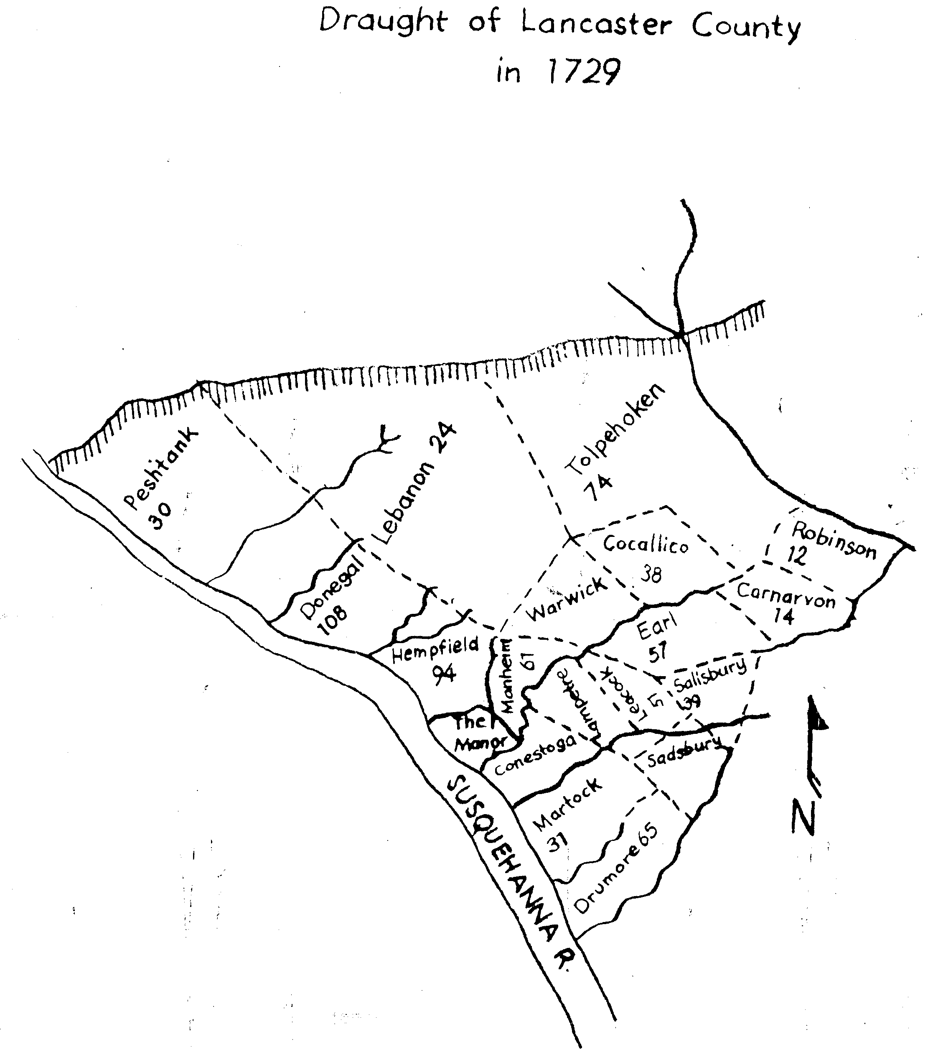

Figure 1 Draught of Lancaster County in 1729

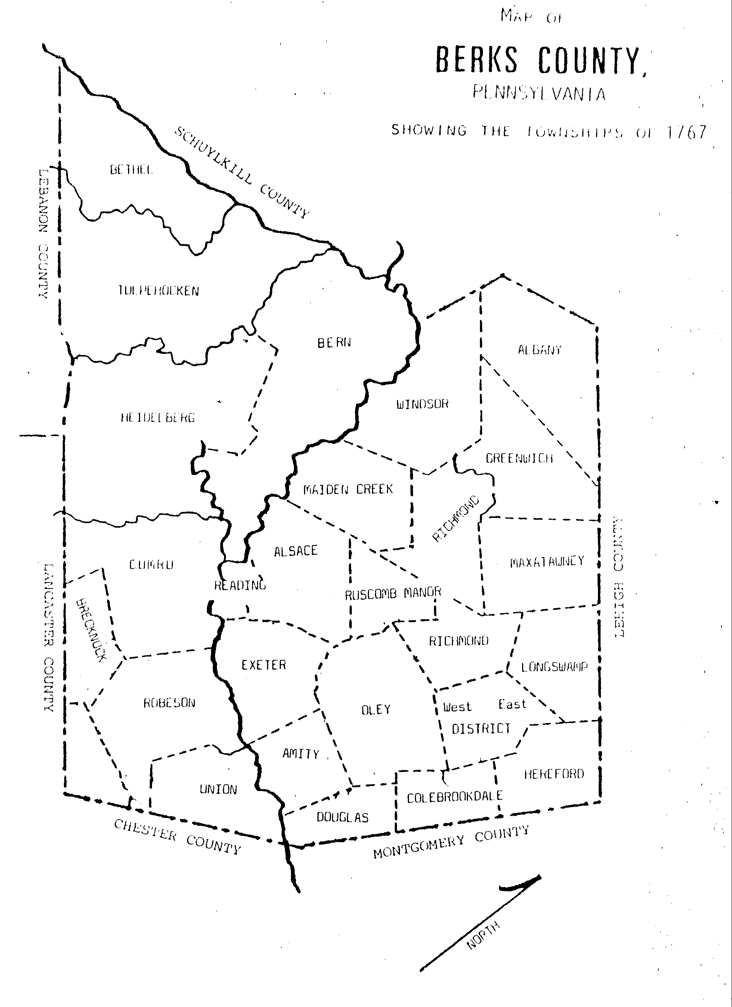
Figure 2 Map of Berks County, Showing The Townships in 1767

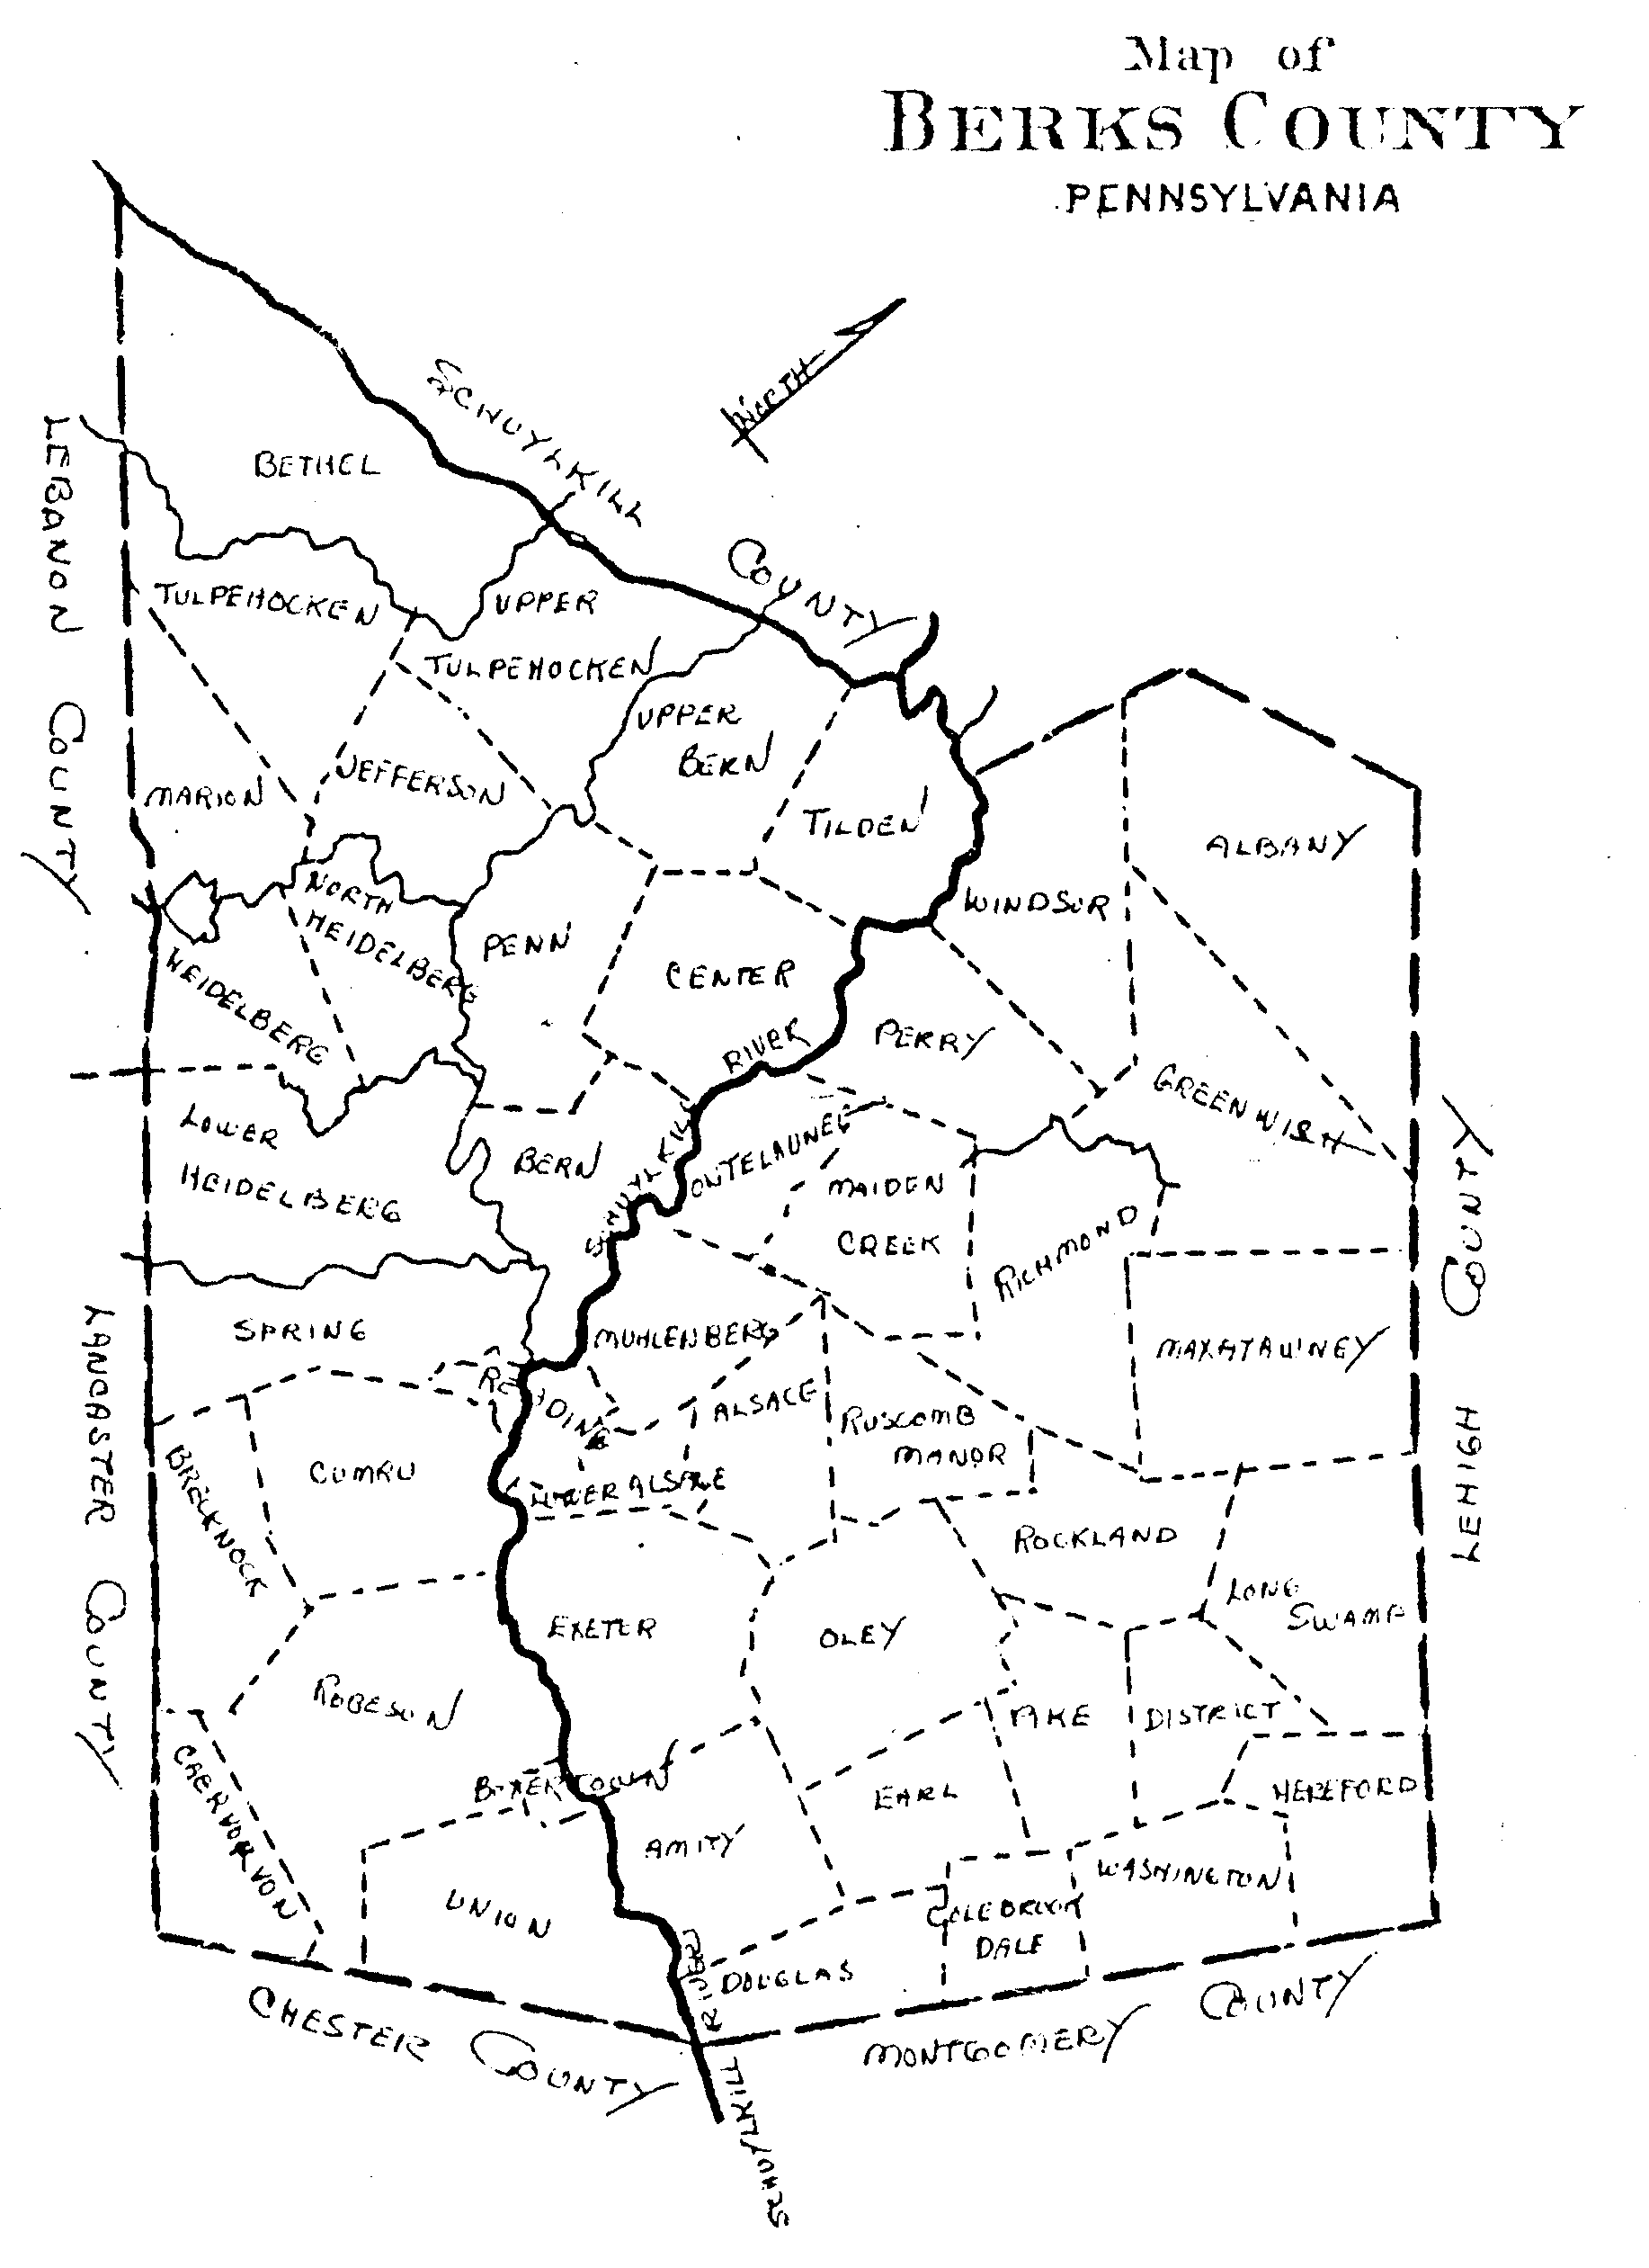
Figure 3 Map of Berks County Pennsylvania

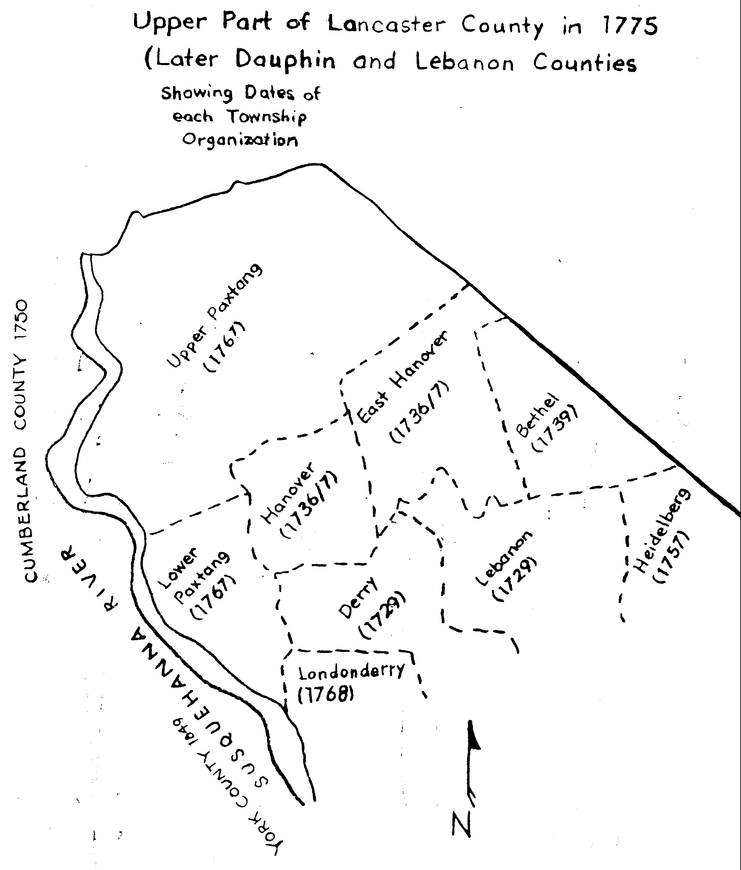
Figure 4 Upper Part of Lancaster County in 1775

Figure 5 Lancaster County (Lower) in 1753 and Later Changes
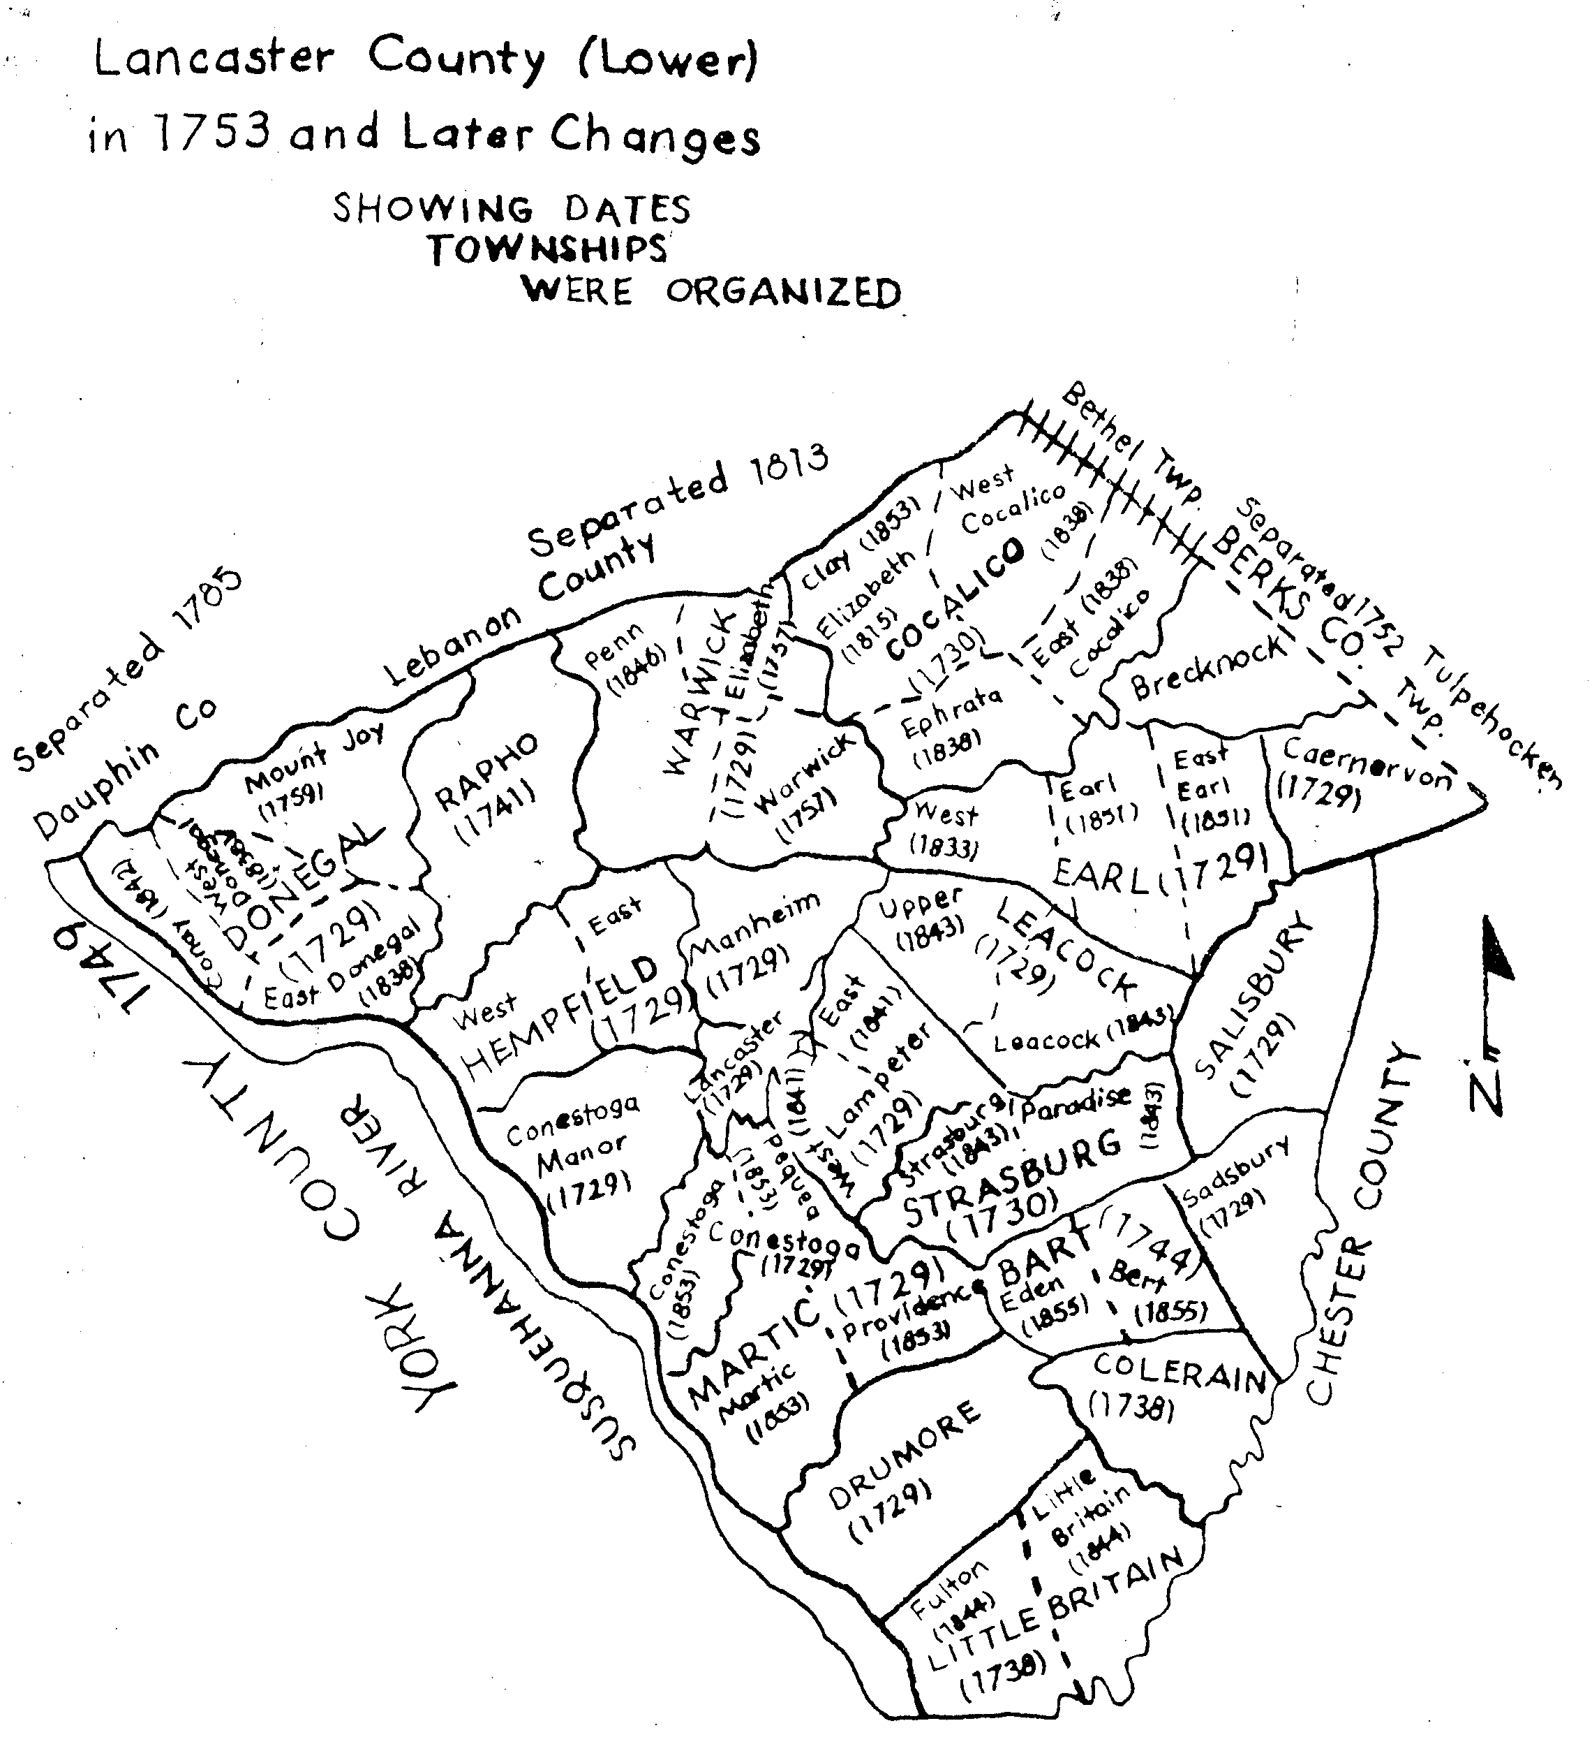
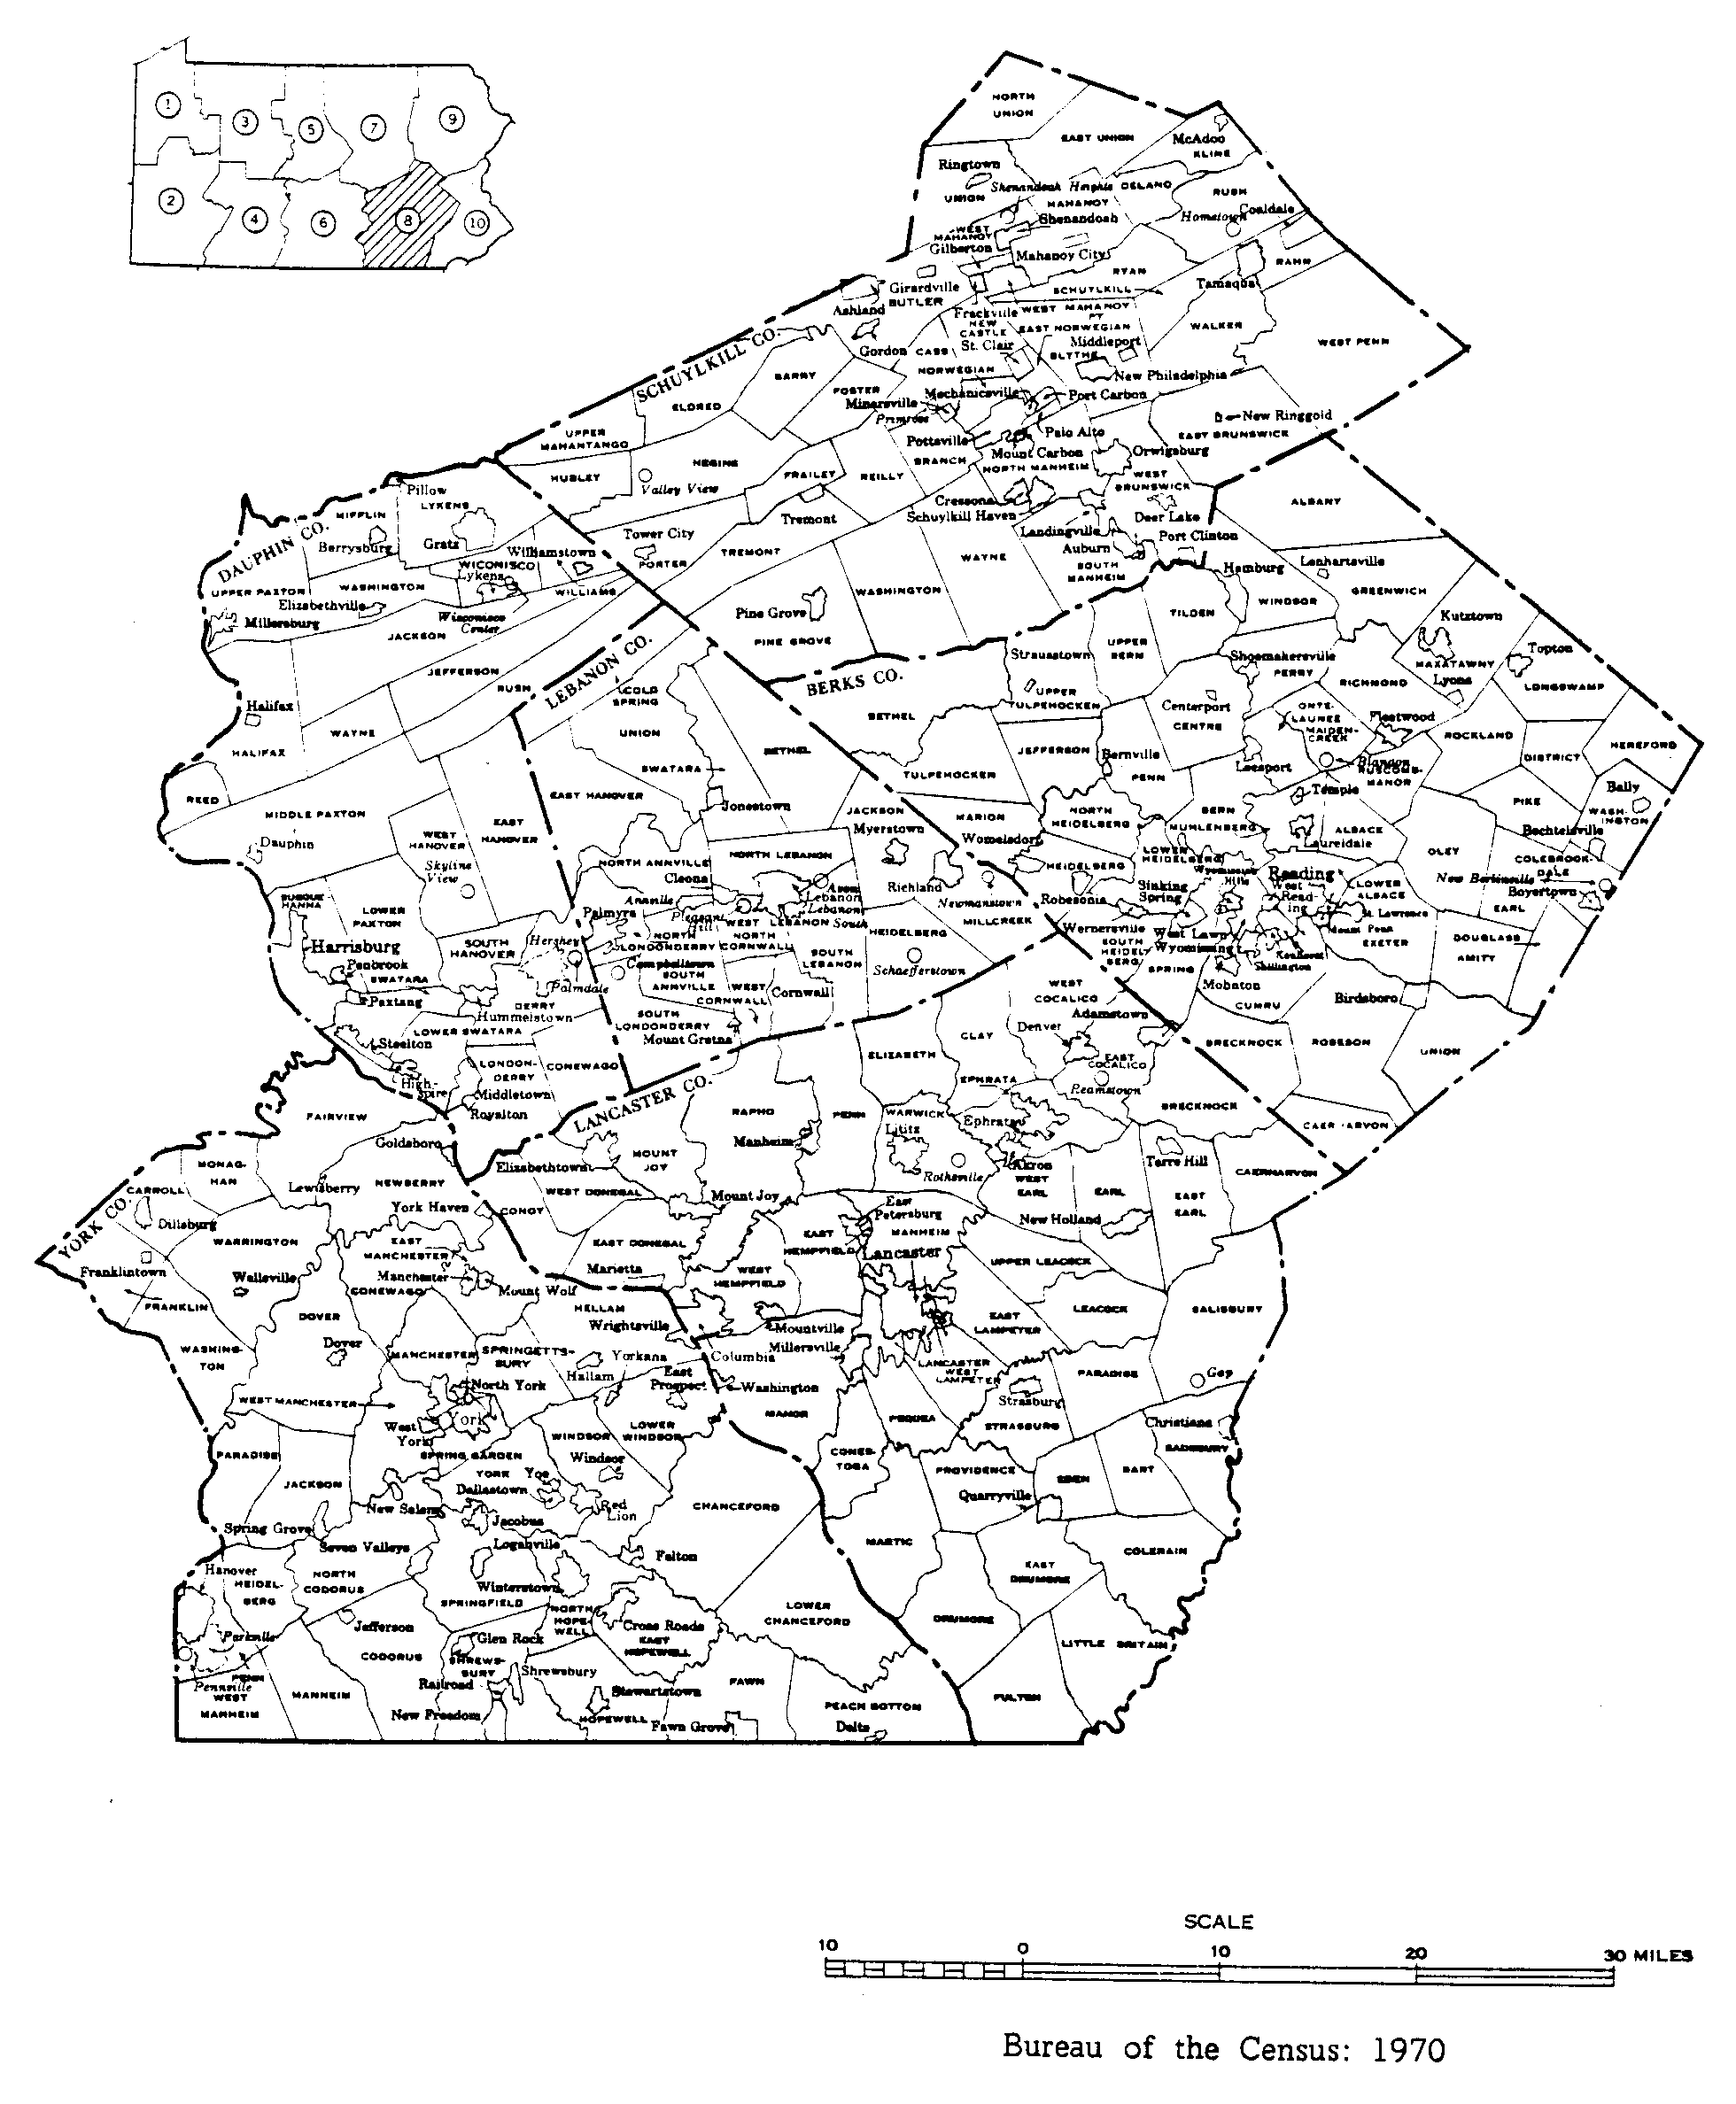
Figure 6 Counties and Townships Surrounding Bethel Township

EARLY RECORDS

CHURCH RECORDS
The GUNCKELs belonged to the Reformed Church. There were a number of churches in Bethel and surrounding townships that they could have attended. A list of possible churches is given below. The list shows the name and location of the church, the first year that records are available, and columns for marriage, baptism, and cemetery records. If the records of the church have been reviewed for presence of the Gunckel family, then the reference identification is shown in the appropriate column. In addition to church records, some ministers kept their own records. These are shown at the end of the list.
Many of these records are available at the Berks County Historical Society Library, 940 Centre Avenue, Reading, PA 19601. In that case the index number, e.g., CR E443, or the microfilm and item number, e.g., MIC 100-7, are shown with an XX indicating that those records have been reviewed. In some cases, the source is an LDS microfilm.
CHURCH | YEAR | MAR | BAPT | CEM
Altalaha Lutheran (CR E92) | 1744 |  | XX
Rehrersburg, Tulpehocken Twsp,
Berks Co.
Bern Reformed Church | 1739 |  | XX
(Now United Church of Christ)
Bern Twsp., Berks Co.
Christ Lutheran (CR C556) | 1743 | [R4] | [R4] |  | **
Stouchsburg, Marion Twsp.,Berks Co.
Christ (Little Tulpehocken) Jefferson | 1744 | XX | XX
Twsp., Lebanon Co. (CR M898)
Cocalico Reformed | 1766 | [R5]
East Cocalico Twsp., Lancaster Co.
Heidelberg Reformed | 1765 | [R5]
Schaefferstown, Heidel. Twsp., Lebanon Co
Millbach Church of the Brethren (Reformed) |  |  | XX |  | **
Millcreek Township, Lebanon Co.
Muddy Creek Reformed | 1743 | [R5]
East Cocalico Twsp., Lancaster Co.
St. Daniel’s (Corner) (S 137g) | 1752 |  | XX
Robesonia, Heidel. Twsp., Berks Co.
St. Jacob’s (MIC 97-1) | 1799 |  | XX | XX | **
Pinegrove Twsp., Schuylkill Co.
St. John’s (Hain’s) (CR K41) | 1743 |  | XX
Sinking Springs, Lower Heidel., Berks Co.
St. John’s (Host) (CR H831) | 1748 | [R5] | XX
Near Womelsdorf, Berks Co.
St. John’s Reformed | 1767 |  |  | [R6]
Bethel Twsp., Lebanon Co.
St. John’s Reformed (MIC 103-3) | 1740
Jonestown, Swatara Twsp.,Lebanon Co.
St. John’s Union (MIC 100-2) | 1774 |  | XX |  | **
Fredericksberg, Bethel Twsp, Lebanon Co.
St. Paul’s (Klopp’s) Reformed  (LDS Microfilm # 020345, item 10) | 1752 |  | XX | [R6] | **
Hamlin, Bethel Twsp., Lebanon Co.
St. Peter’s (Gunkle’s) Union Church | 1816 |  | XX | XX | **
Pinegrove Twsp, Schuylkill C (MIC 18-4,5)
Salem Lutheran (Rick’s Memorial)
Bethel, Bethel Twsp., Berks Co.
Salem Reformed (CR S263) | 1816 |  | XX
Bethel, Bethel Twsp., Berks Co.
Swamp Reformed | 1788 | [R5]
West Cocalico Twsp., Lancaster Co.
Swatara Reformed | 1765 | [R5]
Jonestown, Swatara Twsp., Lebanon Co.
Trinity Tulpehocken | 1748 | [R5] | [R1] | [R7] | **
Jackson Twsp., Lebanon Co.
Zion - St. John’s (Reeds) (CR Z78s) | 1764 |  | XX
Stouchsburg, Marion Twsp., Berks Co.
Zion (Blue Mountain) (CR Z79b) | 1745 |  | XX
Strausstown, Upper Tulp. Twsp., Berks Co.
Zion (Ziegel - Zoar) Lutheran | 1794 |  | XX | [R6]
Bethel Twsp., Lebanon Co. (MIC 100-3)
Zion Union (Reformed & Lutheran) | 1795 |  | XX
Womelsdorf, Berks Co. (CR W872)
Rev. William Boos (Boas), Berks Co. |  | [R5]
Rev. Henry Dieffenback, Berks Co. |  | [R5]
Rev. Daniel Schumacher (CR S392) | 1754 |  | [R4] |  | **
** Churches where records of Gunckels/Kunkels exist.

A history and records of the Trinity Tulpehocken Reformed Church (now known as the Tulpehocken Trinity United Church of Christ) are given by Seibert [R7]. This church is located in what is now Jackson Township, Lebanon County. It is east of Myerstown and north of Richland. In this time period, this area was part of Lancaster County. Although it existed before then, formal record keeping was started in 1748. Listed among the members in 1748 was a J. Kunckel. Marriage and birth records from Trinity Tulpehocken are abstracted below.
Parents | Child | Sponsors
John Kunckel | Ann Catherine | Mrs. Stein
and wife | bapt. May 15, 1749 | & Mrs. Noll
John Kunckel | John (John Michael?) | Michael ________
and wife | bapt. April 8, 1751
John Gunckel | Maria Dorothy
and Margaret | born Jan 11, 1754
 | bapt. Feb 19, 1754
Michael Gunckel | Ann Margaret | John Henry Noll
of Little Swatara | bapt. Oct 8, 1752 | & Ann Marg Stein
Michael Gunckel | Anna Maria | Balthasar Noll &
and Ann Mar | born April 11, 1754 | Anna Maria Stein
 | bapt. April 21, 1754 | now married
Henry Kunkel | Angelina Maria
and Angelina | born May 1, 1833
 | bapt. Oct 14, 1833

Anna Maria Gunckel had her first communion in 1770
George Leonard Emmert and Anna Catharine Gunckel married April 1, 1771
Leonard Gunckel and Rosina Meylin married Jan 16, 1775
______ Kunckel and Catharine were sponsors in 1795
Jacob and Susanna Kunckel sponsors in 1797
Daniel Kunckel and Sarah Kugler married Oct. 30, 1822
The marriages listed above are also listed by Irish [R5].
The birth date for Michael Gunkle, the son of John, is given as April 15, 1751, which is after the baptismal date given above. However, if the baptismal date above is adjusted for the change from the Julian to the Gregorian calendars, it becomes April 19 or four days after the birth.
Maria Dorothy is not mentioned in John Gunckel’s will, however she might have died by then or she might be the Anna Maria who is mentioned in the will.
These records indicate that during the 1750’s there were two Gunckel families: John Gunckel and Michael Gunckel. The John Gunckel appears to be John, Sr. of Bethel Township. Certainly the Anna Catharine who married George Emmert was his daughter. The births of Ann Catherine and John some twenty years earlier and the marriage of Leonard would correspond to the will of John, Sr.
As Michael Gunckel was not a member of the congregation in 1748, but did belong in 1752, perhaps he was the J. Michael Gunkel listed by Hinke [R8] as arriving in Philadelphia on September 26, 1749 on the ship Ranier.
Even though Gunckels participated in the Trinity Tulpehocken Church, the tombstone inscriptions listed by Seibert do not include any Gunckels.
Reference to Gunckels in the records of St. Paul’s (Klopp’s) Church of Bethel Township, Lebanon County are listed below:
Parents | Child | Sponsors
Michael Gunkel | Balthasar | Balthasar Noll
and Maria | bapt. Jan 6, 1756
Christian Hautz | Catharine | John Kunkel
and Barbara | born Aug 24, 1770 | and Catharine
 | bapt. Sep 30, 1770
John (Leonard?) Gunkel | Maria Catharine | George Schaefer &
and Catharine | born Feb 22, 1770 | Maria Catharine
 | bapt. Jan 13
Balthasar Leseh | Anna Catharine | John Gunckel and
and Christiana | born Apr 10, 1774 | Anna Catharine
George Leonard Emmert | Benjamin | Christian Hautz
and Catharine | born Feb 29, 1772 | and Barbara
 | bapt. April
Jacob Gunckel | John | Parents
and Margaret | born Jun 21, 1775
Philip Gunckel | John (John Philip) | George Schaefer,
and Catharine | born Mar 6, 1785 | Jr. and wife
 | bapt. Apr 24, 1785
Philip Kunkel | Michael | Michael Schaefer
and Catharine | born Nov 13, 1787
 | bapt. Nov 25, 1787

These appear to be Michael, Sr. and the children of John, Sr. and Michael, Sr. Catharine, the wife of George Emmert, is Catharine Gunckel, the daughter of John Sr. Philip is the youngest son of John, Sr.
Records of the Christ Lutheran Tulpehocken Church in Stouchsburg are abstracted in the Kunkle Report [R4] and are shown below:
Parents | Child | Sponsors
Michael Gunkel | Michael | Michael Koppenhaver
and Anna Maria | born Mar 9,1763 | and wife
 | bapt. April 3, 1763

Balthaser Kunchel, son of Michael, and Catharine Kobel, daughter of John, married April 29, 1783
Philip Kunchel and Catharine Schaeffer married in July 11, 1784
John Kunchel and Catharine Schaif married in Dec. 27, 1785
Michael Kunchel from Franklin Township, Cumberland County and Maria Kobel of Bethel, daughter of John Kobel married Oct. 30, 1787
Balthaser Gunkel and Sarah Schott married Oct 12, 1813
Samuel Kunkel confirmed Whit Sunday 1836 at age 17
These records also indicate the presence of the families of John Gunckel and Michael Gunckel. The marriage of Philip is certainly that of the son of John, Sr. The John and Michael Kunchel mentioned in the marriages in 1785 and 1787 could be sons of either John, Sr. or Michael, Sr.
Records of St. John’s Union Church of Fredericksburg, Bethel Township, Lebanon County include the following references to Gunckels:
Parents | Child
Philip Gunkel | Cath.
 | born May 16, 1789
 | bapt. June 1, 1789

Philip and Catharine Gunkel were sponsors in 1789
Philip Gunkel is the youngest son of John Sr.
Records of the Millbach Reformed Congregation give Michael and Catharine Kunckel as the parents of Daniel, born December 8, 1798. Michael is the son of John, Sr.
The information in the church records presented above is consistent with there being two Gunckel families in the 1750 to 1770 time frame: John Gunckel and John Michael Gunckel. The family information indicated by these church records is listed below:
John Gunckel
wife - Anna Margaret
Anna Catharine - b. May 15, 1749; m. George Emmert Apr 1, 1771
John Michael- bapt. April 8, 1751
Maria Dorothy - b. Jan 11, 1754
Leonard - m. Rosina Meylin Jan. 16, 1775
John Michael Gunckel
wife - Anna Maria
Ann Margaret - b. 1752
Anna Maria - b. April 11, 1754, first communion 1770
Balthaser - bapt. Jan 6, 1756; m. Catharine Kobel April 24, 1783
Michael - b. Mar. 9, 1763
The families changed congregations periodically, probably knew each other, and used common names for their children.

LAND RECORDS
Land records are in the form of warrants, deeds, and tax rolls. Generally the government transferred title to land to the new settlers with land warrants. When an owner went to record title to land for the first time, they would present the deeds showing the chain of title back to the original land warrant. These would be copied into the public record by the recorder. Sometimes they would bring one of the prior owners to attest to the validity of the title chain.
A Warrantee Map of Bethel Township, Berks County and the adjacent area [R9] shows four parcels under the Gunkle name. They are located immediately to the north of the northwest corner of Thomas Freame’s Manor. The details on the warrants are listed below. A copy of the portion of the Warrantee Map showing the parcels is shown in Figure 7. The Warrantee Map [R9] shows parcel 95 under the name of John Gunkle, Jr., while Howell and Paul [R10] show it as John Gunkle, Sr. The approximate location of these parcels on a contour map is shown in Figure 8.
Parcel 64 | Parcel 95
C-79-84 | C-58-212
John Gunkle | John Gunkle, Jr.
42A 25P $ All | Appl #1452 May 1, 1766
War Apr 19,1774 | 31A 135P & All
Sur Aug 5, 1774 | Sur July 8, 1766
Pat Nov 22, 1791 | Pat July 7, 1767
to Daniel Gunckle | to John Gunkle
 | on War to accept
P-18-281 | June 12, 1767
“Fairfield”
 | AA-10-20
 | “All for love”
Parcel 98 | Parcel XX
C-79-83 | C-54-240
Michael Gunkle | John Kunkle
55A 147P & All | 218A & All
War Mar 13, 1775 | War Nov 27, 1771
Sur May 1, 1789 | Sur Dec 12, 1771
Pat Nov 23, 1791 | Pat Apr 20, 1795
to Daniel Gunkle | to David (Daniel?) Gunkle
P-18-280 | P-24-356
“Hopewell” | “Hempfield”

Neighbors of the Gunkels included the Houtz family: Laurence P (parcel 99), Philip L. (parcel 100), Laurence (parcels 104, 105), Philip (parcel 106), and Henry (parcel 120). Other neighbors were Andrew Emerick (parcel 118), Martin Shuey (parcel 25), and Christopher Stump (parcel 103 and adjoining).
The following is a listing of deed actions involving a John Gunckel.
Deeds 13.43,44 - Recorded August 14, 1792 - On March 3, 1747, Peter Klop sold to Peter Graff land on Swatara Creek in Tulpehoken Township located in Thomas Freame’s Manor.
On Feb 9, 1748, Peter Graff sold the above land to John Gungell of Bethel Township, Lancaster County (note that Berks County had not yet been erected in 1748).
On February 18, 1754, Johannes Kunckle sold to John George Wolf, blacksmith, for 255 pounds the above land in Tulpehocken Township, Berks County that adjoined land of John Oterich, Jacob Summer, and Johan ... Stein. (Tulpehocken Township is adjacent to Bethel Township and to the south.)
A copy of the above action is in Figure 9. Normally, when prior chain of title deeds is recorded, the signature of the sellers is not included. In this case, there is what appears to be a signature of a Johannes Gunckel. At least the name appears to be written in a different hand. The signature on the recorded deed seems similar to the signature of a Johannes Gunckel who arrived at the Port of Philadelphia on September 16, 1738 as shown in Figure 11.
An abstract of the tax rolls is presented by Landis [R11] and listed below. Included is information from the 1754 tax roll for Bethel Township, Berks County taken from Whitmoyer [R1].
BETHEL TOWNSHIP, BERKS COUNTY TAX ROLLS
(year, name, acres/tax, township, county)
1754 John Kuncle, Bethel, Berks
1767 John Gungel, 100a, Bethel, Berks
John Gunkel, labourer, Bethel, Berks
1768 John Gunckel, 100a, Bethel, Berks
John Gunckel Jr., 30a, Bethel, Berks
Leonard Gunkel, single man, Bethel, Berks
1771 Jno. Gunkle, 100a, Bethel, Lancaster
Lenhart Guckle, 1 horse, Heidelberg, Lancaster
1772 Jno. Gunkel, 180a, Bethel, Lancaster
Lenhart Gunkill, 1 cow, Heidelberg, Lancaster
1773 Jno. Gunkle, 160a, Bethel, Lancaster
Jacob Gunkle, 100a, Bethel, Lancaster
1779 Jno Gunkle, 150a, Bethel, Berks
John Gunkel, 200a, Bethel, Lancaster
1780 John Gunkle, 150a, Bethel, Berks
Jno Gunkle, 90a, Bethel, Berks
1781 Jno Gunkle, 150a, Bethel, Berks
1782 Jno. Gunckle, 180a, Bethel, Lancaster
1784 John Gunkle, 200a, Bethel, Berks
John Gunkle Jr., 100a, Bethel, Berks
1785 John Gunkle Jr., 0.10.0 tax, Bethel, Berks
Daniel Gunkle, 1.5.0 tax, Bethel, Berks
Phil. Gunkle, 0.14.0 tax, Bethel, Berks

These seem to be Johannes and his sons who leave home at 16 to 20 years of age and acquire land in their twenty’s. The Lenhart shown here is Johannes’ son Leonard who settled near Ephrata. Daniel and Michael Gunkel are the sons of Johannes.

OTHER RECORDS
The presence of a John Gunckel is also noted in other records, e.g., a John Gunckel of Bethel Township, Berks County was naturalized on Sept. 20, 1761 [R12]. It is not clear which John Gunckel this is.
In a will probated on November 15, 1808, John Kunkle is given as the husband of Elizabeth Eders in the will of her father Andreas Eders of Tulpehocken Township, Berks County (Wills 5.99).
Revolutionary War records from the Pennsylvania Archives - Third Series show the following Gunckel/Kunkels:
Jacob Kunchel of the Capt. Bretz Company in the 6th Battalion from the Tulpehocken - Heidelberg region of Berks County paid exercise fines in 1777-78-79 (V6.293)
Egle [R13] states that among the deserters in Capt. Hedrick’s company in 1777 as printed is a Philadelphia newspaper was Michael Kungle, German born, about 5’4” or 5’5” of a very dark complexion and brown hair and can scarcely speak any English (this was the 11th Regiment and was probably Lancaster County Militia).
LANCASTER COUNTY TAX ROLLS
(year, name, acres, township)
1782 Michael Cunckle, 300a, Hanover
Michael Cunckle, 20a, Hanover

EMIGRANTS FROM EUROPE
Immigrant arrivals at the Port of Philadelphia of Gunckel/Kunkels are identified by Hinke [R8} as:

DATE | NAME | SHIP
Sept 25, 1732 | Balthasar Gunkel, age 20 | Loyal Judith
Sept 16, 1738 | Johanis Conkell, age 30 | Queen Elizabeth
 | Johanes Konkell, age 24
 | Johan Geo. Konkell,age 19
Sept 16, 1748 | *Johannes Kungel, age 44 | Patience
 | *Johan Kungel Jr, age 16
 | Hans Adam Kungel, age 66
 | Hans Adam Kungel Jr., age 30
 | Hans Kungel, age 26
Sept 26, 1749 | J Michael Gunkel | Ranier
Sept 12, 1750 | *George Cunkel | Priscilla
 | Johannes Guckel
Sept 14, 1751 | *Lorentz Kunkel | Duke of Bedford
Sept 8, 1753 | Peter Kunkel | Saint Michael
Oct 1, 1754 | Andreas Cunchel | Phoenix
 | Peter Cunchel
Sept 23, 1766 | Johann Christian Kunkel | Chance
Oct 26, 1767 | *Johannes Kunchel | Brittania
 | *Henrich Kunchel
Oct 10, 1768 | *Johannes Kunchel | Minerva
Sept 18, 1773 | Johann Georg Gunckel | Britannia
Oct 31, 1774 | Johannes Jacob Sunckel | Sally
* listed by Clarke [R14] or by Auerbach [R15]

Clarke [R14] identifies residents of Floersbach and Kempfenbrunn, Hesse, Germany (coordinates B3 on Figure 18) who emigrated to Pennsylvania from 1748 to 1766. The Kunckels are listed below. No Kunckels came from Kempfenbrunn.
From Floersbach
Hans Kunckel wife and 6 children - 1748
Eberhard Kunckel - 1748
*Georg Kunckel, wife, 3 children - 1750
*Lorenz Kunckel, wife, one child - 1751
*Henrich Kunckel and wife, 2 children - 1766
Melchior Kunckel and wife - 1766
*Johannes Kunckel and wife, 1 child - 1766
Hans Michel Kunckel son of blacksmith Melchior - 1766
listed by Hinke [R8]

The article goes on to note that a Lorance Konckel was killed on January 17, 1756 fighting Indians by the Lehigh River and that some of these Kunckels appear on the ship’s lists at the Port of Philadelphia.
Auerbach [R15] also lists a number of emigrants from Floersbach. They are:
*Johannes Kunckel, age 44, July 1747
Anna Magdalena, age 36
*Johannes, age 15
Peter, age 12
Lorenz, age 9
Johann Georg, age 7
Johann Michael, age 5
Katharina, age 2
Eberhard Kunckel, April 1748
Eberhard Kunkel, age 26, March 1748
*Georg Kunckel, age 40, April 1750
Son of Georg, age 10
Son of Georg, age 7
Son of Georg, age 5
*Johann Michael Kunckel/Keinckel, April 1766
*-- Kunkel, July 1766
*Johannes Kunkel, May 1767
* listed by Hinke [R8]

It is possible that the descendents of the Johannes Kunkel, who left Floersbach in July 1747 and arrived on September 16, 1748 on the ship Patience, are the Kunkels who settled in Westmoreland County, Pennsylvania.

SIGNATURES
One way to identify individuals is by their signature. This approach is made difficult by the fact that relatively few signature specimens have survived. In addition, many individuals signed with a mark rather than a signature.
A major source of signatures are the lists signed by the immigrants as they passed through the Port of Philadelphia. Facsimiles of the ship’s lists are given by Hinke/Strassburger [R8 vII]. The J. Michael Gunkel who arrived September 26, 1749 on the ship Ranier signed with a mark as is shown in Figure 10. With one exception, the Gunkel/Kunkels signed with a mark. The exception is the Johannes Gunckel who arrived September 16, 1738 on the ship Queen Elizabeth.
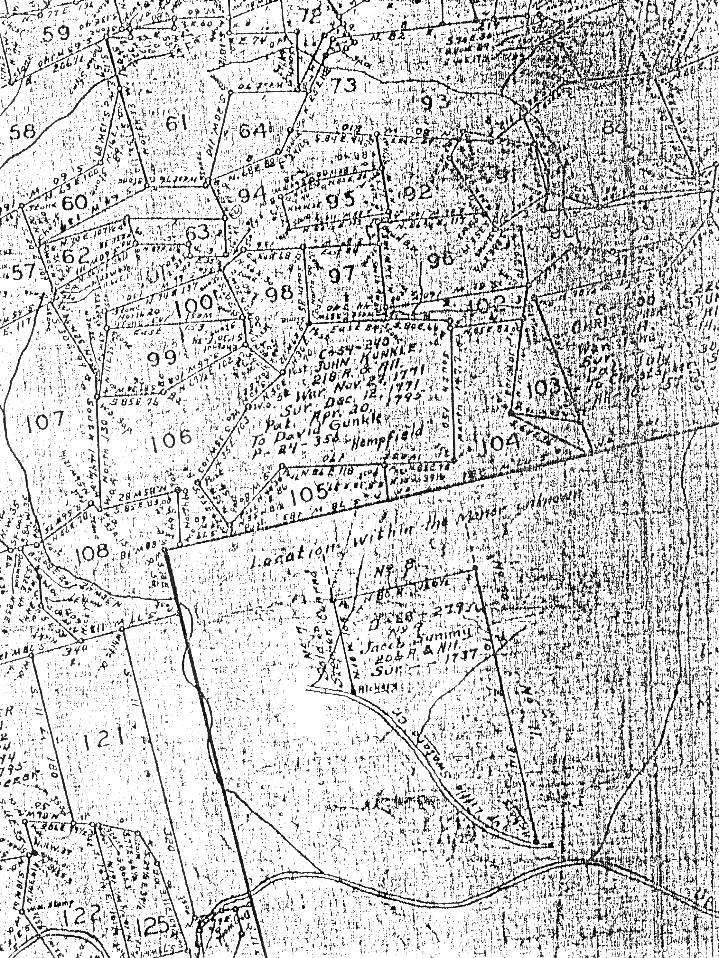

Figure 7 Partial Warrantee Map of Bethel Township
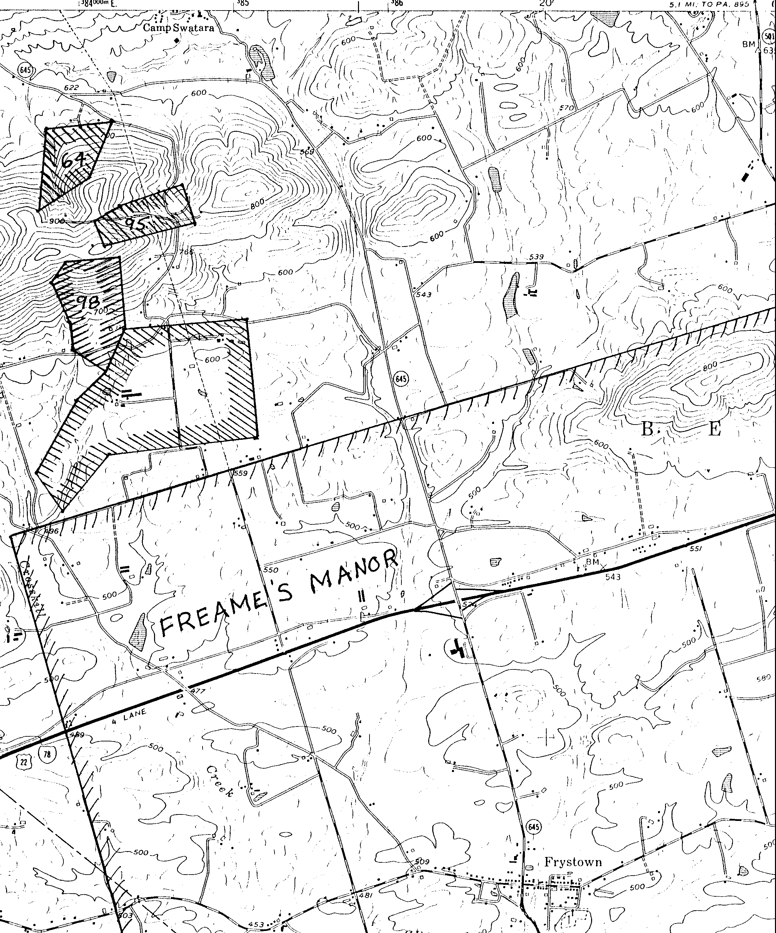

Figure 8 Location of Gunckel Land Parcels
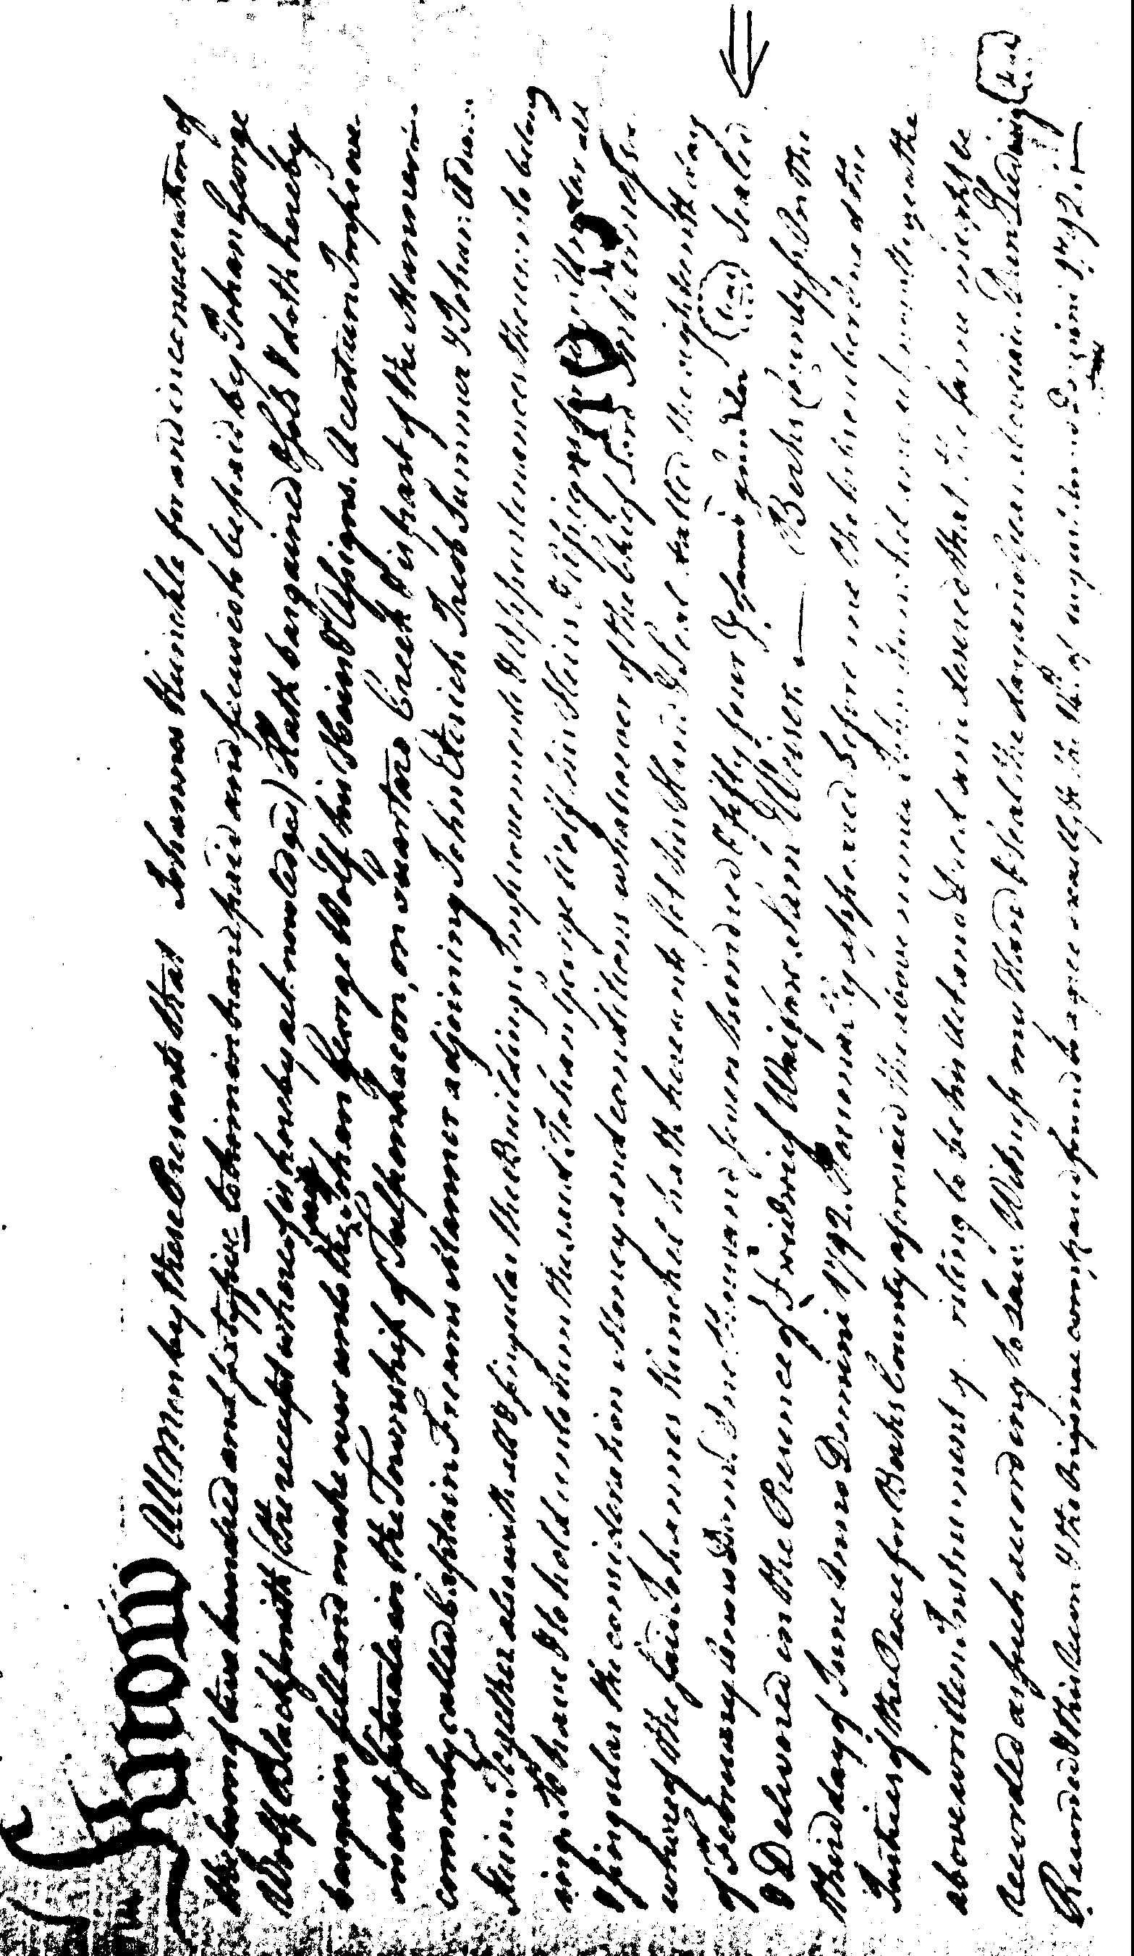

Figure 9 Deed of John Gunckel
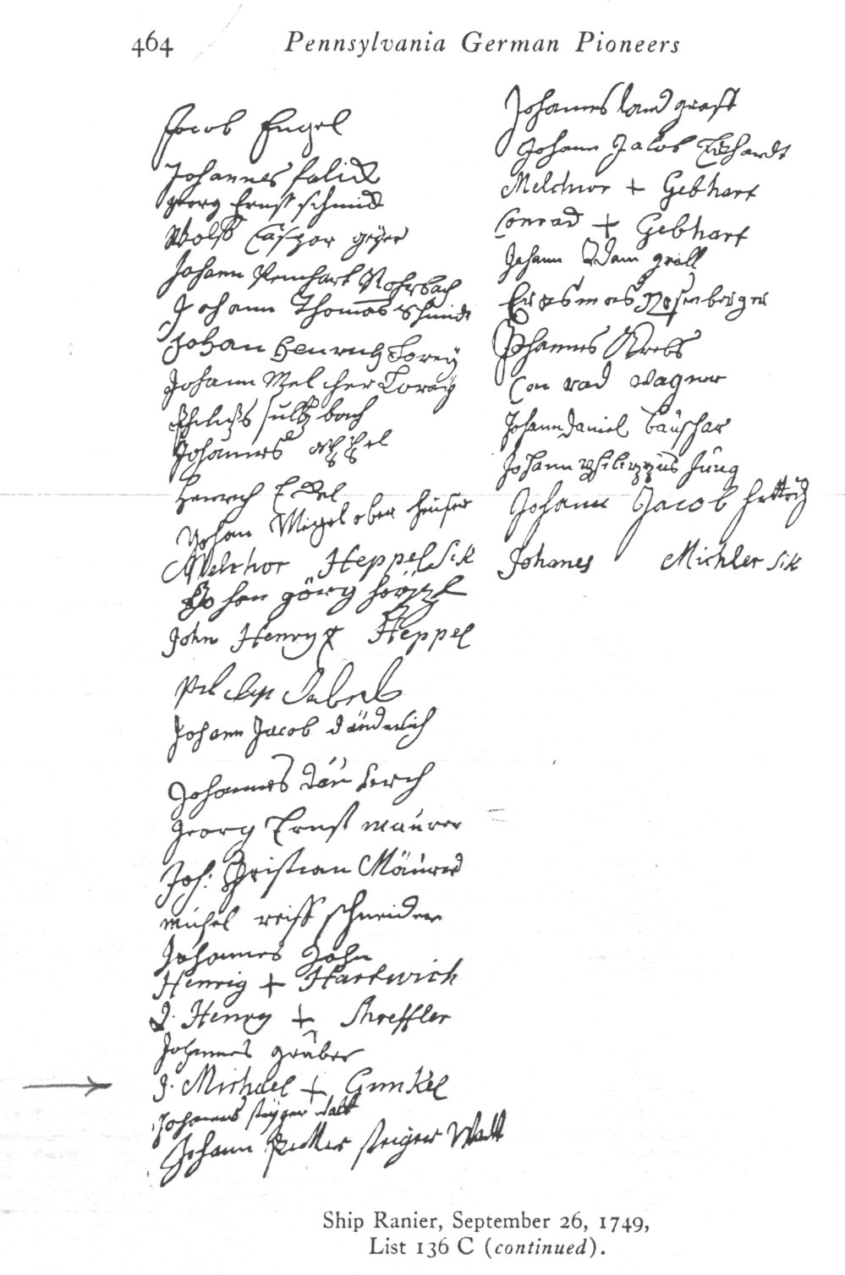

Figure 10 Ship Ranier, September 26, 1749, List 136C

JOHANNES GUNCKEL OF BETHEL TOWNSHIP

The key document identifying Johannes (John) Gunckel is his will. On March 11, 1785, John Gunckel Sr. of Bethel Township, Berks County prepared a will leaving his household effects to his wife and his estate in equal shares to his children John the eldest son, Jacob, Catherine wife of George Leonard Emmick, Michael, Anna Maria wife of Jacob Houtz, Daniel, Philip, and grandchildren John and Catherine, their father, Leonard, being deceased. John’s wife was to receive the interest from the sum of one hundred pounds of gold or silver money for life. His sons John and Daniel were named Executors (Wills B.429 and 3.239).
Daniel renounced the Executorship on 18 August 1795, because he had moved to Hains Township, Northumberland County. John appears to have died by that time, and Jacob became the Executor. (Adm 5.238). The will was filed 24 May 1796. Thus, Johannes likely died in 1794 or early 1795.

A significant question is: when did Johannes Gunckel arrive in America?

Of the approximately 30,000 names (only men were listed) of German immigrants entering through the port of Philadelphia from 1727 to 1775 listed by Hinke/Strassburger [8], there is only one person identified as Johannes Gunckel. He was a passenger on the ship, Queen Elizabeth, which arrived in Philadelphia on September 16, 1738 from Rotterdam via England. Her passenger list contained three Gunckel/Kunkels: Johannes (C) Kunkel, age 30, towards the beginning of the list; Johan George (X) Kunkel, age 19, about the middle of the list; and Johannes Gunckel, age 24, towards the end of the list. The first two signed their names with their mark, that is, they could not write their name. The third individual, Johannes Gunckel signed with his own signature.

This Johannes Gunckel could sign his own name. Further, his age and date of entry are consistent with the early records of Johannes Gunckel of Bethel Township, and he spelled his name including a “G” and a “c” (that is Gunckel rather than Gunkel or Kunkel).

Two signature specimens for the Johannes Gunckel of the ship Queen Elizabeth from the passenger lists are available from Henke/Strassburger [R8]. Further, three signature specimens of Johannes Gunckel of Bethel Township are also available. Johannes Gunckel signed his will on March 11, 1785. He also witnessed the will of Michael Grosman in 1755 and signed his bond on 12 August 1756. Another signature specimen for Johannes Gunckel is from the deed of 1754 shown in Figure 9. These signature specimens and the ones from the Queen Elizabeth passenger lists B and C are shown below.

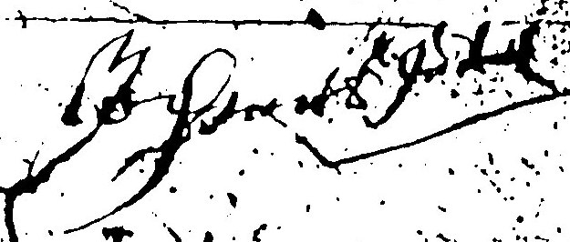

Will of Johannes Gunckel in 1785

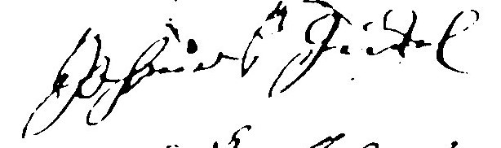

Bond of Michael Grossman in 1756

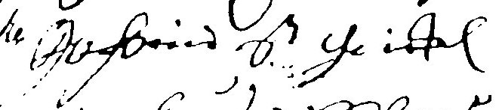
Will of Michael Grossman in 1755

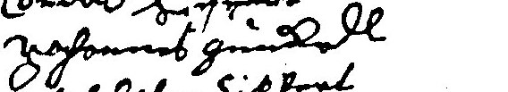

List B Queen Elizabeth in 1738

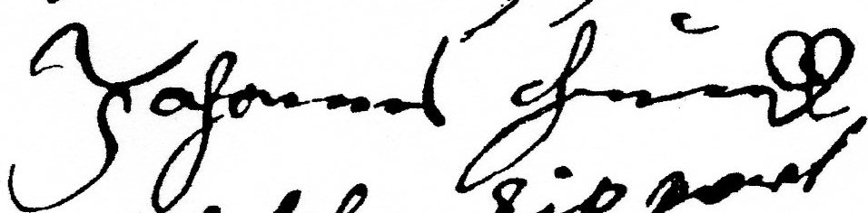

List C Queen Elizabeth in 1738

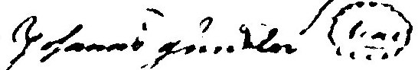

Deed of Johannes Kunckle in 1754

Figure 11 Signature Specimens for Johannes Gunckel

All of the signature specimens are generally similar except for a couple of features. The formation of “J” in the ship’s lists and the deed is more like a printed “J”, while in the other signatures it is more like a script “J”. The end of the stroke for the final “L” is upwards in the ship’s lists and the deed and is downwards for the other specimens. How meaningful these differences are is unknown.

Given the uniqueness of the name (spelled with a “G” and a “c”), the Johannes Gunckel who arrived on the Queen Elizabeth on September 16, 1738 is most likely the Johannes Gunckel of Bethel Township, Berks County, Pennsylvania. The home of this Johannes Gunckel in Germany is not known.

The children of Johannes (John) and their birth dates are listed below:
Name | Birth | Source
John | ABT 1742 | Estimate as being oldest child
Leonard | ABT 1744 | Estimate
Jacob | 28 Sep 1746 | St. Peter’s (Gunkle’s) Cemetery
Anna Catharine | 15 May 1749 | Trinity Tulpehocken Church Births
John Michael | 15 Apr 1751 | Trinity Tulpehocken Church Births
Maria Dorothy | 11 Jan 1754 | Trinity Tulpehocken Church Births
Anna Maria | 3 Sep 1763 | Houtz family records
Daniel | 22 Oct 1764 | Germantown, Ohio Records
Philip | 7 Apr 1766 | Germantown, Ohio Records

The ten-year gap between the births of Maria Dorothy and Anna Maria raises the possibility that Johannes may have had a first wife who died and he, then, took a second wife.

John Gunckel was not listed in the 1790 Federal Census for Bethel Township, although Daniel was. Jacob was listed in the 1790 Census for Pinegrove Township. No Gunckels are listed for Bethel Township in the 1800 Census through the 1840 Census.

CHILDREN OF JOHANNES GUNCKEL

JOHN GUNCKEL, son of Johannes
John Gunckel, the son of Johannes, is mentioned in his father’s will as the first listed child. In addition, he was deceased when his father’s will was proved.
In an action related to the death of John, Jr., on August 18, 1795, Catharine Gunckel, widow of John Gunkel late of Bethel Twp., Berks County, yeoman deceased, received from Jacob Gunkel and Daniel, two of the sons of John Gunkel, forty pounds as her dower rights according to a marriage contract (Deeds 15.545, 546 - Recorded June 6, 1797).
There are no church records indicating children of John, Jr. August 18, 1795 is also the day that Daniel, the son of John, Sr., renounced the executorship of his father’s will in favor of his brother Jacob. Thus it appears that Jacob and Daniel, sons of John, Sr., were settling the estate of their father and their brother John.
Possibly the marriage of John Kunchel and Catharine Schaif on December 27, 1785 at Christ Lutheran Tulpehocken Church is the marriage of John, Jr.

LEONARD GUNCKEL, son of Johannes
Leonard is mentioned in the will of Johannes Gunckel of Bethel Township. Johannes’ will was dated 11 March 1785 and proved on 24 May 1796 (Berks Co Wills B.429). It contains the following reference to Leonard: “...Bequeath unto all my children... and my grand children, John and Catharine, children of my son Leonard Gunckel.”.
Leonard is also mentioned in the will of Philip Lorentz Houtz of Bethel Township. Philip’s will was dated 17 May 1787 (Berks Co Wills). It contains the following reference to Leonard: “...So shall my son Wendle pay to my grand daughter Catharina Gunckel as soon as she is twenty-one years old, eighty pounds is gold or silver...further the one hundred pounds that I lent to my son-in-law Leonard Gunckel, I will that the same one hundred pounds with the interest my grand daughter Catharina Gunckel shall have when she is twenty one years old and these one hundred and eighty pounds the said Catharina Gunckel shall have of my estate and no more, at receiving this money she shall give a release to my estate...”
The wording in Philip Lorentz Houtz’s will suggest that the mother of the granddaughter Catherina and wife of Leonard is deceased.
The Orphan’s Court records for Lancaster County, Pennsylvania for Leonard Kunkle’s estate give his children as Catharine and John (11 December 1782), note that he owned two lots in Heidelberg Township, Lancaster County (27 April 1784) and give the age of his children as fourteen and eight (27 April 1784). The inventory for Leonard’s estate was prepared 9 March 1778 and filed 11 December 1782.
Signatures of the administrators of Leonard’s estate are shown in Figure 12. The signature of Leonard’s brother, Michael Gunckel, can be compared with the signature of Michael Gunkle on his will prepared twenty-six years later and shown in Figure 15. Except for the “G” and the spelling of Gunckel, there seems to be a great deal of similarity.
Deeds relating to Leonard include:
Deeds, Bk O, v 1, p 422, Recorded 4 June 1771 - On 25 April 1771, Wendel Shank and his wife Elizabeth sell lots eight and nine is the Town of Newberry to Lenhart Kunckle.
Deeds, bk S, v 1, p 536, Recorded 20 May 1776 - On 19 March 1776, Jacob Martin of Cocalico Township and his wife Elizabeth Martin sell 125 acres of land in Cocalico Township lying on Cocalico Creek to Leonard Kunkle of Heidelberg Township for the sum of 1300 pounds.
Deeds, bk AA, v 2, p 354, Recorded 28 September 1784 - On 2 June 1784, Rosina Kunkle, Michael Kunkle, and Jacob Miller, administrators of the estate of Leonard Kunkle, sell lots in the town of Newberry in Heidelberg Township to John Shultz.
The Houtz family history at the Lebanon County Historical Society states in part “...93) Anna Catherine, b. 6 Aug 1745, bpt. Christs Lutheran Tulpehocken Church, Berks Co., Pa.; m. John Leonard Gunckel (Kunkle, many spellings)...”.
Reference to Gunckels in the records of St. Paul’s (Klopp’s) Church of Bethel Township, Lebanon County include:
Parents | Child | Sponsors
Christian Hautz | Catharine | John Kunkel
and Barbara | born Aug 24, 1770 | and Catharine
 | bapt. Sep 30, 1770
John Gunkel | Maria Catharine | George Schaefer &
and Catharine | born Feb 22, 1770 | Maria Catharine
 | bapt. Jan 13
Balthasar Leseh | Anna Catharine | John Gunckel and
and Christiana | born Apr 10, 1774 | Anna Catharine

The John and Catharine mentioned above are likely John Leonard Gunckel and Anna Catharine Houtz.
The Trinity Tulpehocken Reformed Church records include a marriage of Leonard Gunckel to Rosina Meylin (Martin?) on 16 January 1775.
The Lancaster County Historical Society [R16 vXXI p70] states that in 1782, Rosina Gundle is listed as one of twenty-five petitioners for tax relief after their crops were ruined in a hail storm.
On March 12, 1798, Christian Honty, Barbara his wife, Samuel Royer and Elizabeth his wife, Baltzer Hontz and Elizabeth his wife of Berks County, John Gunkle and Catharine his wife, Jacob Hontz and Annemarie (Gunckel) his wife, John Hontz and Catharine his wife of the County of Dauphin appoint Wendle Hontz to settle their father’s estate, Lawrence Hontz, deceased, which included land in Bethel Township (Berks Co Deeds 16.128). -- The John Gunkle listed here is generally felt to be John, the son of John, Sr. However, the will of John, the son, was probated three years earlier. Further this John Gunkle is shown as being from Dauphin County, whereas John, the son, lived in Bethel Township, Berks County. Annemarie Gunckel Hontz is the daughter of John, Sr.
A scenario that fits the above facts is: John Leonard Gunckel marries Anna Catharine Houtz about 1768. They have a daughter, Maria Catharine, 22 February 1770. Catharine Houtz Gunckel dies about 1774, and Leonard remarries Rosina Martin on 16 January 1775. Catharine Gunckel marries John Markle. After the death of her grandfather, Philip Lorentz Houtz, Catharine Gunckel Merkle and her husband, John, file for her share of her grandfather’s estate.
Long [R39] indicates that a history of Germantown, Ohio states the Germantown was named after Leonard, who was one of the 152 men killed in the Battle of Germantown in October, 1777.
Egle [R13 4th Series vI p105] identifies a Captain Lorenz Kunkel of the Pennsylvania militia while giving an account of George and John Sauer in the Revolutionary War. The account reads “...In the following autumn (1777) it fell to his lot to be drawn for a two months’ tour in the Pennsylvania militia under Captain Lorenz Kunkel. They marched to Rising Sun, north of Philadelphia, where they were commanded by Colonel Miller. They fired several cannon shot at the British in the city and then retreated through Germantown, in which locality they remained upon the banks of the river until their term of service had expired...”

JACOB GUNKLE, son of Johannes

One of the first known settlers in Pine Grove area after the French and Indian War, 1689-1763, Great Britain Battles France over unsettled territories in N. America, was Jacob Gunkel. He located on the site of the Eagle Hotel in 1771. Here he laid claim to a tract of two hundred acres of land which he subsequently purchased from the John and Richard Penn, proprietors of the Colony of Pennsylvania which included the site of the present borough of Pine Grove. The convergence of several roads on Gunkel’s plantation made it an excellent location for a tavern and soon after he purchased the land he erected a log building, Gunkel’s Tavern, which he kept till 1810 and then he removed to a farm about a mile south from the borough were he died in 1813. His property was located next to the property of his daughter Eva and husband Johannes Loffler.

The will of Jacob Gunckel of Pinegrove Township, dated May 16, 1812 and recorded September 15, 1813, is recorded in the Schuylkill County Wills, book 1, page 9. The will leaves his estate to his wife, Susannah, to his children, Jacob, John, and Catharine, wife of Henry Biegler and to “the children of my daughter Eve, now wife of John Loffler”. The wording of the bequest to his daughter’s children is unusual, in that it suggests that Eve is alive, even though she is not included in the will.
Cemetery records for St. Peter’s (Gunkle’s) Union Church of Pinegrove Township, Schuylkill County includes the following reference:
Jacob Gunkel; born September 28, 1746; died September 2, 1813
Eva Lefler; born Mar 25, 1809; died Jun 21, 1841
Johannes Leffler; born Jul 5, 1764; died Aug 16, 1849; son of Gottfried, Mahanoy Twp., Northumberland Co.
Eva Lofler (nee Kunkle); w/John; died Jan 26, 1857; 83y 11m 15d
Gunkel’s Cemetery, located across the street form St. Peter’s Lutheran Church contains a memorial plaque that reads:
Site of the 1st Reformed-Lutheran Church
1782-1817
Donated by Jacob & Susanna Gunkel
Federal Census records for Gunkle/Kunkels during this time period are listed below. (See the Appendix for an explanation on how to read the Census information.) At that time, Pine Grove Township was part of Berks County.

FEDERAL CENSUS OF 1790 FOR PENNSYLVANIA
(Name, males over 16, males under 16, females, county, township)
Jacob Gunkel, 3,1,2, Berks, Pinegrove
Jacob Gunkel Jr., 1,2,3, Berks, Pinegrove
FEDERAL CENSUS OF 1800 FOR PENNSYLVANIA
(Name, males under 10, males 10 to 16, males 16 to 26, males 26 to 45,
males over 45, females under 10, females 10 to 16, females 16 to 26,
females 26 to 45, females over 45, county, township)
Jacob Kunkle, 00001-00001, Berks, Pinegrove
John Kunkle, 20010-00100, Berks, Pinegrove
FEDERAL CENSUS OF 1810 FOR PENNSYLVANIA
Jacob Gunkle, 00001-00001, Berks, Pinegrove
John Gunkle, 21010-20010, Berks, Pinegrove

These appear to be Jacob, Sr. in 1790, 1800, and 1810; his son Jacob, Jr. in 1790; and his son John in 1800 and 1810. No Gunkles or Kunkels are listed in the 1820, 1830, and 1840 Census for Pine Grove Township. The 1790 Census indicates that Jacob had three sons at home, two born before 1774, and one after 1774; as well as one daughter born after 1774. By 1800, they all had left home.
Jacob, Jr. is shown in the 1790 with four young children, two sons and two daughters, all born after 1774. Jacob, Jr. is not listed again in the Pine Grove Census records.
John, the son of Jacob, Sr., is the John Gunkle who moved to Butler County, Ohio and is listed there in the 1820 Census. He married Catharine Beichler.
It is likely the Jacob Gunkle, Sr. of Pinegrove Township is the son of Johannes Gunckel of Bethel Township: his birth date is in the right time frame and he lived close enough to be named administrator of his father’s estate. The signature of Jacob Gunkle taken from the estate papers of his father is shown in Figure 13.
Tax, census, and land records for Gunckels in Pinegrove Township are abstracted below.
PINEGROVE TOWNSHIP, BERKS COUNTY TAX ROLLS
(year, name, acres/tax)
1779 Michael Gunkle, 130a
Jacob Gunkle, 200a
1780 Jacob Gunkle, 200a
1781 Jacob Gunkle, 200a
1784 Jacob Gunkle, 50a
1785 Jacob Gunkle, 0.11.0 tax

Michael Gunkle is likely the son of Johannes Gunckel of Bethel Township.
Berks County deed actions relating to Jacob Gunkle include:
On January 10, 1807 Jacob Gunkle sells to Baltzer Montz of Pinegrove Township land containing 44 acres for $300 (Deeds 22.186).
On March 4, 1809, Jacob Gunckel of Pinegrove Township, Berks County, yeoman, and Susannah his wife sell to John Gunckel for 450 pounds land in Pinegrove Township containing 255 acres (Deeds 24.486).
On May 21, 1810, Jacob Gunckel of Pinegrove Township, Berks County, yeoman, and Susannah his wife sell to John Gunckel yeoman for 255 pounds land containing 235 acres, part of the larger tract of land called “Gunckels Farm” (Deeds 24.488).
References to Gunckels in the records of St. Paul’s (Klopp’s) Church of Bethel Township, Lebanon County include:
Parents | Child | Sponsors
Jacob Gunckel | John | Parents
and Margaret | born Jun 21, 1775

Records of St. Jacob’s Church in Pinegrove Township, Schuylkill County include the following references to Gunkels:
Parents | Child
Jacob Kunkel | Johann Adam
and Catharina | bapt. Jan 13, 1806

Johannes Gunkel and Catharina were sponsors frequently 1799 to 1809
Jacob Kunkel and Susanna were sponsors in 1804
Tombstone inscription for Jacob Kunkel: born Jan 27, 1797; died Jan 22, 1805
Montgomery [R18, p475] gives the election district voting in Pinegrove Township in 1797 at the public house of Jacob Gunckel. Montgomery [R18, p1194] also lists a Jacob Gunckle and a John Gunckle among the tax payers at the first levy in Norwegian Township in 1802. Mayhill [R3 p166] shows a Jacob Gunklee of Berks County taking the oath of allegiance on June 30, 1778.
A possible scenario consistent with the above information is:
Jacob Gunkle, Sr. - b. Sep 14, 1746 d. Sep 2, 1813
Wife - Margaret
Jacob, Jr. - born ABT 1763
Catharine – born ABT 1764, married Henry Biegler
Wife - Susannah
Eve – born 11 Feb 1773, married John Leffler
John - born 21 June 1775, married Catharine Biechler

In the Census of 1800, John Leffler, John Biegler, Henry Biegler, Jacob Kunkle, and John Kunkle are listed within the space of nine entries. Thus, they probably lived close to each other. There were no Bieglers or Lefflers listed in Pine Grove Township is 1790.
John Gunkle married a Catharine Beichler (Biegler). Deeds recorded in Berks County show an action relating to John: On February 14, 1805, Catharine Biechler, intermarried with John Gunckel, appoints an attorney to handle her share of her father’s, John Biechler, estate in Pinegrove Township, Berks County (Deeds 22.12).
Census records for the Pine Grove Beichlers (Bieglers) are shown below. The Census has Biegler and Biechler used in alternate Census. This is probably because of the phonetic transcriptions by different census takers.
The four Biegler families listed in 1800 appear to be two generations: 1) John, the elder, his wife, and Magdalena all born before 1765 and 2) John A. and Henry, both born after 1765. John, the elder, died in 1805, so the 1810 Census only shows John, the younger, with his mother living with him. The 1800 Census shows one child living at home with John, the elder, a daughter born after 1764. This could be Catharine, who was born in 1777.
The Henry Beigler shown in the 1800 and 1810 Census is likely the husband of Catharine Gunkle, the daughter of Jacob Gunkle, Sr. The Henry Beigler is the 1820 and 1830 appears to be too young to be the husband of Catharine.
The Census information suggests that there were two Biegler families is Pine Grove Township: descendants of John Biegler and descendants of Magdalena Biegler. However, John and Magdalena may have been brother and sister-in-law.

1800 FEDERAL CENSUS FOR PINEGROVE TOWNSHIP
Name, Age Distribution
John A. Beigler 20110-00010
Magdalena Biegler 00100-00201
John Biegler 00001-00101
Henry Biegler 31010-20010
1810 FEDERAL CENSUS FOR PINEGROVE TOWNSHIP
Name, Age Distribution
Henry Biegler 41201-12001
John Beigler 10010-30011
Adam Beigler 01110-31010
1820 FEDERAL CENSUS FOR PINEGROVE TOWNSHIP
Name, Age Distribution
Henry Beichler 100010-30010
John Beichler 010010-32010
Magdalena Beichler 000000-00001
Adam Beichler 002010-30201
1830 FEDERAL CENSUS FOR PINEGROVE TOWNSHIP
Name, Age Distribution
John Bichler, Sr 0010201000-0112001000
Henry Bichler 1110001000-0101010000
1840 FEDERAL CENSUS FOR PINEGROVE TOWNSHIP
Name, Age Distribution
Widow Biegler 0000000000-0000000010
John Biegler 0000000100-0001000100
John Biegler, Jr. 1200010000-0000100000
1850 FEDERAL CENSUS FOR PINEGROVE TOWNSHIP
Name, Age, Birth Place
John Bechler, age 45, born PA
Sarah Bechler, age 44, born PA
Isaac Bechler, age 18, born PA
Edward Bechler, age 15, born PA
Dennis Bechler, age 10, born PA
John Bechler, age 3, born PA
Catharine Bechler, age 68, born PA

Rock [37] has developed information on the Leffler family. Eve Gunkle, daughter of Jacob, Sr. married Johannes (John) Leffleer. John Leffler’s will reads: …the 7th December 1841 According to the inheritance lay of Anvbeu I leave my body to the earth, in praising God, I leave to my inheritance children and surviving wife with the power of executioner of my last will. In case of my wife’s inability to be my will’s executioner I appoint herewith Jacob Lofler and his inherents, Johannes Lofler, Wilhelm Lofler, Michael Lofler, Jourdon Lofler, Philieb Lofler, my daughter Salomn Lofler, Eva is dead, Enisabet Lofler, …equal inheritants, except for my daughter Salomn shall be provided with some land and a homestead for her own as long as she lives and no inheritant shall be able to take anything away from her. After her death everything she leaves behind shall go to the inheritant of her choosing. Everything shall be sold that’s carrying my name, my widow knows best the value of the estate and also to whom it should be sold, as I have instructed her to do. I decree my son Jonathan Lofler or in his absence my son in law Jacob Ellenbaum executioners. This is my will and testament. Jahannes Lofler as witness: Martin Gauss
Of all the children, only Salome is singled out to receive land and a homestead. This is probably because she was single and living at home. Her father was providing for her future support. The 1840 Census shows one daughter living at home, while the other children have left home. The daughter at home is likely Salome.
The end of the will refers to “my son Jonathan Lofler”, but the list of children earlier in the will does not include Jonathan. The list of children does include a Jourdon. However, Jourdan can not be found in the church, land, and Census records. Further, the Census records indicate only six male children for John Leffler. A possible explanation is that Jourdan is a transcription error. Presumably, the original will was handwritten in German and transcribed into the public record. This transcription process could have mistakenly replaced the word Jonathan with Jourdon. Both names start with a “Jo”. A poorly written “n” can appear like a “u” and a poorly written “at” could appear like a “d”. Replacing Jourdon with Jonathan in the list of children gives six male children for John Leffler, which is consistent with the Census records and explains why Jourdon is not mentioned in the church, land, and Census records.
John and Eve had another daughter, Regina, who was not mentioned in the will. St Jacob’s Church records give a date of birth for Regina of 28 February 1806 and a date of death of 25 April 1808. Thus, Regina was not alive at the time of the will, nor was she alive during any census year, so she would not show in either record.
Birth dates for the children of Eve and John Leffler are:
Jacob b. 27 Jun 1792 d. 8 Oct 1870
John b. ABT 1794
Salome b. ABT 1800
Eva b. 25 Mar 1802 d. 21 Jun 1841
Elizabeth b. 4 Feb 1804
Regina b. 28 Feb 1806 d. 25 Apr 1808
William b 17 Sep 1807
Michael b. 11 Jun 1809
Jonathan b. ABT 1813
Philip b. ABT 1817
These birth dates are consistent with the Census records listed below for John and Eve.
Eve’s husband, John Loeffler, and their children are mentioned in the 1800 and subsequent Census records. All Pine Grove Loefflers appear to be the family of John and Eve. These records through 1850 are listed below.
1800 FEDERAL CENSUS FOR PINEGROVE TOWNSHIP
Name, Age Distribution
John Leffler 20010-10010
1810 FEDERAL CENSUS FOR PINEGROVE TOWNSHIP
Name, Age Distribution
John Leffler 21110-21010
1820 FEDERAL CENSUS FOR PINEGROVE TOWNSHIP
Name, Age Distribution
John Leffler 220001-00301
Jacob Leffler 200010-00100
1830 FEDERAL CENSUS FOR PINEGROVE TOWNSHIP
Name, Age Distribution
John Leffler 0011110100-0010100010
Jacob Leffler 2011010000-1000010000
William Leffler 1000100000-2002000000
1840 FEDERAL CENSUS FOR PINEGROVE TOWNSHIP
Name, Age Distribution
John Leffler 0000000001-0000010010
William Leffler 0100010000-1200000000
John Leffler 1000100000-0010111000
Jona Leffler 2000100000-1000100000
1850 FEDERAL CENSUS FOR PINEGROVE TOWNSHIP
Name, Age, Birth Place
William Lefler, age 40, born PA
Eve, age 19, born PA
Elizabeth, age 16, born PA
Filla, age 13, born PA
Jane Gungle, age 77, born PA
John Lefler, age 38, born PA
Mary, age 37, born PA
Daniel, 17, born PA
George, 11, born PA
Catharine, age 9, born PA
Jonathan Lefler, age 29, born PA
Lydia, age 25, born PA
Lewis, age 15, born PA
Aaron, age 12, born PA
Maria, age 9, born PA
Jonathan, age 7, born PA
Thomas, age 5, born PA
Susanna, age 3, born PA
Lydia, age 4/12, born PA
Kate Lefler, age 18, born PA
John Lefler, age 28, born PA
Pracilla, age 28, born PA
Simon, age 10, born PA
Samuel, age 9, born PA
William, age 7, born PA
Cyrus, age 4, born PA
Reuben, age 6/12, born PA
The 1820 Census indicates that the two oldest sons of John Leffler have left home. One son, Jacob, stayed in Pine Grove and is also listed in the 1820 Pine Grove Census. The other son, John, Jr., apparently left Pine Grove. However, the 1830 Census suggests that John, Jr. may have returned home, but had left again by the time of the 1840 Census.
The 1830 Census indicates that John Leffler’s son William had left home but stayed in Pine Grove. William is listed in the 1830 Pine Grove Census.
The 1840 Census indicates that all of John Leffler’s children had left home, except for one daughter. John Leffler’s sons, Philip, Michael, and John, left Pine Grove, while his sons, Jonathan and William, remained in Pine Grove. Two John Lefflers are listed in the 1840 Census. The younger John is possibly the son of Jacob Leffler. It also appears that John, the younger, might have had two aunts living with him for the 1840 Census.
The 1850 Census includes William and Jonathan, sons of John and Eve Leffler. William Leffler’s first wife had died by 1850, so the Jane Gungle, age 77, shown living with William in 1850, is probably an aunt who is keeping house. Her age suggests that she might be the wife of Jacob Gunkle, Jr., the son of Jacob Gunkle, Sr.
If one accepts the birth dates for Eva and Elizabeth and accepts that Salome was the daughter who stayed home, then the Census data is inconsistent for Salome. The 1810 Census for John Leffler shows two daughters born between 1800 and 1810 and one daughter, presumably Salome, born between 1794 and 1800. The 1820 Census for John Leffler shows three daughters born between 1794 and 1804. The 1840 Census for John Leffler shows one daughter at home, Salome, born between 1800 and 1810.
Thus, the 1810 Census for John Leffler suggests that Salome was born in before 1800 and the 1840 Census for John Leffler shows the daughter at home, Salome, being born in 1800 or later. If Salome was born in 1800, then the inconsistency might be due the vagaries in the date the Census was taken.
Philip Leffler is show in the 1840 through 1880 Census records, which are summarized below:
Year Age Location
1840 between 20 & 30 Manhein, Schuykill Co, PA
1850 33 Schuykill Haven, Schuykill Co, PA
1860 42 Washington Twsp, Tippecanoe Co, IN
1870 53 Americus, Tippecanoe Co, IN
1880 64 Americus, Tippecanoe Co, IN
Jonathan Leffler is show in the 1840 through 1880 Census records for Pine Grove. The age related information from these Census records is:
Year Age
1840 between 20 & 30
1850 29
1860 49
1870 56
1880 67
The 1850 age is most likely in error, as his oldest child was age fifteen. That would make Jonathan age fourteen when his child was born.
It appears that John Leffler and Michael Leffler, sons of Eve and John Leffler, moved to Jackson Township, Lebanon County, Pennsylvania and are found in the Census records for Jackson Township. These records are summarized below:
Name Year Age
John 1840 between 40 & 50
John 1850 49
John 1860 65
Michael 1850 40
Michael 1860 51
Michael 1870 61

MICHAEL GUNKLE, son of Johannes
The Berks County deed records indicate the Michael was living in Philadelphia in the mid 1780’s. The 1790 Census indicated that he still lived there in 1790 as a grocer with his wife, one daughter, and one son under the age of sixteen.
The Chester County Historical Society has several papers from Michael’s estate. They include an advertising flyer from Philadelphia shown in Figure 14. Copies of Michael’s signature from his will and a deed are shown in Figure 15.
Berks County deed actions relating to Michael Gunkle include:
Deeds 19.464 - Recorded March 8, 1803 - On October 28, 1784, Nathan Sellers of Philadelphia, for five shillings, sold to Michael Gunckel 400 acres of land on the North branch of Swatara Creek and Beaver Creek that he obtained by a Warrant October 1, 1784.
On December 10, 1785 Michael Gunckle, for two hundred pounds, sold the above land to John Sheaffer of Philadelphia.
Deeds 10.274,275 - Recorded December 28, 1787 - On October 28, 1784, for five shillings, David Sellers of Philadelphia sold to Michael Gunckle of Philadelphia 400 acres of land that he obtained by a Warrant dated October 1, 1784. The land adjoins that of Michael Gunckle in Berks County.
On December 10, 1785, for 200 pounds, Michael Gunckle sold to John Shaeffer the above 400 acres.
Deeds 10.275 - Recorded December 28, 1787 - On February 7, 1786, John Schaffer and Jacob Kickants sold the Presburgh Estate on the Swatara Creek in Berks County adjoining land of Michael Gunckle and the Gottenburgh Estate over the Blue Mountains in Berks County adjoining land of Christian Gunckle.
Deeds 10.41,42 - Recorded Feb. 24, 1787 - On December 14, 1784, for five shillings, Benjamin Miller sold to Michael Kunckle of Philadelphia 400 acres of land that he obtained by a Warrant dated November 5, 1784. The land adjoins that of Lorenze Howitz, John Gunckle, and George Stump in Bethel Township, Berks County.
On February 7, 1787, Michael Gunckle of Philadelphia, Merchant, for 34 pounds and 10 shillings sold to Ennion Williams, Merchant, of Bethel Township in Berks County the above 400 acres of land.
The “History of Centre and Clinton Counties” states as follows: “David Shakespeare conveyed the Frederick Uberlin land to Michael Gunckel 30 December, 1794”
Federal Census records for Michael include:
FEDERAL CENSUS OF 1790 FOR PENNSYLVANIA
(Name, males over 16, males under 16, females, township, county)
Michael Gunkle, 1,2,2, Grocer, City of Philidelphia

The following material is taken from the HISTORY OF CHESTER COUNTY, PA by Futhey and Cope published in 1881 [R19].
Gunkle, Michael, about the beginning of the last decade of the last century, come from Philadelphia (where he was a mill burr-maker) to East Whiteland township. Here he purchased a thousand acres of land, cleared off the timber, put up many buildings, two grist-mills, a saw-mill, and made other valuable improvements. He married Catharine Miller, born at Millbaugh, in Lebanon County, where her father owned one of the oldest mills in the State, and once used as a fort for protecting the settlers from Indians. Catharine (Miller) Gunkle’s paternal grandmother was a Miss Pechin, a Huguenot, who fled from France to escape persecutions, and married Martin Miller, as emigrant from Germany. Michael Gunkle left four sons, - John, Michael, William, and Daniel. His real estate was divided into three shares, Michael getting his proportion in other property. The Gunkle family is of German extraction, and Michael had two brothers, who settled in Ohio, from one of whom is descended ex-Congressman L. B. Gunkle, of Dayton, in that State. Michael Gunkle was a man of wonderful energy, an indomitable will, manifested great public spirit, and was highly esteemed.

DANIEL GUNCKEL, son of Johannes
Daniel Gunckel probably lived in Bethel Township in 1785 when his father wrote his will. Daniel then moved to Hains Township, Northumberland County by 1795 when he renounced the executorship. Next he moved to Centre County with his brother Philip, living there from around 1800 to 1811. He then moved to German Township, Montgomery County, Ohio.
Federal Census records for Daniel include:
FEDERAL CENSUS OF 1790 FOR PENNSYLVANIA
(Name, males over 16, males under 16, females, township, county)
Daniel Gunkel, 2,1,4, Bethel, Berks

The following material is taken from Hentz’s [R20 pp 73-74] history of the Germantown area.
Daniel Gunckel was a brother of Philip and came to the Twin Valley in the year 1811. This gentleman is universally well spoken of, but did not attain to the prominence of his brother Philip. He was a man of rather retired disposition and quiet habits of life. He built and operated a fulling mill on Mud Lick, where at present stands the distillery of David Rohrer. He was a member of the Reformed Church, but changed his church relations whilst here by uniting with the United Brethren.

PHILIP GUNCKEL, son of Johannes
Philip was raised in Bethel Township, Berks County. He moved to Centre County, PA and lived there until 1803, when he moved to German Township, Montgomery County, Ohio.
Linn in HISTORY OF CENTRE AND CINTON COUNTIES, PENNSYLVANIA published in 1883 [R21 p380] gives the following information.
MILLHEIM - This town was laid out by Philip Gunkle, who, Nov. 1, 1797, bought eight acres and twenty-six perches of the Frederick Uberlin warrantee of Michael Gunkle, and laid out part of the town thereon. The main portion is upon the John Cash warrant, which was sold by David Shakespeare to Michael Gunkle, also Dec. 3, 1794. The western end is on the John Harris warrant for twenty-eight acres and one hundred and fifteen perches. A deed was executed by Adam Kreamer to Philip Gunkle, Feb 21, 1800. At the time (1798) there were two mills, - the old Hubler mill, which stood near D. A. Musser’s present residence, and the Gunkle mill, site of D. A. Musser’s mill. This fact suggested the name Millhiem (“home of the mills”).
The following material is taken from Hentz’s [R20 pp 68-73] history of the Germantown area.
Philip Gunckel, in his day more familiarly known as Judge Gunckel, was a native of Berks County, Pennsylvania. A few years previous to his removal to Ohio he went to Center County with his family, to reside there. It was from here that he immigrated to the Twin Valley. He was then in his thirty-ninth year, and had a wife and several children. He was a man of intelligence, enterprise, and activity, of clear foresight, and shrewd business capacity. He brought some money with him to this State, which he invested very judiciously, and by means of which he laid the foundation for future wealth. The first tract of land which he secured he purchased of James Hatfield and Robert Hardin. For this, though but little of it was under cultivation at the time, he paid at the rate of ten dollars per acre, which may then have seemed a high price. But he saw the advantages of the situation. He knew then that right here was the site for the future town of this Valley. He began to improve it by building on it a mill. This became the nucleus for the town. It attracted mechanics and trades people, and when a number of them had permanently established themselves, he concluded to layout his tract of land into a town. The mill which Mr. Gunckel erected was begun in 1805 and finished in 1806. It was the first and only mill for many years in a district of many miles extent, and hence was largely patronized. And though not erected from philanthropic motives, yet thereby Mr. Gunckel became a benefactor to the community in which he lived, furnishing them with an invaluable convenience. By means of the income derived from this mill, the proceeds realized from the sale of town lots, and from other good investments, he rapidly grew in wealth and accumulated a large amount of property, so that in his day he was the richest man in the Twin Valley. His talents and executive ability soon came to be recognized not only by the people of his township, but by the citizens of the county of Montgomery. As a consequence he was often called to hold public office. For a number of years he served his county as Associate Judge of the Court of Common Pleas. He was also chosen a delegate to one of the constitutional conventions of the State, and served one term as representative in the State Legislature. In all these positions he acquitted himself with honor to himself and to his constituents. He was, moreover, a leader in all the important public movements for the improvement of his township and county. Many of these were suggested by him, and by the aid of his influence and co-operation were brought to a successful issue.
Mr. Gunckel had enjoyed no special educational facilities in his youth. What he was he had made himself by force of will and close application of business. Providence had bestowed on him a sound body and a vigorous mind, and of these he made the best possible use which his circumstances permitted him. He was not a man of idle habits or despondent disposition, but on the contrary, of indomitable perseverance and industry, courage, and cheerfulness.
As a citizen and public official Mr. Gunckel has done more than any other man of his time in his community, to promote the interests and secure the prosperity of his section of country. For this, and many other reasons, he is deserving of the first place among the Pioneers of the Twin Valley. The remembrance of his name and achievements is, therefore, not to be suffered to perish, but ought to be cherished and perpetuated by and among the people who dwell in the Valley of the Twins.
Mr. Gunckel was a communicant member of the Reformed Church, to which his descendants still largely adhere. But being the proprietor of the town, and moved by impulses of general benevolence, he also favored and aided other churches. He was married thrice, but left no issue except by his first wife. This lady’s name was Catharine Schaeffer, daughter of the Mrs. Schaeffer whose biography is given on a subsequent page. She was the mother of eight children. Of these, John, Michael, Catharine, Philip, Jacob and Sarah, were born in Pennsylvania, whilst David and Elizabeth were born in Ohio. Catharine became the wife of Lewis Shuey. Sarah was married to Henry Zeller, and Elizabeth to Dr. C. G. Espich. The most prominent among his descendents, bearing his name are, William Gunckel, banker, and Lewis B. Gunckel, attorney and ex-member of Congress, both of whom are residents of Dayton, Ohio.
Having been born in Tolpehocken Township, Berks County, Pennsylvania, on the 7th day of April, 1766 and having died in Germantown, Ohio, on the 24th day of May, 1848, Mr. Philip Gunckel attained to the age of 82 years, and 17 days. His wife Catharine, born in the same locality on the 12th of July, 1766 died August 2, 1836, at the age of 70 years and 20 days. The earthly remains of both, having been buried in the Lutheran graveyard in Germantown, were later exhumed and re-interred in the Germantown cemetery, where their resting place is marked by a marble monument.”
The signatures of Philip taken from two letters that he wrote to his brother Michael are shown in Figure 16.
Philip Gunckel’s will was dated January 3, 1847 and recorded June 6, 1848 (Montgomery Co., Ohio Probate Records). The will lists his heirs as: John; Jacob; Daniel; Barbara Gunckel, wife of Michael; Mary E. Gunckel, wife of Philip; Sarah, wife of Jacob Wesco; Elizabeth, wife of C. G. Espich; and Catharine.
In an action filed 18 July 1848 [R22] to prove Philip’s will, the following heirs were identified: 1. PHILIP & wife Mary Elizabeth & their children , William F. of Butler Co, OH, Catherine w/o Andrew Emrick of Preble Co, OH, Albert, Mary Ann w/o Henry Duckwald, Elizabeth w/o William A Shuey, Philip W., Charles, Margaret Jane, Ellen Louisa, & infant unnamed last all minors. 2. CATHERINE w/o Lewis Shuey, of Mont. Co, OH. 3. Elizabeth w/o Christian G. Espich - their children - Orange R. of Mont Co, OH, Catharine Elizabeth w/o James R. Lowder of Butler Co, OH. 4. MICHAEL & wife Barbara - their children- George W., Henry S., Michael S., Lewis B., Elizabeth w/o Daniel J. Rowe, Catherine w/o Edward Weakley of Clark Co, OH. 5. JACOB. 6. DANIEL. 7. Sarah w/o Jacob Wesco of Grant Co, IN, their children - Henry & Daniel Sellers, Catharine w/o Samuel Blimm of Grant Co, IN, Jacob Zeller of Preble Co, OH, Adam Zeller of Mont. Co, OH. 8. JOHN P. dec’d, his children John of Bluntsville, IN, David, Philip, Jacob, Aaron of Wayne Co, IN, Catharine w/o George Pierce, Mary w/o John Vinsonhaler of Bluntsville, IN, Margaret w/o Thomas Mayhard of Butler Co, OH, Sarah w/o William Manfield of Butler Co, OH, Mahalla w/o William Thompson, & Elizabeth Ann w/o Milton Henton both of Cincinnati, OH. Will left 1/7 share to children & their heirs except Catherine w/o Lewis Shuey.

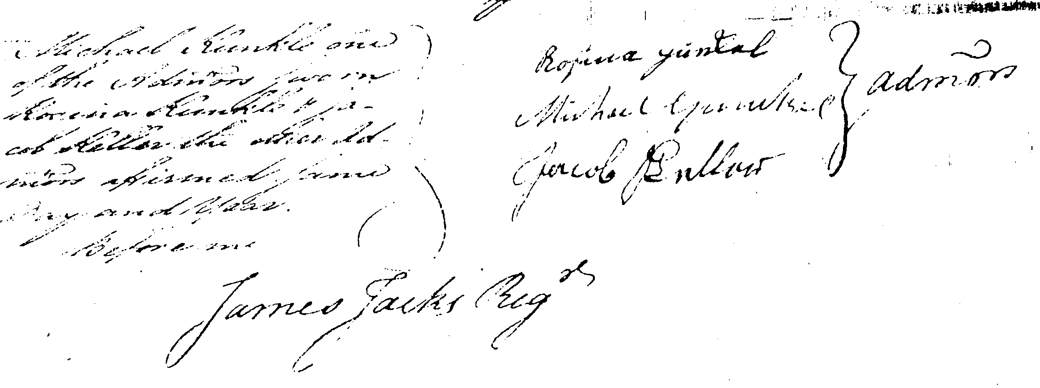

Figure 12 Administrators of the Estate of Leonard Gunckel

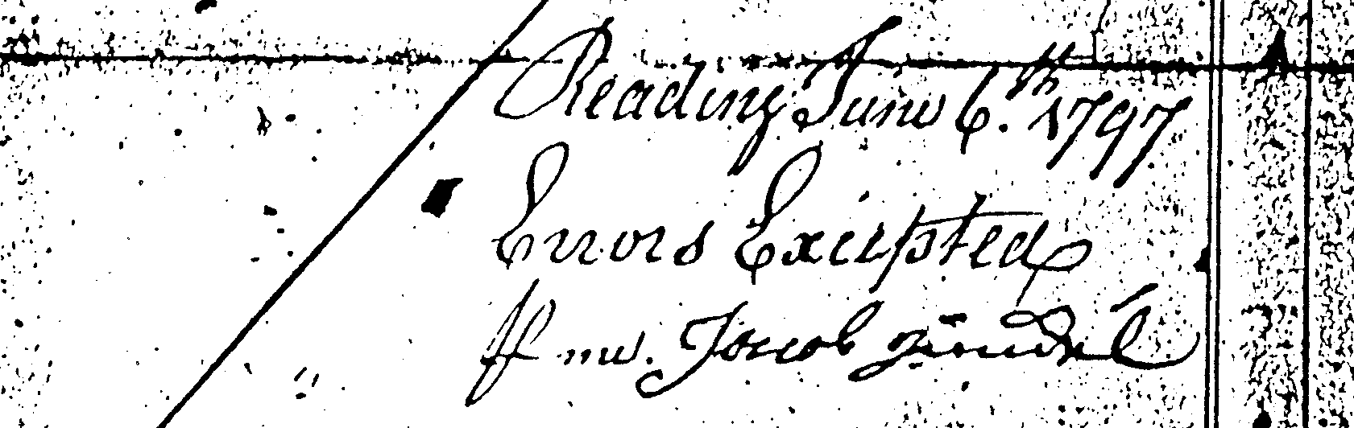
Signature of Jacob Gunckel on Inventory of Estate of Johannes Gunckel

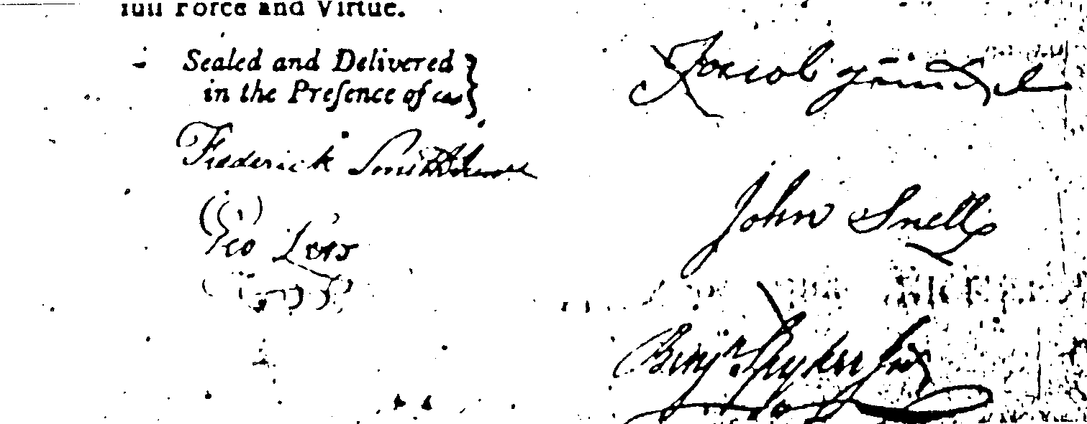
Signature of Jacob Gunckel on Bond for Estate of Johannes Gunckel

Figure 13 Signatures Specimens of Jacob Gunckel
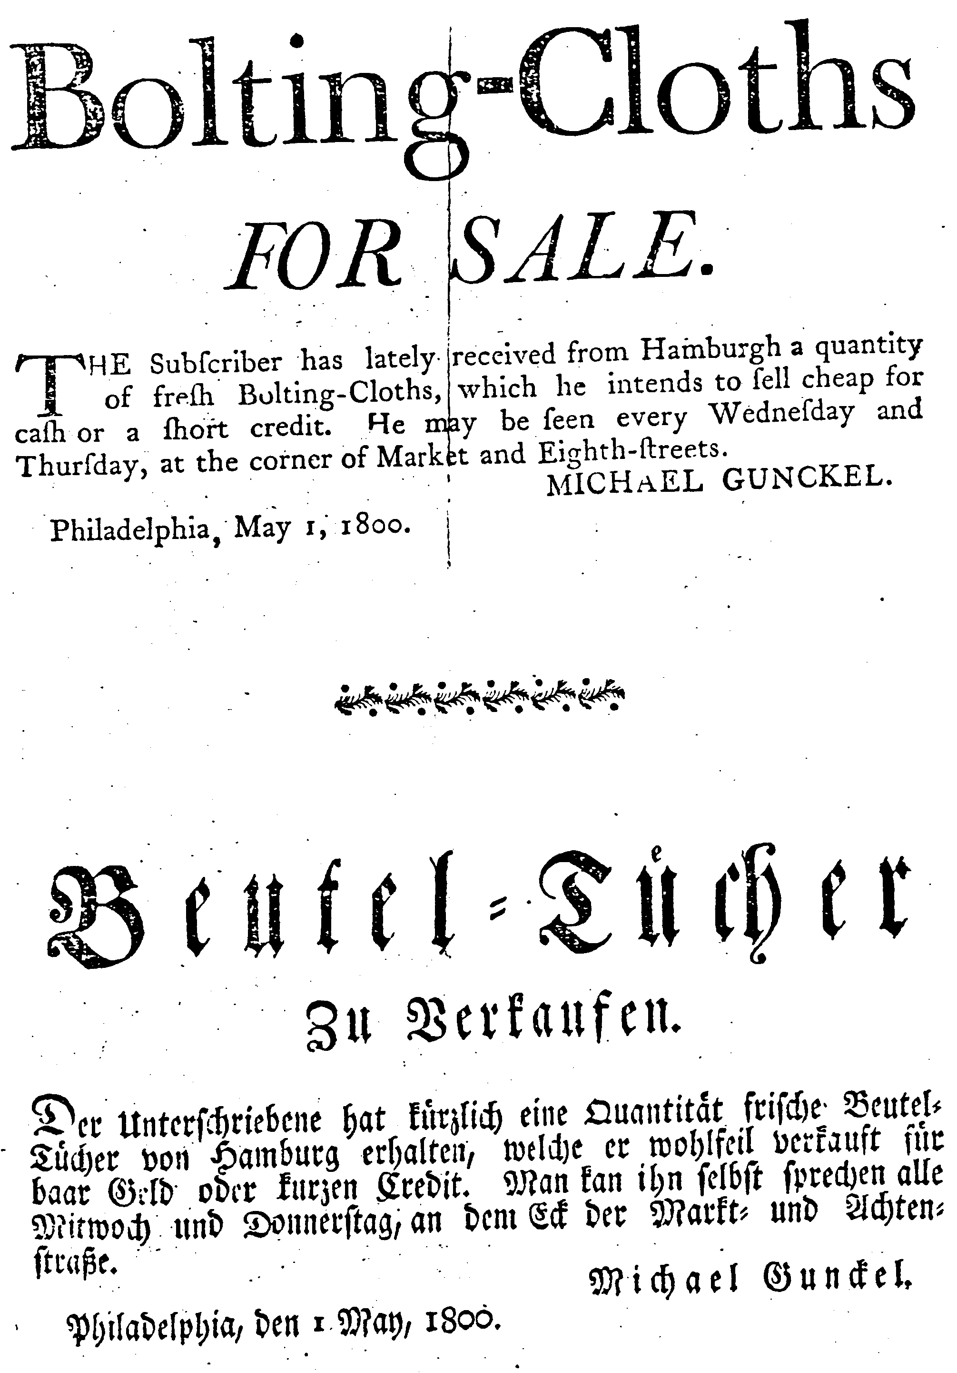

Figure 14 Advertising Flyer of Michael Gunkle

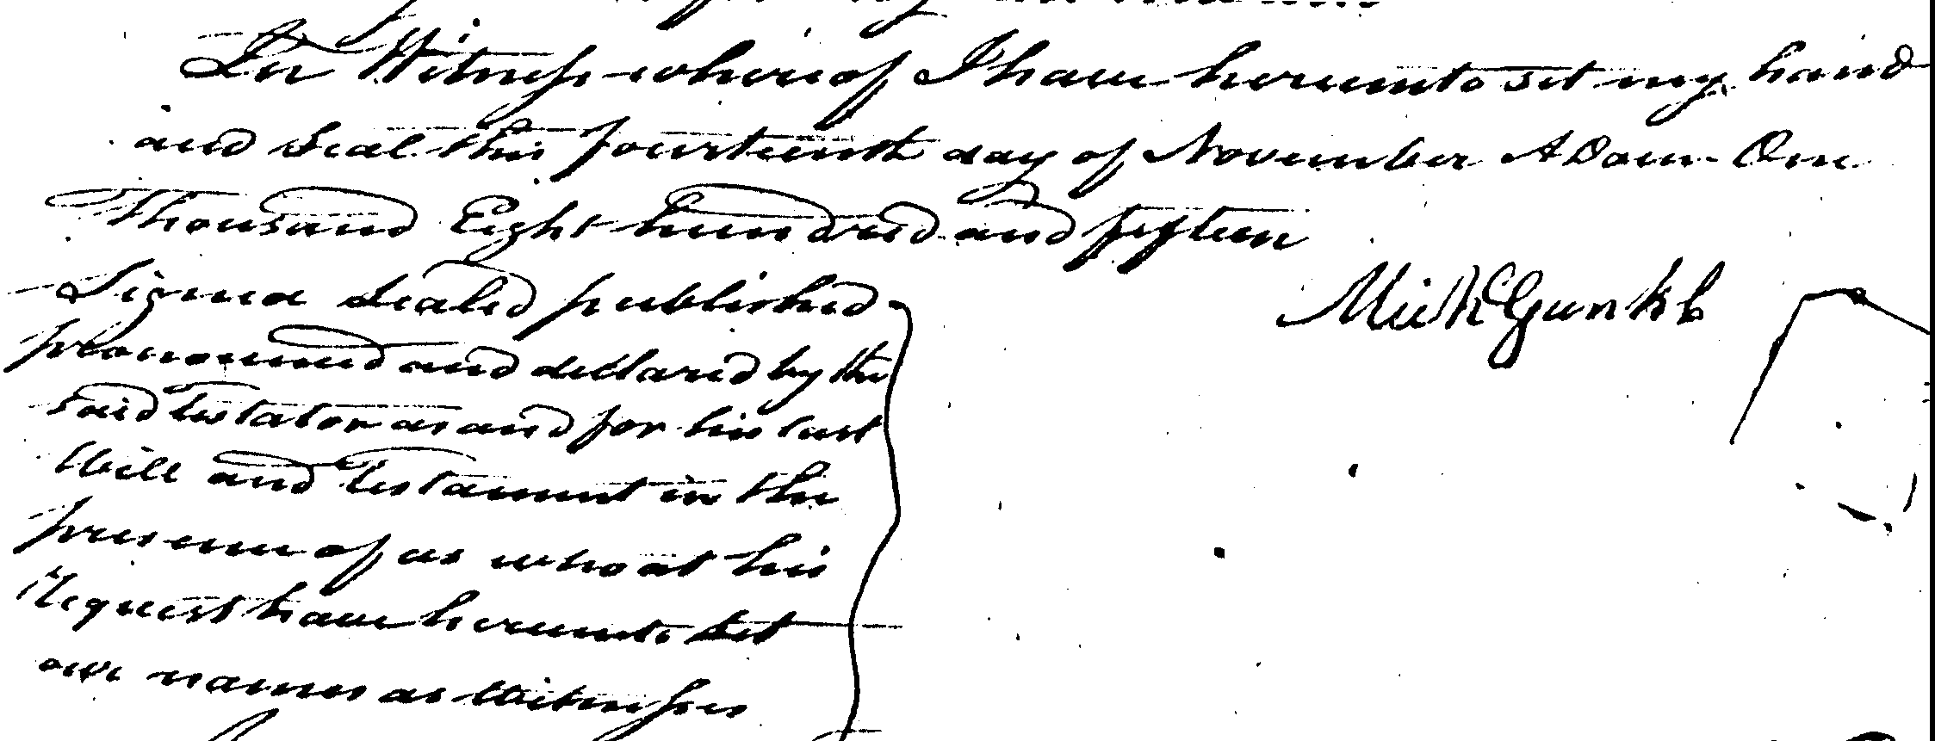
Signature of Michael Gunkle on his will dated November 14, 1814

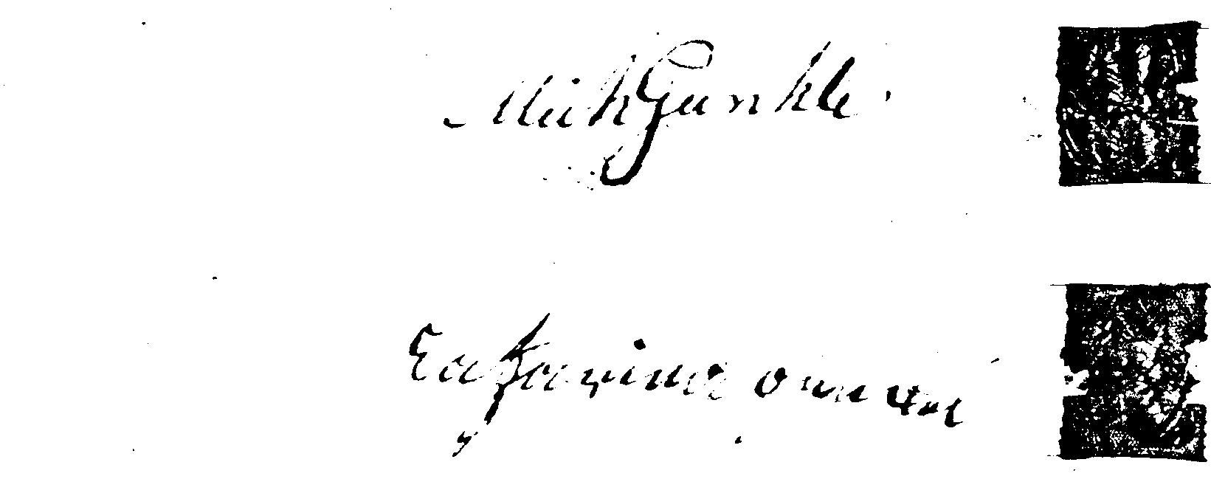

Deed from Michael Gunkle and wife to Michael Lapp for land in Chailiston Twsp, December 5, 1797 (Chester County deeds D568)

Figure 15 Signature Specimens of Michael Gunkle

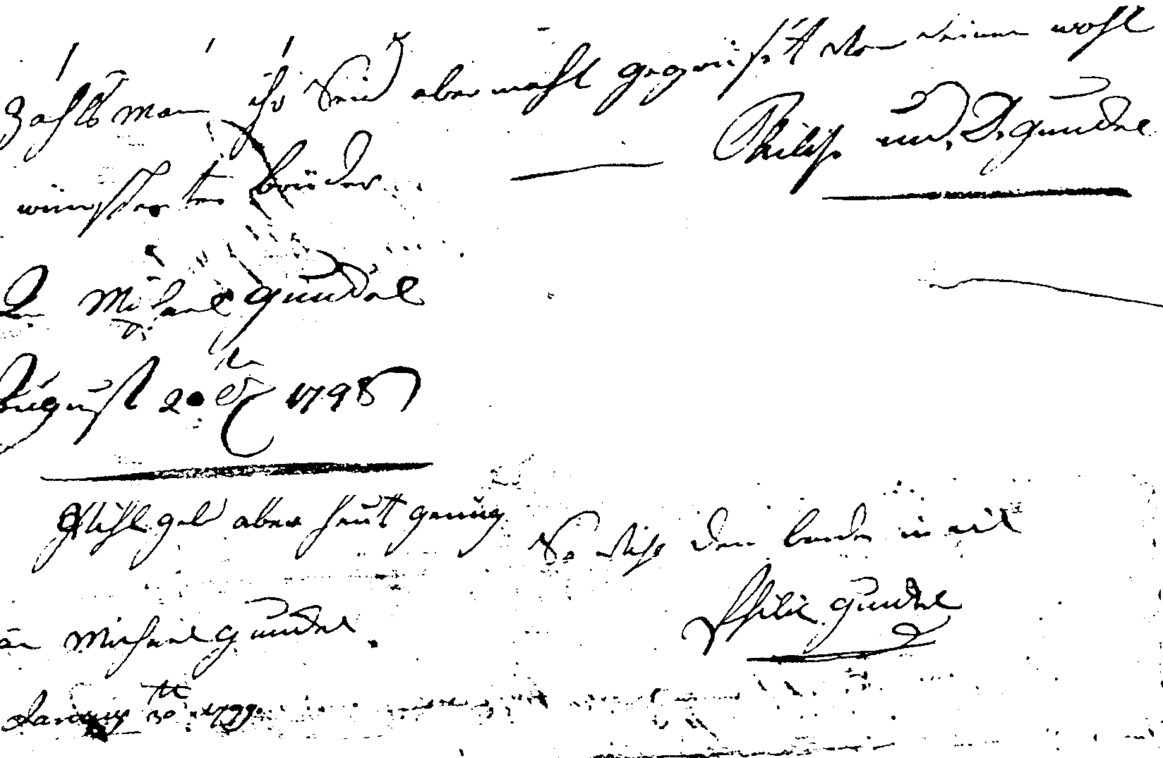

Figure 16 Signatures of Philip Gunckel on Letters Dated 1798 & 1799

OTHER KUNKELS OF BERKS CO.

JOHN GEORGE KUNKEL FAMILY OF ALBANY TOWNSHIP
Montgomery [R23] identifies a George Kunkel Sr. as an early pioneer to Albany Township, Berks County settling there before 1754. Two of his children are known: George and Peter. Peter moved to Lynn Township, Lehigh County.
George Kunkel Jr., the son, prepared his will March 4, 1818 naming his wife Catharine and the following children: Michael, Jacob, John, Catharine Bachman, Salome Wagaman, David, Andreas, and Andrew with Michael as executor. The will was probated on November 30, 1819. (C.171, 5.365)
On December 23, 1820, John Kunkle, Jacob, David, Adam, and Andrew as sons and heirs of George Kunkle late of Albany Township, Berks County, yeoman deceased, acknowledge they received from Michael Kunkle, executor, the sum of $59.16 each being their share of their fathers estate (Deeds 31.475).
In action involving a child of George Kunkel, on January 20, 1827, John Kunkel and Sarah his wife, the late Sarah Gron, heir of Martin Gron deceased give their friend John Old power of attorney (Misc Deeds C3.23).
A Jno. Geo. Kunkell of Albany Township, Berks County became a citizen on September 18. 1765 [R12].
An abstract of the tax rolls are presented by Landis [R11] and listed below.
BERKS COUNTY TAX ROLLS
(year, name, acres, tax, township)
1767 Geo. Kungle, 100a, Albany
Geo. Kunkel, single man, Albany
1768 Geo. Kunkel, single man, Albany
1779 Geo. Kunkle, blacksmith, 200a, Albany
1780 Geo. Kunkle, 200a, Albany
1781 Geo. Kunkle, 200a, Albany
1784 Geo. Kungle, 258a, Albany
1785 Geo. Kunkle, 1.17.6 tax, Albany

The Federal Census included the following information.
FEDERAL CENSUS OF 1790 FOR BERKS COUNTY, PENNSYLVANIA
(Name, males over 16, males under 16, females, township)
George Gunkel, 2,3,2, Albany
Jacob Gunkel, 1,1,2, Albany
Jacob Gunkel Jr., 1,1,2, Albany
FEDERAL CENSUS OF 1800 FOR BERKS COUNTY, PENNSYLVANIA
(Name, males under 10, males 10 to 16, males 16 to 26, males 26 to 45,
males over 45, females under 10, females 10 to 16, females 16 to 26,
females 26 to 45, females over 45, other free persons, slaves)
George Kunkle, 21101-01010-00
FEDERAL CENSUS OF 1810 FOR BERKS COUNTY, PENNSYLVANIA
No Kunkels listed for Albany Township
Records for Rev. Daniel Schmucher’s Church are abstracted in the Kunkle Report [R4]. The baptisms for Allemangel are shown below:
Parents | Child | Sponsers
Jurg (Geo.) Kunchell | Anna Margareta | Jurg Leniperth,
and Margaret | bapt. July 24, 1757 | in Allemanegel,
 | aged 4 weeks | & Anna Maria
------ | Margareta Bely | John Geo. Kunchell
 | bapt. 1764 | & Ann Margareta
John Geo. Kunchell | Jurg Jac | Jurg Lili
and Anne Maria | born Oct 9, 1769 | & Anna Margaret
 | bapt. Nov 5, 1769

Records of the Rev. Daniel Schmucher’s ministry for baptisms at Heidelberg, Lehigh County are shown below:
Parents | Child | Sponsors
John Kunchell | Marg. Maddalena | Caspar Schnerr
and Anna Margaret | bapt. Aug 8, 1762 | & Ann Magdalena
 | age 7 weeks
Joh Kunckell | John Michael | John Michael
and Margareta | born 4th Tues before | Kunchell & Anna
 | New Year 1764 | Margaret Schitter
 | Dec 5, 1763
 | bapt. April 28, 1764
Michael Kunchell | Maria Magdalena | Casper Schnerr
Anna Margaret | born Aug 14, 1766 | & Mary Magdalena
 | bapt. Sept 15, 1766

The baptismal records of Jerusalem Lutheran and Reformed Church, Berks County, PA are abstracted by Landis [R11] and are shown below:
Parents | Child
Joh. Georg Kunkel | Maria Catharina
and Anna Maria | born April 20, 1771
 | bapt. April 29, 1771
Jacob Gunkel Jr. | Johanes
and Elisab. | born Sept 9, 1794
 | bapt. Nov 2, 1794

Records for the Friedens Church, Wessnersville, Albany Township, Berks County (also called Allemengle) are abstracted in the Kunkle Report [R4] and shown below:
Parents | Child | Sponsors
John Geo. Kunckell | Michaell | Geo. Michael Hol-
and Catharine | born Mar 9, 1774 | lenbach & Margaret
 | bapt. Apr 24, 1774
John Geo. Kunchel | Daniel | David Fry and
and Catharine | bapt. July 9, 1775 | Maria Elizabeth
 | 3 weeks old
John Geo. Kunchell | Christina | John Nicholas
and Catharine | born June 12,1777 | Hollenbach &
 | bapt. Oct 12, 1777 | Clara Backer
Jacob Gunkel | George Henry | George Gunkel
and Elizabeth | born Aug 19, 1792 | Catharine Jorg
 | bapt. Sept 16, 1792
Peter Kunkel | Daniel | Andreas Kunkel
and Magdalena | born Mar 2, 1798 | & Maria
 | bapt. Apr 8, 1798
Peter Kunkel | David | George Kunkel
and Magdalena | born Mar 5, 1809 | & Catharine
 | bapt. Apr 3, 1809
Peter Kunkel | Andreas | John Kamp
and Magdalena | born ? | & Gertrude
 | bapt. July 28, 1816
David Kunkel | Rebecca | John Kunkel
and Barbara | born May 23, 1807 | Sara Kron
 | bapt. June 28,1807
David Kunkel | Daniel | Michael Kunkel
and Barbara | born June 3, 1809 | Maria Steygerwalt
 | bapt. Aug 26, 1809
David Kunkel | Regina | Barbara Wageman
and Barbara | born June 15, 1811 | widow
 | bapt. July 21, 1811
John Kunkel | Rachel | George Kunkel
and Sara | born June 15, 1808 | & Catharine
 | bapt. July ---
Geo. Adam Kunkel | Maria Magda. | George Kunkel
and Magdalena | born Sept 19, 1812 | & Catharine
 | bapt. Oct 10, 1812 | the grandparents
Adam Kunkel | David | Michael Kunkle
and Maria Magdalena | born Aug 19, 1816 | & Regina
 | bapt. Sept 24, 1816
Adam Kunkel | Daniel | Daniel Hermanger
and Magdalena | born July 18, 1819 | & Christina Kron
 | bapt. Aug 15, 1819
Adam Kunkel | Sara | Jean Kunkel
and Maria Magdalena | born Jan 15, 1824 | Liddy Wageman
 | bapt. Feb 22, 1824
Adam Kunkel | Isaac | John Wageman
and Elizabeth | born ? | & Salome
 | bapt. Sep 9, 1821
Daniel Kunkel | John | Peter Kunkel
and Maria | born ? | & Magdalena
 | bapt. Sept 15, 1822
Daniel Kunkel | Daniel | John Zimmerman
and Maria | born July 16, 1822 | & Maria
 | bapt. Oct 5, 1822
Daniel Kunkel | Reuben | Sebastion Faud
and Maria | born Oct 22, 1824 | & Maria
 | bapt. Mov 28, 1824

Revolutionary War records from the Pennsylvania Archives - Third Series show the following Gunckel/Kunkels:
George Kunkle paid exercise fines as a member of Capt. Ritter’s Company of the 3rd Battalion from the northern part of Berks county in 1777-1780 (V6.308)

PETER KUNKEL FAMILY OF HEREFORD AND COLEBROOKDALE TOWNSHIPS
Peter Kunkel prepared his will in June 1, 1783 naming Jacob Bechtel and Abraham Stouffer executors and leaving his estate to his wife Anna and daughters Elizabeth and Catharine who were unmarried and under the age of twenty (Wills B.439, 3.328)
On May 20, 1797, Anna Kunckel, widow of Peter, late of Colebrookdale Township received from the executor of the will 150 pounds (Deeds 16.101).
A Peter Kunkle of Hartford (sic) Township, Berks County became a citizen in 1765. He scrupled against swearing an oath [R12].
An abstract of the tax rolls are presented by Landis [R11] and listed below.
BERKS COUNTY TAX ROLLS
(year, name, acres/tax, township, ID#)
1767 Peter Kunkel, 175a, Hereford
1779 Peter Gunkle, Hereford
1781 Peter Gunkle, Hereford
1784 Peter Kunkle, 100a, 5 persons in household, Colebrookdale
1785 Peter Kunkle, 1.15.0 tax, Colebrookdale

The Federal Census included the following information.
FEDERAL CENSUS OF 1790 FOR BERKS COUNTY, PENNSYLVANIA
(Name, males over 16, males under 16, females, township)
Peter Gunkle,1,1,3, Colebrookdale
Revolutionary War records from the Pennsylvania Archives - Third Series show the following Gunckel/Kunkels:
Peter Kunkle paid exercise fines as a member of Capt. Strouse’s Company of the 1st Battalion from the eastern section of Berks County in 1777-1780 (V6.299)

THE GUNCKEL FAMILY IN EUROPE

The ancestor of Johannes Gunckel of Bethel Township has been given variously as Philip Gunckel of Alsace Lorraine, Johann Christoffel Gunkel of Breitenborn, Germany - the father of J. Michael Kunkel, or Lorentz Gunkel, also of Breitenborn, Germany. Each of these alternatives is discussed below.

PHILIP GUNCKEL OF ALSACE LORRAINE
A lineage for the Gunckel family of German Township, Montgomery County, Ohio is given in the notes in a family bible located in the Public Library in Germantown, Ohio. These notes are given below.
Inside Cover: Michael Gunckel is my name.
So much of my Michael Gunckel
Johan George Gunckel
Second Page: Philip Gunckel Germantown Ohio
Third Page (appears have been pasted in later):
A picture of Colonel George Arbin Gunckel
Philip Gunckel of Alsace Lorraine France. Marched under William of
Orange (Protestant) 1688. Was knighted for bravery.
Michael Gunckel son of Philip came to America.
John Gunckel Sr. son of Michael died 1785
Philip Gunckel II son of John G. b. April 1776 d. May 24, 1848
Michael Gunckel son of Philip
George Gunckel son of Michael b. Dec. 19, 1820 d. July 19, 1909
Oliver I. Gunckel son of George W. b. May 23, 1846 d. Aug. 19, 1924
George I. Gunckel son of Oliver I. Gunckel
Lieut. Col. Entered as 2 Lieut. in 1904 Retired as Lt Co 1919
Born Nov 15, 1876 died Apr 17, 1937
Possessor of bible at the time of his death
Similar information is given by Brien [R24] who states:
The Gunckel Genealogy relates that in 1688, one Philip Gunckel of Alsace Loraine, marched under the banner of William of Orange and after the battle of the Boyne in Ireland, was knighted for bravery. He had among other children, a son Philip, who was the ancestor of the American family thru his son Michael.
John Gunckel, son of Michael, was the colonist; the date of his arrival is not known ... He died in Bethel Township, Berks County in 1785.
However, the source of Brien’s information may have been the Gunckel family bible.
William of Orange is William III, Prince of Orange (1650-1702), and is better known as the William of William and Mary, King and Queen of England. William was the Stadtholder (ruler) of Holland. His marriage in 1677 to Mary II, Protestant daughter of James II, resulted in Parliament inviting him to accept the crown jointly with his wife after the “Glorious Revolution” (1688). He subdued Jacobite resistance in Ireland and Scotland and ruled alone after Mary’s death in 1694.
The Battle of the Boyne on the River Boyne in Ireland on July 1, 1690 ended James II’s attempt to regain the English throne. William III’s 35,000 troops decisively defeated the Catholic Jacobites’ 21,000. Northern Ireland’s Protestants celebrate the victory to this day on July 12.
Review of Peerage records did not identified a Philip Gunckel. However there is a Godert van Ginckel (1644-1703) listed by Gibbs [R25]. Godert was the Baron of Amerongen, a village sixteen miles southeast of Utrecht near the Rhine in the United Provinces of Holland (Castle Zuijlestein). A history of the Barons of Amerongen is given by Mulder [R26]. Godert was the General of Calvery for William III and accompanied him to England in 1688. Godert was then appointed Lieutenant General and Commander in Chief of the Army in Ireland. Having distinguished himself by the capture of Athlone on June 20, 1691 and winning the Battle of Aghrim on July 10, 1691, William created him Baron of Aghrim, county Galway, and Earl of Athlone, county Roscommon. On October 13, 1693 the king granted him the forfeited estates (about 21,000 acres) of William Dongan, Earl of Limerick, Ireland, but this grant was reversed by Parliament on December 15, 1699. Godert was appointed Commander in Chief of the Armies in Flanders. He became Veldt Marshal of the States General in 1702 and was second in command to Marlborough. He died in Utrecht on February 11, 1703. The last heir died in 1844.
Godert van Ginckel’s descendents are documented by Mulder [R26] and no Philip or Michael is among them. Moreover there is no similarity of given names with the Gunckel’s of Bethel Township. Therefore, it is not likely that Godert is a relative of the Johannes Gunckel of Bethel Township. However, Godert van Ginckel does meet the description given in the bible: marched under William of Orange and knighted after the Battle of the Boyne. It seems likely that some one found Godert’s history and because of the similarity of surnames (Ginckel versus Gunckel) identified him as a possible relative. Over time a possible relative became a relative and then an ancestor. This type of occurrence is not uncommon in genealogy research.
In addition, the identification of Alsace Lorraine as the place of origin of the Gunckels is also suspect. As result of the strong anti-German sentiment of World War I, many people of German ancestry gave their place of origin as Alsace Lorraine, France. Note that the owner of the bible had served in World War I.

JOHN MICHAEL GUNKEL OF BERKS COUNTY
The accepted tradition, for at least one hundred years, is that Johannes Gunckel and the J. Michael Gunkel, who landed in Philadelphia on the ship Ranier on September 26, 1749, are the same person. For example, Egle on page 32 of his NOTES AND QUERIES published in 1896 identifies the father of Leonard Gunkel as J. Michael Gunkel. However, examination of original records, e.g., church, probate, and ship’s lists, offers compelling evidence that Johannes and J. Michael were two separate individuals.

For example, Egle states “as letters of administration were on that day granted to his widow Rosina and his father, J. Michael Gunkel (Kunkel).” However, the copy of the letters of administration on file at the Lancaster County Courthouse, filed under Leonard Cunkle, and dated November 10, 1778 list “Rosina Cunkle Widow and Relict of Leonard Cunkle late of Cocalico Township Deceased Michael Cunkle and Jacob Keller”. Thus, the reference to J. Michael and the father-son relationship do not come from the letters of administration. Michael is more likely to be Leonard’s brother, rather than his father.

When J. Michael arrived in Philadelphia, he signed the ship’s list with an “X”; that is, he could not sign his name. On the other hand, Johannes signed his will with his own signature; that is, Johannes could write his name. Johannes also witnessed the will of his neighbor, Michael Grosman, in 1755, using the same signature that he used on his will thirty years later.

Records of Trinity Tulpehocken Reformed Church and of St. Paul’s (Klopp’s) Church, both near Bethel Township, list a John Gunckel with wife Margaret and a Michael Gunckel with wife Anna Maria as the parents of children during the period 1749 to 1756, again indicating the presence of two different individuals.

Listed among the members of the Trinity Tulpehocken Reformed Church in 1748 was a J. Kunckel. This is the year before J. Michael arrived.

Johannes and J. Michael lived in Bethel Township at the same time, went to the same churches, and used the same names for their children. Therefore, it is easy to see how, when given only some of the information, there might be confusion. However, it is now clear that there were two separate individuals, not a single person.

MacKenzie [R27] gives the following information on John Michael.

This branch of the Kunkel family is descended from the family of that name, which has been located in Breitenburn, Germany, since prior to their migration into Pennsylvania in 1749. The ancestors of this American family were Johann Christoffel and Anna Maria Gunkel, Kunckell or Kunkel.
ISSUE
I. Johann Heinrich, b. 1st July, 1710.
II. Johann Balthassar, b. 4th Apr. 1713.
III. Johann Friedrich, b. 20th Apr. 1716.
IV. Johann Conrad , b. 10th May, 1719.
V. Anna Margreth, b. 2d Oct. 1721.
VI. Susanna Margreth, b. 2d Mar. 1725.
VII. Johann Michael, b. 20th July, 1727.
VIII. Johann Heinrich (sic), b. 15th Jan. 1734.
JOHANN MICHAEL KUNKEL was christened in Breitenburn, Germany, 20th July, 1727; d. in Lancaster Co., Pa., about 1780. He took the oath of allegiance at Philadelphia, Pa., in 1749. m. (wife’s name unknown) and located in Heidelberg Township, Berks Co.
ISSUE
I. Michael. II. Leonhard, d. about 1778. III. Samuel
Leonhard Kunkel of Euphrata, Pa., d. about 1778; m. in 1775, Rosina Stumpf, b. 14th Feb. 1749; d. 14th June, 1833.
ISSUE
I. Mary Catherine, b. about 1776; m. Jacob Merkle
II. John, b. 14th Sept 1777.

Leonhard of Euphrata is the son of John not the son of John Michael.

LORENTZ GUNKEL OF BREITENBORN, GERMANY
Heinrich P. Gobel [R28], a local historian in Breitenborn, has used church records to create a family tree for the Gunkels of Breitenborn. The original Gunkel was a Hans Gunkel who was born in Neuhutten, Germany. He moved to Breitenborn where he was a glass maker. Information on the family of Hans Gunkel is listed below.
Hans Gunkel, born c 1636 in Neuhutten, moved to Breitenborn
wife, Margreth
Catharine Gunkel, born 1675
Anna Juliana Gunkel, born 1677
Johann Heinrich Gunkel, born 1680
Johann Cristoffel Gunkel, born 1682
Lorentz Gunkel, born Dec. 3, 1683, married Nov. 15, 1709
Maria Apolliana Gunkel (twin), born Feb. 12, 1687
Maria Susanna Gunkel (twin), born Feb. 12. 1687
Maria Louisa Gunkel, born April 13, 1689
The family of Hans’ son Johann Cristoffel, is listed below.
Johann Cristoffel Gunkel, born 1682, married Sep. 17, 1704
wife, Anna Maria Moller
Burkhardt Gunkel, born Nov. 7, 1707, died Aug. 5, 1745
married Juliana _____ Aug 2, 1731, had 5 children
Johann Heinrich Gunkel, born July 7, 1712, probably died young
Johann Balthasser Gunkel, born April 4, 1713
Johann Friederick Gunkel, born April 20, 1716
Johann Conrad Gunkel, born May 7, 1719, died July 1719
Anna Margreth Gunkel, born Oct. 2, 1721
Susanna Margreth Gunkel, born March 2, 1725
Johann Michael Gunkel, born July 20, 1727
Johann Heinrich Gunkel, born Jan. 15, 1734
married Maria Juliana Stoffel
Johann Cristoffel’s son, J. Michael, is thought to be the J. Michael Gunkel of Berks County. His age is appropriate. The names of the children of John Michael Gunckel in Berks County were Anna Maria, Balthaser, and Michael, which correlate with those of Johann Cristoffel’s family.
The family of Hans’s son Lorentz is listed below.
Lorentz Gunkel, born Dec 3, 1683, married Nov 15, 1709
Wife, Anna Catharina Gundlach
Johann Oswald Gunkel, born Mar 30, 1711
married Eleonare Hartwig
Johann Georg Gunkel, born Aug 17, 1714
married Anna Elisabeth Sommer
Johann Heinrich Gunkel, born Jan 27, 1715/16 died young
Anna Maria Gunkel, born Aug 5, 1719
Johann Gunkel, born Aug 16, 1722
married Anna Margarethe Lorentz
Johann Jacob Gunkel, born Sept 17, 1726 died young
Lorentz’s son, Johann born 1722, is possibly the Johannes Gunckel of Bethel Township. He was the right age, his wife has the right name, and Johannes lived in Berks County near J. Michael a possible first cousin. However, the names of children of Johannes do not correlate with well the names of Lorentz’s family. Further, the family of Hans Gunkel was a family of glass makers, while Johannes and his children were millers.
Breitenborn is located in what is now the State of Hesse, County of Gelnhausen, Germany. Hall [R29] provides background information and maps of Hesse. His map of Hesse and of Gelnhausen are shown in Figures 17 and 18. There are two Breitenborns in Gelnhausen: Breitenborn A.B. (coordinates A2) and Breitenborn A.W. (coordinates A1). Breitenborn A.W. is the one of interest. It is located near the town of Grundau and is about 25 miles northeast of Frankfurt.
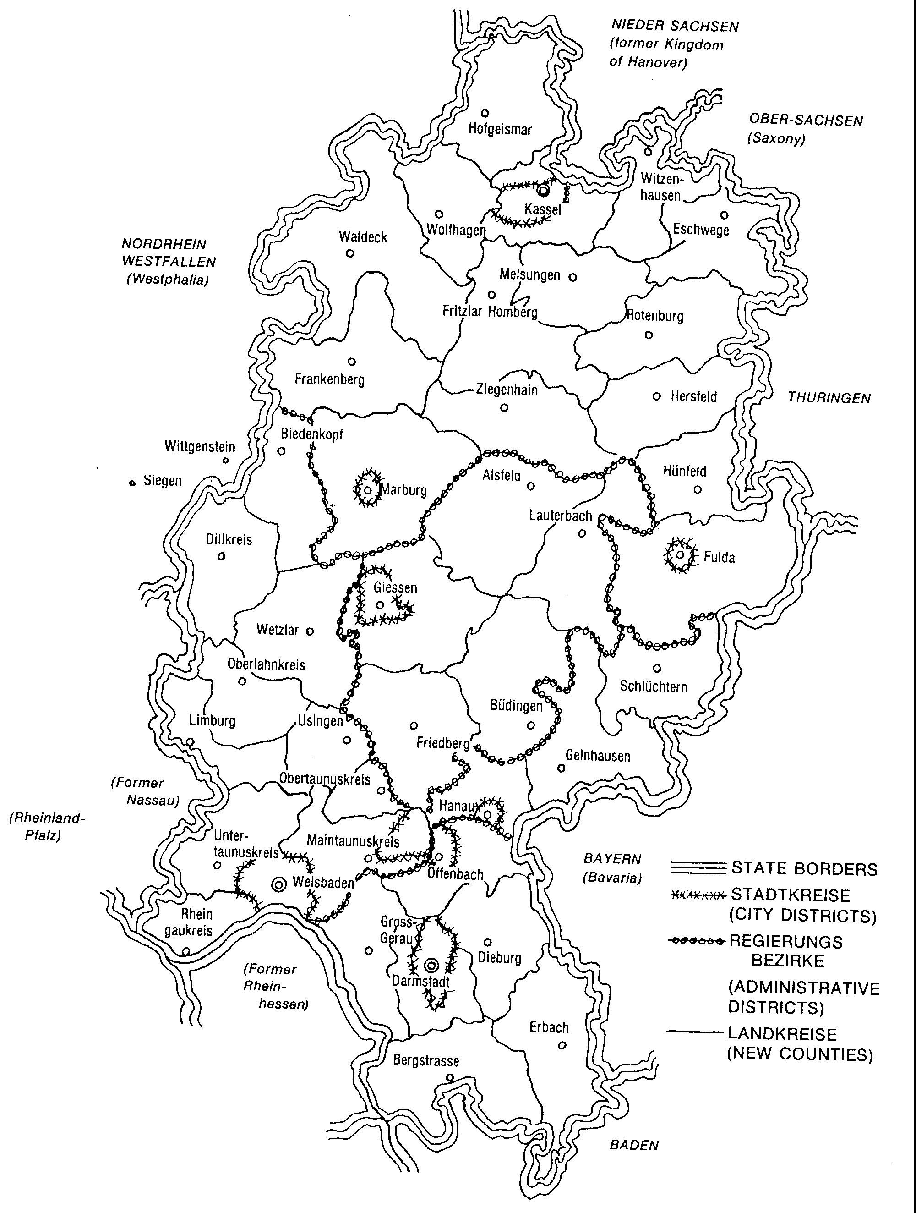

Figure 17 Map of the State of Hesse, Germany
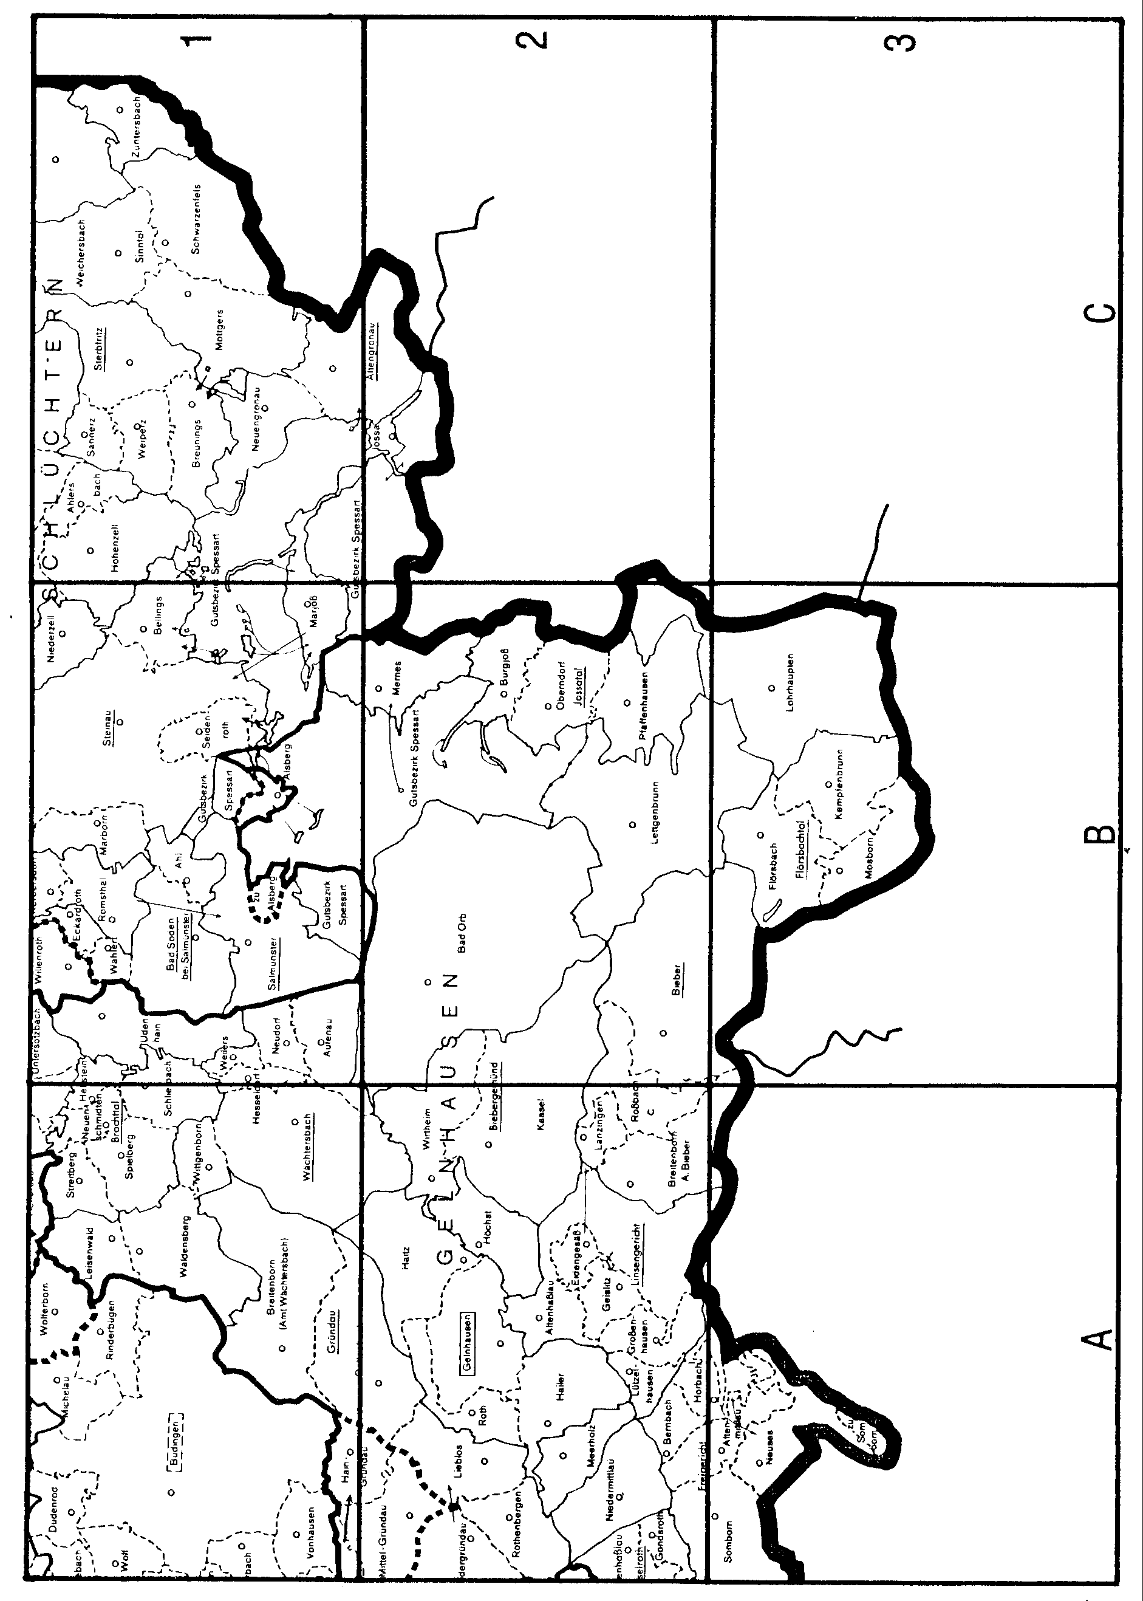

Figure 18 Map of the County of Gelnhausen, State of Hesse
SETTLEMENT IN PENNSYLVANIA

John Gunkle, son of Leonard, grandson of Johannes
The Lancaster County Historical Society [R16 vXXIX p126] gives information about John Gunkle. John is described “A clockmaker made and sold clocks at a place in Cocalico township, now Ephrata township, called Trout Run. His period was from 1830 to 1840. He was fully equipped with machine and engine, and personally made his own clocks, and while he made but few, it is said that anyone who has a John Gunkle clock has a good one. The name is also spelled Kunkle. He was German by birth.”
Lancaster County deed actions relating to John Gunkle include:
Deeds, bk YY, v 2, p 169, Recorded 31 August 1796 - On 16 February 1796, John Merkle of Allen Township, Cumberland County and his wife Catherine Kunkle Merkle sell their rights to 125 acres of land in Cocalico Township to John Kunkle for 600 pounds. The land was bounded on the East by land of Abraham Landis. (Catherine is John’s sister)
Deeds, bk YY, v 2, p 169-171, Recorded 31 August 1796 - On 5 March 1796, Abraham Landis and his wife Rosina Gunkle Landis sell their rights to 125 acres of land in Cocalico Township and to lot 56 in the town called Newman’s Town in Heidelberg Township to John Kunkle for 250 pounds. The 125 acres were bounded on the East by land of Abraham Landis. (Rosina is John’s mother)
Deeds, bk 18, v 1, p 381, Recorded 4 January 1820 - On 11 July 1797, John Gunckle of Cocalico Township and his wife Susanna sell part of a 125 acre piece of land to Benjamin Royer.
In his will dated April 14, 1849 and Codicil dated May 1, 1852, John leaves his estate to his wife Catharine, his older children, George and Aaron, and his younger children, John, Samuel, William, Rudolph, and Hannah. John’s will was proved on August 27, 1856 (Lancaster County Records).
A printed Birth Registry and a letter to Samuel from Rudolph in 1882 that give birth and death dates for John Gunkle, his wives, and his children are in the possession of F. Howard Groff [R17].
Federal Census records for John Gunkle and his family include:
FEDERAL CENSUS OF 1800 FOR PENNSYLVANIA
(Name, township, county, family)
John Gunckel, Cocalico, Lancaster, 11200-00100
FEDERAL CENSUS OF 1810 FOR PENNSYLVANIA
(Name, township, county, family)
John Kunkle, Cocalico, Lancaster, 31010-00011
FEDERAL CENSUS OF 185O FOR PENNSYLVANIA
(Name, age, birth location, township, county)
John Gunckle, 78, PA, Ephrata, Lancaster
Catharine, 79, PA
Hannah, 37, PA
Susannah Gunkel, 28, PA, Ehprata, Lancaster
Aaron Kunkle, 49, PA, Hopewell, Cumberland
Rebecca, 53, PA
Moses, 23, PA
Martin, 22, PA
John, 15, PA
Wm Kunkle, 39, PA, Hopewell, Cumberland
Frances, 38, PA
Rudolph Kunkle, 34, PA, Hopewell, Cumberland
Elizabeth, 40, PA
Hanna, 8, PA
Amanda, 5/12, PA
FEDERAL CENSUS OF 1860
(Name, age, birth location, township, county, state)
Aaron Kunkle, 60, PA, Hopewell, Cumberland, Pennsylvania
Rebecca, 64, PA
Martin Kunkel, 32, PA, Hopewell, Cumberland, Pennsylvania
Agnes, 26, PA
David, 6, PA
Wm, 1, PA
Samuel Gunkel, 50, PA, Ross, Clinton, Indiana
Mary, 49, PA
Samuel, 22, PA
Benjamin, 18, PA
Wm Gunkle, 49, PA, Ephrata, Lancaster, Pennsylvania
Hannah, 47, PA
Rudy Gunkel, 44, PA, Upper Leacock, Lancaster, Pennsylvania
Elizabeth, 54, PA
Hanna E., 17, PA
Manda, 10, PA
It appears that John’s sons lived in Cumberland County in 1850 and spelled their surname with a “K”. By 1860, all but Aaron had left Cumberland County and resumed spelling their surname with a “G”. Aaron and his descendents continued to spell their surname with a “K”.
It is possible that William had a wife, Frances, in 1850. If he had a wife, she must have died. In 1860, he appears to be living with his sister, Hannah. In his will, dated December 22, 1871 and Codicil, dated June 23, 1874, William (living in Ephrata) leaves his estate to his sister Hannah for life and thence to his brothers, Aaron and John (John living in Wayne County, Ohio), his nieces and nephews, and family friends. William’s will was proved June 29, 1877 (Lancaster County Records)

Daniel Gunkle, son of Michael, grandson of Johannes

The following material is taken from the HISTORY OF CHESTER COUNTY, PA by Futhey and Cope published in 1881 [R19].

Daniel Gunkle was married, Oct. 29, 1822, to Sarah Kugler, born July 15, 1803. She was the daughter of John and Harriet Kugler, of Lower Merion, Montgomery Co., granddaughter of Paul Kugler, and great-grand-daughter of a German emigrant who settled in Eastern Pennsylvania in the early part of the last century. To Daniel and Sarah (Kugler) Gunkle were born nine children, - George W., Dr. William H. (dec’d), Harriet C. (died young), Eliza C. (m. Dr. Frank Rieser, of Berks County), John F., Victoria J. (m. Dr. John G. Thomas, of Delaware County), and Sarah S. Of the sons, George W. m. Louisa Watson, Dr. William H. m. Mary R Ellmaker, and John F. m. A. Lizzie Davis.
Daniel Gunkle died Dec. 3, 1879, and his surviving widow resides on the homestead with her unmarried son, Michael M. Mr. Gunkle was well educated, having attended, besides the common schools, the famous school of Rev. Mr. Grier, at Brandywine Manor. He was a member of the East Whiteland Presbyterian Church. Though a miller by trade, he made farming his general avocation. He was interested in all public improvements, and was universally respected in the community.

SETTLEMENT IN OHIO

Hentz [R20] published a history of the settlement of Germantown in 1882. The following material is taken from his book.
Of the Gunckels there were three, Philip, Daniel and a nephew of these two, also named Daniel. Their prominence among their contemporaries entitles them to the first place...
Daniel Gunckel, the nephew of the above two, came to the Twin Valley at a still later period. Like his uncles he was a miller, which occupation he here followed.
All three of the gentlemen, just named, have left issue, and from them all the Gunckels of Montgomery County are descended. They are at this time a very numerous and widespread connection.

MONTGOMERY COUNTY, OHIO

GERMAN TOWNSHIP, MONTGOMERY COUNTY, OHIO
A description and history of German Township is given in THE HISTORY OF MONTGOMERY COUNTY, OHIO [R30] and given below.
This rich and populous district is situated in the southwest corner of Montgomery County. It adjoins on its west side Preble County, on its south side Butler and Warren Counties, on the east Miami Township, and on the north Jackson and Jefferson Townships. It embraces a territory of thirty-seven sections and a fraction of a section, and, according to the last official census, contains a population of 3,451. In the spring of 1803, shortly after the law took effect by which Montgomery County was formed, the Associate Judges of the County Court established the four original townships of the county - Washington, German, Dayton, and Elizabeth.
German Township included all of the territory west of the Miami River to the State line, parallel to and two to three miles south of the present southern boundary of Miami County. On the 10th day of June, 1805, the records read “German Township, bounded at present by the Miami River on the east, Butler County of the south, the line east of the third range on the west, and the north side of the first tier of sections in south side of third township, fifth range, and fourth township, fourth range, as the north boundary line, elections to be held at Philip Gunckel’s Mill, on Twin Creek.” At a session of the County Commissioners, February 3, 1806, it was ordered that two tiers of sections on the south side of Jefferson Township be attached to German on the north. March 7, 1809 a portion of German was added to Jefferson; and upon the erection of Jackson Township, December 7, 1814, the lines were again changed, and a part of German used in the formation of that township. Thus the lines on the north, south, and west have remained up to the present; but, March 7, 1831, about ten full sections were cut off its eastern portion to form a part of Miami Township, and the section line between Sections 4 and 5, Township 2, Range 5, became its eastern boundary.
Big Twin Creek divides German Township into two nearly equal parts, passing across its territory from northwest to southeast. It has two classes of lands - uplands and bottom lands. The latter are situated in the valleys of the streams, and constitute about one-third of its soil, while the former lie on the elevated parts of the township, are less productive, and hence also less valuable than the bottom lands. The average value of uplands is $50 per acre; that of bottom lands, $100. The surface of the uplands is rolling, and their soil a yellow-brown clay, producing all the cereals, fruit and tobacco. The bottom lands are level, their soil a black alluvial mold of vegetable origin and very productive. This township is well watered, having many fine springs and a number of good streams, among which are the two Twins, Shawnee Creek, Dry Run and Mud Lick. Timber is still sufficiently abundant, consisting mainly of maple, oak, beech and poplar. A great deal of fine walnut existed here at one time, but it has now almost entirely disappeared. Thousands of tall, smooth trees of it have been felled, cut up for firewood, split into fence-rails, or appropriated to other similar purposes.

TWIN VALLEY
Twin Valley derives its name from two streams, one of which is called Big Twin, and the other Little Twin, and the junction of these streams into one at Germantown has given them the name of Twins. From Germantown, the united stream continues in it course southward for the distance of about six miles, and then empties into the Miami River. Taking the mouth of the Twin as the starting-point, and proceeding along its course to Germantown, thence about two miles more along both of its branches, we pass through the entire Twin Valley and reach its northern terminus. The valley itself is formed of the bottoms contiguous to the Twins and the hills by which they are enclosed, and is from one to two miles in width. Underneath the outer soil of this valley there is found a deposit of gravel from one to three feet in thickness which operates as an underdrainer, as will as furnishing cheap material for making solid roads. In addition to their natural fertility, these bottom lands possess this advantage, that they do not suffer as much as other lands from a want or a superabundance of rain, and produce whether the summer season be wet or dry - advantages seldom found combined, and which give these lands their chief value. Two miles south of Germantown, upon a high bluff overlooking the valley, are found the remains of an ancient fort, covering a space of about twenty-five acres. The trees that but recently grew on it have been cut down, and its site forms a part of a well-cultivated farm. By means of the plow and harrow, its embankments have been reduced to a level with the adjoining surface, so that, to the eye of the casual observer, not much remains to be seen of this once vast enclosure, yet there is enough left to trace all its outlines. There are many similar works in Southwestern Ohio, but who were their builders? what use and purpose did they serve? and what is their age? are questions which are difficult - perhaps impossible - of solution. The geology of this valley is likewise highly interesting. Beneath its soil, on the hillsides, is a limestone rock of animal origin and a marine deposit. It is simply a consolidation of shell animals (Mollusks) that live in the ocean. The shells in this fossil rock are as well and clearly defined in form and outline as any shell newly thrown up by the waves from the ocean bottom. There is the greatest variety of species of them, and one may count a dozen or two varieties in a rock of the size of a man’s hand. The gravel deposit of this valley affords no less a dozen different kinds of rocks, coming from formations which are far removed from one another. These pebbles are rounded off to almost the regularity and smoothness of marbles, giving evidence of having been subjected to friction, perhaps by being carried great distances by some unknown process or catastrophe, and large boulders are found lying on the outside surface, which have been brought here from great distances. Here, then, in this valley, upon it hillsides and fields and by its streamlets, both the antiquarian and the geologist will find a promising field of research and study.

GERMANTOWN
Germantown is situated in the Twin Valley, with Little Twin Creek on its east side, and Big Twin on its west and south sides, being in the forks of these streams. It was laid out by Philip Gunckel, who, on the 4th day of October, 1814, certified that the plat as recorded was correct. The first sale of lots occurred October 21, 1814, and the second sale November 15, 1815. It was called Germantown because the people who built up the town and lived around it were Germans. Howe, in his “Historical Collections of Ohio,” says “Germantown was named from Germantown, Penn.,” but in this he is mistaken; the name was given for the reason just stated. Its site, as well as its surroundings is in a high degree beautiful. The valley immediately around the town is on almost all sides enclosed by hills, which are in large part covered by trees, forming a forest-crowned wall, presenting a very pleasing picture. The town is regularly laid out; its streets are wide, well graded and macadamized. The climate is most salubrious, the drainage admirable, malarious diseases unknown, and the health of the people excellent. The post office was established in October, 1818, Peter Shaeffer being the first Postmaster. Germantown has no railroad, but has, nevertheless, good railroad facilities by means of omnibus lines to the C., H. & D. and C., C., C. & L. at Carlisle and Miamisburg, which points are each but four miles distant. The town possesses good public buildings; the schoolhouse is a very substantial, three-storied structure, overlooking the valley, containing twelve rooms, four on each floor; the Town Hall is an edifice that would do credit to a much larger town; and the armory, originally built for an academy, engine house and prison, are all quite new, capacious and attractive. There are four churches of good architectural style, some of them finished and furnished with taste and elegance. The town also has what many large places lack - a public park, containing about five acres of ground, which has been but recently laid out. Germantown has at present three dry goods stores, four grocery stores, two hardware, two furniture, two tin and stove stores, a number of other mercantile establishments possessed by such towns, three hotels and one banking house. The Exchange Bank was established by Col. John Stump and did business a few years, when it was merged into the First National Bank of Germantown, which was organized July 18, 1863, by Christian Rohrer, William Gunckel, John Stump, John F. Kern and others, beginning business September 1 of that year, with a capital of $50,000, which has since been increased to $75,000. John F. Kern was elected President, and John Stump, Cashier; the former serving as President of the bank until January 10, 1882, when he resigned, and was succeeded by Joseph W. Shank. Col. Stump was succeeded as Cashier by J. H. Cross, who was elected January 16, 1869; began his duties February 1 of that year, which position of trust and confidence he has filled up to the present. During many years, the German was the only language spoken among the people of this town, but the English language has almost entirely supplanted it as a medium of social and business intercourse.

SUNSBURY
Sunsbury is but a small village of about forty dwellings; is separated from Germantown by a space of about a quarter of a mile, and is located directly south of the latter town, on the Carlisle & Germantown pike. It is a very old place, being the first point settled in German Township, and for a number of years was the only village or place of business in the Twin Valley. It was not, however, platted until March 18, 1825, according to the county records. Its people form, to some extent, a community by themselves, yet their interests are largely identified with those of the people of Germantown, and though small in size and population, some of the most prominent men in the township have lived here, such as the Emericks, Catrows and Liggets. It has never given much prospect of growth, and to-day has no more houses that it had forty years ago, and is beginning to show its age by its external appearance.

EARLY SETTLEMENT
German Township has had two classes of settlers, who have succeeded one another, the first of whom were the squatter, who remained but a few years; and the second the pioneers, who stayed and became the permanent occupants of the soil. The squatter period begins with the year 1798, and ends with the year 1804. Previous to the former period, the Indians held undisputed sway in the Twin Valley, and lingered here with fond attachments even after encroaching civilization had robbed them of their means of support. As late as 1804, the Shawnees had a town on Shawnee Creek, on land now adjoining Sunsbury, from which tribe that stream takes its name, and it is said of Tony Killbuck, who was one of their number, that, for a long time, he utterly refused to leave the country. He built himself a hut on the west side of the Big Twin, near the site of Conover’s Mill, and for years no amount of persuasion could move him to abandon the land of his birth and the scenes of his earlier years; and when at last he yielded to the inevitable fate of his race and concluded to move on westward, he did so with great reluctance only, and left very sad and dejected.
The first white settlers came to this township in the year 1798, from Kentucky, but they were not all natives of that State; perhaps but few of them were. Some were natives of Pennsylvania, others of Maryland, Virginia and North Carolina. The names of some of these people have been preserved, and are as follows: Benjamin Smith, James Griffith, John Pauly, William Cutler, James Hatfield, Robert Hardin, Lickum Hardin, James Hardup, James Porter, George Worthington, Samuel Hawkins (who had been a Colonel in the Revolutionary army, and was a man of superior intelligence), John Winegardner, William Polk, John Bundaker, Richard Brown, John Herman, William Eastwood, Eden Hardin, John Cutler, Martin McGrea, Nathaniel Lyon, Conrad Eisile, Anthony Richard and Abraham Hartzel. These people were not actual settlers, but squatters only, but as soon as the land was offered for sale, some purchased. Many were too poor, and had not the means to buy, whilst others had the means, but were not willing to purchase and to remain. These, as soon as circumstances permitted or necessity impelled, moved away and made room for those who became actual settlers. The land upon which Germantown was subsequently laid out was entered and owned by James Hatfield and Robert Hardin, who sold it to Philip Gunckel in the year 1804, at the price of $10 per acre.
...These first settlers are said to have been a quiet, orderly and peaceable class of people, and, religiously, were mostly of the Baptist persuasion; at least, the only minister who labored among them, the Rev. Mr. Lee, was a Baptist preacher. They erected a house of worship on the farm later owned by Christopher Emerick. It stood in the woods on the hill, was a log structure, and was never quite finished. The second class of settlers has sometimes become the permanent occupants and owners of the soil, and this happened to be the case in German Township. But in many instances, these have again sold out, and a third class only has come to remain.
The first of the second class of settlers were principally from Berks County, Penn., who, later were re-enforced from the same and other States. In 1803, Philip Gunckel, Christopher Emerick, David Miller and George Kern, all natives of Berks County, Penn., came to Ohio on a prospecting tour. After visiting different localities, they concluded to purchase land about sixty miles east of Cincinnati, on Bull’s Skin Creek, near its junction with the Ohio River. Mr. Gunckel was a miller by trade, and, in the selection of land, aimed to secure a site for a mill, and the others deferred to Mr. Gunckel’s judgment in their selections of land. The four contracted for 1,000 acres on this stream, from the agent of a Virginian named Redford, which land was a part of the Virginia Military Survey. They started for Virginia to see Redford and secure from him deed and title of the land which they had bought from his agent, but, on arriving at the man’s residence, they found that he was dead, and the executor lived 150 miles further off. They therefore abandoned the project of settling on Bull’s Skin, and returned to Pennsylvania, still, however, with the intention of moving to Ohio. Their glowing account of the beauties of this State created a “Western fever” in their locality, and twenty-four families concluded to sell out and move to Ohio during the following spring, all of whom were natives of Berks County, Penn., although a few were then living in Center County of the same State. They set out on their westward journey in the spring of 1804; met at Pittsburgh, as previously agreed upon, where they loaded their wagons and goods upon flat-boats, and, with their families, floated down the Ohio to Reading, a hamlet not far from the former place, where they tarried a fortnight, considering what to do or whence to direct their steps. A few found employment and remained; the rest continued their journey toward the north, intending to locate in the Miami Valley, of which they had heard, but with no special objective point in view, trusting rather to fortune and the guidance of providence. Passing through the Miami Valley, they were delighted with the county which they saw, finally arriving at “Hole’s Station,” near which lived a wealthy German farmer named Alexander Nutz, who they were very glad to meet, for he spoke their own tongue. They encamped on his farm, and, the weather being worm and pleasant, they took up their abode in the woods, where they lived in wagons and temporary huts for about two weeks.
Mr. Gunckel was looked upon by these people as their leader, being a man of superior intelligence, and the only person among them who spoke the English language with any degree of fluency; therefore, they were inclined to follow his fortunes, and locate where ever he did. He explored the country for miles around, and finally concluded to settle on Big Twin Creek, within the present corporate limits of Germantown, and the rest of the colony made up their minds to locate around him. Mr. Gunckel was influenced in this selection by the fact that the stream afforded a good mill site, as it was his intention to erect a mill as soon as properly settled. Those who followed Mr. Gunckel’s leadership crossed to the west bank of the Miami River, traveled on in the direction of Twin Creek, which they reached August 1, 1804; and here, by the side of this stream, they rested as the end of a long and wearisome journey and here was now their future home. The earlier settlers who lived in this valley were ready to sell out to the Pennsylvanians, and those of the latter who had the means at once purchased land, while a few found unentered Government land and secured that. Before winter set in, the newly arrived immigrants had secured land, built their cabins and begun the battle of life in the primitive forest of the Twin Valley. Such was their enterprise and industry that they did more for the improvement of the county in one year than their predecessors had done in half a dozen of years, and at the end of twelve months, they had attained such a condition of independence and thrift that want of suffering was unknown among them, Religiously, they were either Lutherans or Reformed, and in those days it used to be said that all the difference between the two denominations was that in the Lord’s Prayer, the one said “Vater Unser and the other Unser Vater,” hence there was little occasion for alienation between them. After the first arrival, came others, and the immigration hither continued steadily, so that in 1808, German Township was pretty thickly populated, and the land in the entire township, excepting some swampy portions, had been entered and occupied. The following are the names of those heads of families who came to this valley from Pennsylvania in the 1804 colony, some of whom, however, settled outside the present limits of German Township: Philip Gunckel, Christopher, John and William Emerick (who were brothers), George Kiester, Jacob Bauer, George Moyer, John Gunckel (who subsequently returned to Pennsylvania), John and Christipher Shuppert, Peter Gebhart, George Stettler and his five sons, William, Henry, Daniel, George and Jacob, John Barlet, Abraham Puntius and George Kern (who came with them as far as Cincinnati, where he remained two years, coming to this township in 1806). There were twenty-four families of them when they started from Pennsylvania, but they did not all get to the Twin Valley. Some dropped off on their way hither and settled elsewhere, while others remained so short a time that they cannot be claimed as pioneers of this valley. The names of all such have been omitted from the above list, and those alone appear who became actual settlers.
The people who came to this valley between the years 1804 and 1808 were, with perhaps a few exceptions, natives of Germany, or of German descent, most of them belonging to the latter class hailing from Pennsylvania, while a few came from Maryland and other States; but wherever they came from, they were all of the same stock of people, and may all be ranked under the general category of Pennsylvania Germans. Those pioneers were well adapted for the life which they had chose, being brave and adventurous in spirit, and strong and healthy in body. They were true and hardy sons of the soil, relishing sport no less than labor and adventure.

GERMANTOWN CEMETERY
Davidson and Stoltz [R31] provide a history of the Germantown Cemetery that is quoted below:
This burial ground, which has always been known as the Germantown Cemetery, was not developed until late in the first half century of the village’s history. (1849) It came, however, to be the final resting place for many citizens of German Township who had earlier been buried at some other location.
Sunsbury Hill Cemetery was established in 1805, however when Germantown Cemetry was opened most of the pioneers buried there who still had living relatives were moved here.
Germantown Graveyard was laid out by Philip Gunckel in 1809 on the plot that is now the front lawn of Emmanuel Lutheran Church. He provided it for the use of both Lutheran and Reformed congregations and most of the early residents of the village who professed any formal church connection belonged to one of these two groups.
They fell into dispute over the graveyard, which resulted in the Lutherans moving most of their dead to Germantown Cemetery.
Bodies were also moved here from the Twin Chapel Church Cemetery which was located at the corner of West Carrollton-Farmersville and Diamond Mill Roads.
The Zeller farm cemetery was also moved here after Little Twin Creek began to erode the graves.
The German Cemetery Association was organized on July 1, 1849. It was possible to become a member of the Association for $10 and this entitled you to a burial lot with 12 spaces. President of the Association was John Stump, Vice President was Henry S. Gunckel, and Treasurer, John F. Kern. On August 1, 1849 the directors of the Association agreed to buy ten acres which would include the area of the present cemetery from Rt. 725 to the turning circle. In 1861 a residence was erected for the sexton. In 1878 an additional eight acres was secured for the cemetery grounds to the north.
This cemetery remained in the hands of the Association until January, 1972 when it was transferred to a union type of management provided for in the uniform code of Ohio. The cemetery is jointly operated by the Trustees of German Township and the Council of the Village of Germantown. In addition to the traditional sources of income which the Association had, such as the sale of burial plots and the opening of graves, the new board has a ½ mill levy in German Township to provide for operation.

GERMANTOWN BIOGRAPHICAL SKETCHES

CATHARINE LORISCH SCHAEFFER, mother-in-law of Philip Gunckel
The following material is taken from the work of Hentz [R20 pp 109-125].
The facts of this lady’s life, as far as they have been collected and put together, are as follows:
Her maiden name was Lorisch, and the place of her birth in Berks County, Pennsylvania. Her father’s given name is not known. Her parents were farmers. Somewhere between the years 1750 and 1760, when Catharine was yet a child, it happened one day, whilst the whole family were in the harvest field at work, that they were surprised by hostile Indians. It was the time of the French-English war, carried on for the possession of the “North-west;” the Indians were allied to the French, and under their instigation were committing depredations in the settlements which were under English protection. They were unusually ferocious at this time, devastating and depopulating large districts of country. The German people of Pennsylvania especially suffered from their incursions. Many a peaceful home among them was laid in ashes, whilst their inmates were either cruelly massacred, or else carried away into captivity. There were, at the time spoken of, four of the Lorisch family, both parents, Catharine and an infant girl. The latter was seated on the ground, and the first that the mother saw, to know that there were Indians near, was a large Indian rushing toward her child and snatching it up, either to kill it or else to carry it off. This so excited her, that, ere she had time to reflect of the consequences of her act, she struck the Indian over the head with a rake. At this the brutal savage became so enraged that he instantly sunk his tomahawk into the woman’s head. The rest of the family were made captives, and were at once started westward. There were other Indians and other captives whom they joined on their way. Their march continued for many days, and took them over rivers and across mountains and through dense forests, and was extremely fatiguing, especially to the women and children. They had very little to eat, and thus to fatigue and sorrow were added the pangs of hunger. Catharine’s infant sister, being the greatest sufferer of all, as there was nothing at all she could eat or drink, cried incessantly. Her cries becoming annoying to the Indians, they tore the child from its sister’s arms, and threw it into a stream to drown it. Catharine became frantic with grief, and begged piteously for the life of the child. Her entreaties moved an old squaw to pity, and she interceded for her, and succeeded in having the child restored to her. Soon after this a deer just killed was brought into camp. It had had young, and being still warm, Catharine milked it, and with the milk fed her famishing infant sister, and thus saved her life. The Indians went a great distance; how far they went Catharine did not know then, and afterward could not tell. They may have gone as for as Western Pennsylvania, or even into Ohio. There are those who say the Mrs. Schaeffer, when late in life she came the Twin Valley, recognized this as one the localities through which she had passed during her captivity. But the writer is somewhat skeptical as to the truth of this fact. Catharine retained charge of her sister in the camp as she had done on the march, and performed to her the part of a nurse and a mother. After some time the father and his youngest child were given their freedom, and returned to their home, but with Catharine the Indians were unwilling to part. For seven long years she remained in captivity. Her infant sister’s name was Elizabeth, who, later, married John Emerick, moved from Berks to Dauphin County, and from there to the Twin Valley, about the year 1810, was the mother of George Emerick, with whom she spent the last years of her life, and died at the age of about ninety years.
Catharine Lorisch was a rather handsome maiden. of the shape and complexion of countenance and general make-up of form, which were admired by the Indians. Her features were regular, her complexion was fair and ruddy, her eyes dark and brilliant, and her hair was auburn. It was on account of these external attractions that the Indians were anxious to retain her, and watched and guarded her with jealous eye. She was well enough treated, but the years of her captivity were to her, nevertheless, years of sadness and sorrow. Yet she bore all her afflictions with quietness and patience. Her parents were members of the Lutheran Church, and had taught her to pray. In her captivity she remembered their instructions, and was comforted. She never ceased to pray to her Savior for a pious heart, and for her restoration to her kindred and home. She was assigned as servant to an old Indian chief, who was no longer able to engage in the chase, or to accompany his tribe on their various excursions. She prepared and set before him his food, and ministered to his comforts as a child would to a parent. She soon learned to speak the Indian language with fluency, which she never after forgot. The Indians pierced her nose and ears, and put on her such ornaments as they themselves are accustomed to wear. They aimed to make her forget her home and friends, and to attach her permanently to themselves. But in this they were not quite successful. For though she tried to make the best of her lot, her thoughts and affections were always with her relations.
The Indians at last trusted her as much as they did one of their own number. She was often left quite alone with the aged chief, and suffered to go unattended into the wilds, to gather herbs and roots and firewood. Frequently, prompted by curiosity, she would wander off great distances. It thus happened that one day, having gone from home a greater distance than usual, she come to a river bank, where she saw white men engaged in building a large boat. She approached them, and they allowed her to pick up chips which she carried with her for firewood. At first the men building the boat took her to be an Indian, but after she was gone they talked about her between them, and come to the conclusion that she was a white person. She came again the next day, and on inquiry they found their suspicion confirmed. As after this she did not make her appearance again, they determined to steal her. With this end in view they waited a favorable opportunity. This soon came. By some means they learned that the men had all gone away. They went to their village, found Catharine, and told her that they had come to take her away. She was but too glad and ready to accompany them, and at once went to work to prepare for her departure. When the old chief learned what was going on, he called Catharine to him, and bade her affectionately good-by, made her many presents of trinkets such as Indians prepare with their own hands, and wept like a child, an exhibition of affection and grief quite unusual for an Indian. The trinkets Mrs. Schaeffer kept to the end of her life, and always valued them very highly.
The locality where this took place is not accurately known at present. By some it is supposed to have been in the vicinity of Wheeling, Virginia, on the Ohio side. But this is mere conjecture. It is more likely that it was in Northeastern Ohio, along the shores of Lake Erie, inasmuch as at the time various Indian tribes had here permanently established themselves, and lived more securely than they did in the southern of south-eastern part of what now constitutes the State of Ohio. The boat or ship, being built, may have been designed for lake navigation. The builders of it were, at least, no ordinary persons, as the sequel plainly indicates.
After Catharine had been liberated, the question arose where to take her. As she knew not what had became of the family, or where, if they were still living, they now were, to take her to her former home was out of the question. In this dilemma the gentleman, who had charge of the workmen, decided to take her under his care, provide for her wants, and treat her as if she were his own child. As these events happened about the year 1760, or somewhat later, when the French had been excluded from the county, and the colonies were subject to England, the inference to be drawn is, that the boat built was a naval vessel, designed for service on Lake Erie, and that Catharine’s protector was a naval officer, employed in the service of his Majesty the King of England. It is a cause of regret that here data are lacking, to speak with more confidence. But whoever this man may have been, this much is definitely known, that he took Catharine with him to some large eastern city, placed her in his own family, dressed her in a style becoming his own station in society, and afforded her the best educational facilities available. She ought now to have been happy, but she was not. She seems to have been a person of very warm family attachment, and nothing could render her truly happy and contented except a restoration to her kindred and childhood’s home.
By this time Catharine had grown to be a young lady, and had arrived at an age when young people begin to think and meditate upon their personal affairs and interests. She now more often than ever thought of home and friends, and, as she did so, the desire ever grew stronger within her once more to see and greet her father. When she had acquired the art of writing, and from her study of geography, had learned the locality of her childhood home, she addressed a letter to her father. To this letter, to her inexpressibly joy, she received an answer, which informed her that her father was living and well. As may be readily inferred, he had but one desire concerning her - he wanted to see her once more, and that right speedily. Accordingly, in this same letter, he invited her to return at once. That lost child had been in his thoughts and affections these many years. As Jacob of old had bitterly wept over the loss of his son Joseph, so this father had mourned over his captive daughter. Perhaps he had long given her up for lost and dead. The greater was his joy now on hearing that she was alive and safe.
But Catharine’s benefactor, by this time, had become so much attached to her, that he felt reluctant to give her up. There was everything about her to endear her to any one, but to this man she was doubly precious from the manner in which she had come under his protection. He therefore used every proper means to induce her to remain. He promised her a life of quiet and abundance, and assured her of the treatment of a child, if she would abide with him and his family. But it was all to no purpose. She continued to beseech him for permission to visit her father, and he at last consented, with the understanding, however, that she was to return. She went. There was gladness when father and child met once more, and fondly and gratefully grazed upon one another. As they recited to each other their peril and sufferings, their trials and sorrows, they wept and laughed by turns.
But now came another trying ordeal for Catharine. She had come on a visit only, and was expected to return, after a proper length of time, to the man who had rescued and befriended her. To this her father could not think of giving his consent. The mere thought of separating again from his child gave him pain. To let her go away seemed almost like sending her back the savage men of the wilderness. The more and the longer he thought of it, the less able was he to make up his mind to do it. What was she to do? She felt herself under obligation to her kind benefactor. He had redeemed her from a captivity almost worse then death, and had kindly taken her to his home, and had treated her with the lavish indulgence of a fond parent. Was she to reward him for all this by deserting him against his will? Besides this, had he not held out to her the prospect of wealth and social position? What could her father give her in compensation for such sacrifices. He was but a plain farmer, and had no flattering prospects to offer her. All he could promise her was, a father’s affection, menial service and hard toil. Between these conflicting interests and obligations Catharine’s struggle was a most severe one. But finally, natural affection triumphed over everything else. She decided to remain with her father, and sacrifice wealth and station to the love which she cherished for him.
Some years after this she gave her hand in marriage to Peter Schaeffer, a young man of the neighborhood in which she resided. With him she lived happily until his death. As already stated, they had eight children. After her husband’s decease Mrs. Schaeffer made her home in the family of her son-in-law, Mr. George Boyer. When the Boyers moved from Berks to Center County, she accompanied them, and when from there again they emigrated to Ohio she went with them to the same State. She came to the Twin Valley in 1805.
Mrs. Schaeffer was a communicant member of the Lutheran Church, and a devoutly pious lady. The Bible was her constant companion. She never, if able to be present, absented herself from the sanctuary on the Lord’s Day. During the dozen years that she lived in the Twin Valley, she proved herself a blessing to all with whom she came in social contact. During her captivity among the Indians she had acquired from them some knowledge of the medicinal properties and uses of roots and herbs. As physicians in her day were not very numerous, she was often applied to for advice and assistance in cases of sickness. It thus happened that by degrees she got into quite an extensive medical practice. She was especially skilful in midwifery, and those who knew her best had the utmost confidence in her as reliable physician.
She thoroughly understood the Indian character, and always retained a dread of the Red Man. She declared the Indians to be a treacherous, vindictive, and cruel race, with very few redeeming qualities about them. Whilst living among them, she saw them commit acts of the most savage and shocking barbarity. They often brought white captives into the camp, who had incurred their special displeasure. These they would slowly torture to death amidst the intensest sufferings. They would first strip their victims to the skin, then they would make incisions into the flesh all over their bodies, and into these they would inset sharp-pointed and ragged-edged sticks, until they would bristle all over with them, They would then set fire to these sticks, and slowly roast their victim, until, after hours of the most excruciating agony, death would come to their relief. Whilst this was being done by the executioners the rest of the savages seemed to be in great glee, dancing, shouting, and whooping, and feasting themselves upon the horrible agony of their helpless victim. The children of white people who had given offence to them, they would hold suspended by the arms over a fire until life would become extinct in them. Mrs. Schaeffer, whilst witnessing such scenes, would almost die of terror. Such were the impressions thereby made on her mind, that the remembrance of them would make her tremble with excitement to the end of her days.
During the first few years of her residence in Ohio the Indians were still numerous in this State. They soon learned who she was, and after that she was frequently favored with their visits. They would hang around her for days, encamp in the woods near her residence, and visit her day after day, always asking for this or that favor. She conversed with them in their own tongue, and treated them kindly, not because she cherished any feeling of kindness for them, but more because she feared them. She would allow no one to offend them, knowing how very vindictive and revengeful they were. She would always rather hide from them than meet them. And there really was reason for her fears. They considered her one of their own race. and had they had a chance, they would have abducted her, and carried her to their distant haunts.
The number of the descendents of this lady can not, by this time, fall far short of one thousand. Five hundred, at least, of the people of Germantown are directly descended of her. Her own family was large, and her children have reared large families, and every generation has intermarried into other families, until at present a large portion of the population of Germantown is related to her. The only regret is that some of her descendents, whilst they carry in their veins her blood, in their hearts do not carry her Christian character and virtues.
Mrs. Catharine Schaeffer died August 16, 1818, in the seventy-third year of her life. Her remains lie buried in the Lutheran graveyard in Germantown. A marble slab marks their resting-place.

Dr. CHRISTIAN G. ESPICH, son-in-law of Philip Gunckel
The following material is taken from the work of Hentz [R20 pp 242-243].
Is the first of Germantown’s physicians who acquired a permanent residence. He was the son of the Rev. Charles Espich, a Lutheran clergyman. His previous residence had been New Philadelphia, Ohio, from which place he came to Germantown in the year 1820. Shortly after his arrival he married Elizabeth Gunckel, youngest daughter of Judge Gunckel. By those who knew him well he is described as a very tender hearted man, and an enthusiast in his profession. His calling seemed to enlist all his thoughts and affections. His education was limited, but his devotion to his profession was so entire and intense, that he acquired a practical knowledge, which made him an eminently successful practitioner. In this he furnishes an example worthy of imitation. A physician, like a minister, to be a successful and useful man, must lay aside all else, and give himself exclusively and entirely to the business of his calling.
Dr. Espich was moreover, a man of fine physique, of a military bearing, and very neat in dress. Though not a practical soldier, he had the carriage of a soldier, and it was probably this on account of which he was made a general of militia. In his early years he went through all the hardships incident to a new country. His career terminated when he was yet in his best years, dying Nov. 24, 1853, at the age of fifty-six years. He was loved and admired in life, and lamented in death.

MICHAEL GUNCKEL, son of Philip
The following material is taken from the work of Hentz [R20 pp 264-265].
Deserves to be mentioned next to Colonel Stump as a prominent, influential, and useful citizen. He was the second son of Judge Philip Gunckel, was born in Bethel Township, Berks County, Pennsylvania, and came to the Twin Valley with his parents in the year 1804, being then in his seventeenth year. In early life he entered upon mercantile pursuits, in which he continued nearly all his days. He married Barbara Shuey, daughter of Martyn Shuey, by whom he had a numerous family. He erected the building later owned by Colonel Stump, and now occupied by John Zehring, in which he conducted his business. During the war of 1812 he served in the army, first as captain and later as colonel, and did duty about the forts in the vicinity of Greenville, Ohio. He also served one term in the State Legislature. Born September 22, 1787, died September 17,1857.

LEWIS B. GUNCKEL, son of Michael, grandson of Philip
The following material is taken from [R30 pp 211-213].
Hon. Lewis B. Gunckel, lawyer and ex-Congressman, was born in Germantown, Ohio, October 15, 1826. His grandfather, Judge Philip Gunckel, and his father, Col. Michael Gunckel, were among the first settlers in Montgomery County, and besides other official positions, represented the county in the Legislature. Lewis B. Gunckel graduated at Farmers’ College in 1848, and at the law school of the Cincinnati College in 1851. He was admitted to the bar the same year, and has been in the active practice in Dayton ever since, holding a leading position, and enjoying a large and lucrative business. But he has always taken an active part in politics. He was a firm and consistent Whig during the existence of that party. He refused to go into the “Know Nothing” movement, but was among the first in Ohio to take his stand as a Republican, and he has ever since remained a zealous and active member of that party. In 1856, he was a delegate to the Philadelphia National Convention, and afterward did efficient work for Fremont upon the stump in Southern Ohio. In 1862, he was elected to the Senate of Ohio, and continued a leading member during the memorable sessions of 1862, 1863, 1864 and 1865; for the last three years of which time, he was Chairman of the Judiciary Committee. He was an ardent Union man during the war, and was noted in the General Assembly as the friend of the common soldier; one of his first bills being for relief of soldiers’ families. The constitutionality and expediency of the bill was then questioned, and, in his speech in reply to Hon. W. S. Groesbeck, he closed by saying “But we can economize elsewhere - retrench everywhere - and save enough to the State, in its local and general expenses, to make up the entire sum. But if not, we should bear it cheerfully, heroically. We must fight or pay. We ought to do both; we must do one or the other!” He was the author of the soldiers’ voting law, and of various bills to send surgeons, nurses, medicines, etc., to the soldiers in the front, and to care for the widows and children of those who were killed in the service. He also introduced a bill looking to the establishment of a State Soldiers’ Home, and of a State Bureau for the collection and preservation of the name, family, enlistment, service and valor of every Ohio soldier, and for the gratuitous aid in procuring bounties and pensions. During the session of 1863, Mr. Gunckel made a speech in support of the war, which the Republican papers printed in full, and pronounced the ablest made during the debate. It was afterward printed and circulated as a campaign document. In 1864, Mr. Gunckel was a Presidential Elector and canvassed the State for Lincoln. During the same year, his favorite idea was adopted by Gov. Brough, and a State Soldiers’ Home established near Columbus, with Mr. Gunckel as one of its Trustees. The next year, Congress enlarged upon the idea, and established the “National Home for disabled volunteer soldiers,” and by joint resolution appointed Mr. Gunckel as one of its twelve managers. After serving four years, Congress re-appointed him for the six years’ term, and during the entire ten years, he was the efficient Secretary of the Board. In 1871, Mr. Gunckel was appointed by the President of the United States, Special Commissioner to investigate frauds practiced upon the Cherokees, Creek and Chickasaw tribes of Indians, and his report assisted the Government in discovering and prosecuting the guilty parties, and also making important reforms in the Indian service. In 1872, Mr. Gunckel was elected to the Forty-third Congress from the Fourth District of Ohio. He served on the Committee on Military Affairs, and his first speech in the House was upon the army appropriation bill, and in favor of a reduction of the army and of the expenses of the war establishment. His speeches in favor of “cheap transportation,” and the “equalization of soldiers’ bounties,” and against appropriating $3,000,000 for the Philadelphia Centennial Exhibition, attracted much attention, and were generally commended for their sound argument and strong practical common sense. His shorter speeches were generally against “jobs” and schemes of extravagance, and in favor of a more honest and economical administration of public affairs. He voted to repeal the act, passed by the preceding Congress and known as the “salary grab;” and although entitled to the increased compensation, refused to draw the same. During his Congressional term, he continued to perform the arduous duties of a manager and Secretary of the Board of the Soldiers’ Home, but refused the compensation tendered therefore, and paid for his clerical assistance out of his own pocket. In 1874, the Republicans nominated him for a second term, but it was the “off year,” and hard times, want of employment, the temperance crusade, etc., caused his defeat and that of his party in Ohio. But the people of Dayton regard Mr. Gunckel’s best work, the establishment and successful management of the Dayton Soldiers’ Home. Since the war, it has been his “pet idea,” and, seemingly, the ambition of his life. For twelve years, he worked quietly, unobtrusively, without pretension or boasting, but with wonderful patience and industry, under many discouragements, and with the burden of many other duties, public and private, until he succeeded in making the Dayton Home, not only one of the most beautiful and attractive places in the United States, but, confessedly, the largest and best institution of its kind in the world. When his long term as manager ended, the Board of Managers, including the President, Chief Justice, and Secretary of War, unanimously adopted resolutions expressing in most complimentary terms their regard for Mr. Gunckel, and returning to him their thanks for the ability, energy and industry, with which he had performed his duties as manager and Secretary. And at a banquet, subsequently given by the citizens of Dayton to the Board of Managers, Hon. George W. Houk, a prominent Democrat, complimented Mr. Gunckel for his efficient services in promoting the success and prosperity of the institution, and Maj. Gen. J. H. Martindale, speaking for the board, and detailing its work, said: “I recollect after the passage of the act, when we met together in the office of the Surgeon General, in the city of Washington. Gentlemen, Ohio was ably represented in that board. Salmon P. Chase, the great Chief Justice; the gallant, bold, defiant War Secretary, Edwin M. Stanton; and I think it fair to say in this presence - I will not hesitate to speak of it - that if in this broad land of ours the very eye of inspiration had looked out for pure intelligence and ardent heart and generous enthusiasm to cooperate with that board, they could not have chosen better than the then local manager - Lewis B. Gunckel.” For several years past, Mr. Gunckel has devoted himself to the practice of his profession, making occasional addresses on public occasions. Although regarded as one of the ablest and most successful jury lawyers in Southern Ohio, it is known that he habitually uses his influence to prevent litigation, and settle cases already commenced; and has earned (if ever lawyer did) the blessings promised to peacemakers. Mr. Gunckel was married in 1860, to Kate, daughter of V. Winters, and has two children living. His home is not only one of the happiest in Dayton, but, as many besides the writer knows, is “given to hospitality.

HENRY S. GUNCKEL, son of Michael, grandson of Philip
The following material is taken from the work of Hentz [R20 pp 279-281].
Was the second son of Colonel Michael Gunckel, and grandson of Judge Phillip Gunckel, and was born in Germantown, September 20, 1810. He entered early in life upon mercantile pursuits, and for some years served as clerk in the store of Colonel John Stump, whose daughter Sarah he married in 1834. Soon after his marriage he became partner of Mr. Stump. He soon became prominent in public affairs - was a good public speaker, and deeply interested in state and national affairs. He was not a scientifically educated man, but was well read, and had good natural talents. He made himself familiar with the laws and history of his country - was amiable in disposition, and courteous in manners, and was possessed of attractive conversational powers. As a consequence of these excellencies, he enjoyed the esteem of the people of the Twin Valley. Twice, in 1842 and again in 1844, he was elected to represent his county in the State Legislature, and served his constituents with entire satisfaction. But he never sought office and honor. He was no professional politician. Political office was not much to his taste. He much preferred privacy to publicity. During the last twenty years of his life, he gave his attention almost exclusively to the purchase and sale of leaf tobacco. He died February 8, 1873, in the sixty-third year of his life. With this event terminated the career of one of Germantown’s noblest sons - a man who was beloved and respected by all who knew him in life, and whose death was lamented with the sincerest regrets by an appreciative community.

WILLIAM F. GUNCKEL, son of Michael, grandson of Philip
The following material is taken from the HISTORY OF MONTGOMERY COUNTY, OHIO
[R30].
William Gunckel was the Montgomery County Recorder 1844 to 1849 (p II-535).
William Gunckel was a Justice of the Peace in German Township. (p III-51)
The Methodist Episcopal Church - This is the youngest of all the congregations in Germantown. Ordinarily, the Methodists are the first at work in any new settlement; but here they came in last. The reason of this was that the people who settled in this township were Germans, and for many years the German was the only language spoken by them, and as this denomination for a long time confined its labors to the English-speaking portion of the people of this country, they made no effort to build up a congregation in Germantown until the English language had come into use. Somewhere about the year 1834, they began to talk of organizing a congregation. At this time, they held service regularly in Germantown, and worshiped in the United Brethren Church. They gained ground rapidly, and, in the year 1837, were able to build a house of worship, and this is the same edifice which the congregations still occupying. It was not finished at once, and for some time services were held in the basement room. It was remodeled and enlarged in the year 1865, and is at present a commodious and comfortable place of worship. At one time, this congregation had a numerous membership, gathering them in from different sources, but at present it is numerically the weakest of all the churches in Germantown. About 1848, a part of this congregation split off and organized a Protestant Methodist Church, one of the leaders of this movement, Mr. William Gunckel, having previously purchased the building which had been erected by the New-Measure Reformed, and this church they occupied as a place of worship. for while they flourished, received numerous accessions and made rapid progress, but, after running a short race of seeming prosperity, they began to grow less, until, after the lapse of a few years, the organization was disbanded. Owing to these and other causes, the Methodist Episcopal Church is this township is not strong, but what it will be in the future, time will reveal. Of the pastors of this congregation, so little is known and remembered that it is impossible to give any reliable account of them. They have come and gone in such quick succession that they have made no history for themselves; and where there is no history, there remains none to be written. (p III-44)
The first newspaper published in Germantown was called the Germantown Gazette, and was started in 1826 by Conrad Schaeffer, a German, from Alsatia, France. He was a pioneer newspaper man, and previous to his advent here, had published papers in Lancaster and Canton, Ohio. One-half of the Gazette was printed in German, and one-half in the English language. He remained here but one year, then went to Hamilton, Ohio... The next attempt in this line was made by William Gunckel in 1845, in partnership with Moses B. Walker, but the latter soon withdrew from the firm, and Gunckel continued the work alone. He began doing job work, and after an experience of three years in job printing, started the Germantown Gazette, which was a large-sized, well-conducted weekly journal. It was regarded as a good family newspaper, and hence enjoyed a large circulation. In 1849, Mr. Gunckel disposed of this paper to Joseph Reeder and Josiah Oblinger... (p III-48)
Three acres of ground were leased of Daniel Kiser, north of Dayton, where the fair was held for three or four years, when from lack of public patronage it was discontinued, and no fairs were held in this county until the fall of 1852. In August of that year a number of gentlemen met at City Hall for the purpose of reviving the Association. An organization was effected with William Brown as President; Daniel Thatcher, Vice-President; Robert W. Steele, Treasurer; and Oliver Kitteridge, Secretary.
This was the first organization of the Montgomery County Agricultural Association under the laws and rules of the Ohio State Board. On October 21 of that year a fair was held on the original “stamping grounds,” Swynie’s wagon yard.
A reference to the financial success of the exhibition may not prove uninteresting as an indication of the amount of funds necessary to conduct a fair in those days, and also as suggestive of the very generous patronage of the public in an entertainment for its benefit only.
Total Receipts - $356.11 Total Expenditures - $321.54
In 1853 the State Fair was held in the bottoms south of Washington Street. The County Fair held at the same place in October.
At the close of the fair in 1854 the Association found themselves $900 in debt.
In 1855 the membership increased to 1000, the fair a success, and debt of $900 cancelled. In that year ten acres of the present grounds were purchased, and in 1856 the fair was first held on the site of the present grounds.
We will now briefly review the management of the Association up to its succession in 1874 by the Southern Ohio Fair Association.
In 1852 its managers were James Hall, John Calhoun, William Gunckle, Henry Shideler and J. C. Vorhees...(p II-503)
Pursuant to notice, a large number of the pioneers of Montgomery County assembled at the Council Chamber in Dayton, on Saturday, November, 30, 1867. On motion, Samuel D. Edgar was chosen President, and E. Lindsley, Secretary, and the following persons reported their age, etc.: ... William Gunckel, born in Germantown, Ohio, May 9, 1809;...(p II-508).
After an interval of more than ten years, a meeting of public-spirited citizens was held at the Phillips House on the 7th day of December, 1867... The purpose of the meeting was to form a County Horticultural Society. After appointing a committee to draw up a constitution and by-laws, the meeting adjourned to meet again at the Council Chamber December 14, at which time the present Montgomery County Horticultural Society was organized, with Nicholas Ohmer, President; William M. Gunckel, Vice-President...(p II-508).
The Exchange Bank was established by Col. John Stump and did business a few years, when it was merged into the First National Bank of Germantown, which was organized July 18, 1863, by Christian Rohrer, William Gunckel, John Stump, John F. Kern and others, beginning business September 1 of that year, with a capital of $50,000, which has since been increased to $75,000. (p III-26)
John Bettelon and William Gunckel, in 1872, established a Savings Bank at 208 East Third street. Mr. Bettelon withdrew from the firm, and Mr. Gunckel is still carrying on the business (p II-603).

John Elster Gunckel, son of William F, grandson of Michael

John E. Gunckel funeral memoriam provided the following information [R32].

John E. Gunckel was born at Germantown, Ohio, 69 years ago. He was the son of Mr. and Mrs. William Gunckel, who were of a pioneer family of that historic town. He attended the public schools and fished in the little stream that runs nearby. and when through with his academic course, entered Oberlin College, where he remained three years.
Gunckel came to Toledo about 40 years ago, and in the first years of his residence here was engaged in the real estate business. However, having a liking for a railroad career, he eventually gave up private business affairs and became local ticket agent for the Lake Shore & Michigan Southern railroad, his office being located in the old Burnett House, at Perry and Summit streets, which a few years ago was torn down.
Eventually, he was promoted to traveling passenger agent of the Lake Shore road. With that title and later the title of passenger agent, he served the Lake Shore more that 20 years, a part of the time with his office in the Boody House.
Early is his business and railroad career, Gunckel evinced a deep interest in the newsboys, or the boys of the street, as he called them, and 24 years ago he gathered about him more that 100 of the roughest and most unkempt street urchins, mostly newspaper venders, at a Christmas dinner in the old Marine building on Water street, and formed the Toledo Newsboys’ Association.
How the association grew has been told time and again. Its total past and present membership is something more than 10,000. Out of the ranks of the association, and largely through Gunckel’s philanthropic work, there developed some of the most successful business men of Toledo.
While acting as a passenger agent, Gunckel’s office in the Boody House for years was the mecca of hundreds of street urchins, who, whether is trouble or merely desirous of a pleasant greeting, were always sure to receive help and sympathy.
More than six years ago, Mr. Gunckel’s Toledo friends, rich and poor alike, began a movement that culminated in the erection of the splendid Newsboys’ building on Superior street at a cost of $100,000. The money was contributed by business men, school children and some of it came even from the penny hoardings of the newsboys themselves. The building was dedicated four years ago last Washington’s Birthday. The building, which is the only one of its kind in the world, stands as a monument to the founder. Gunckel, from the beginning, held the title of president of the Newsboys’ Association.
Six years ago the trustees of the association prevailed upon him to give up his railroad position and devote all his time to work among the street merchants. He was then chosen president of the Toledo Newsboy’ Association for life. He also held the same life title with the National Newsboys’ Association, which was organized in St. Louis during the world’s fair in 1904.
It is a well-known fact that Gunckel, while with the Lake Shore road, had the most enthusiastic co-operation of the late President W. R. Callaway, and that, at the time of his retirement, the president and the other officials of the company offered to retain him on the payroll of the New York Central Lines, with the privilege of devoting all his time to his work among the newsboys. With the advice of the trustees, the generous offer was declined.
Several times Gunckel refused the importunities of political parties to run for mayor of Toledo, always saying that he preferred to be at work among his boys.
Mr. Gunckel held the rare distinction of being an honorary member of nearly every club in Toledo.
Born August 14, 1846; died August 16, 1915.

G. W. and W. F. GUNCKEL, grandsons of Philip

The following material is taken from the work of Hentz [R20 pp 250-251].

G. W. and W. F. Gunckel acquired their knowledge of dentistry in the office of J. Jones. They formed a partnership and for several years thus practiced their art. The latter moved to Middletown, Ohio, and there continued his occupation. Whilst the former remained and followed dentistry for fifteen years in Germantown, then he quitted the business, and assumed the position of cashier in the “Farmers’ Bank of Germantown.

George W. Gunckel was the son of Michael P. and the grandson of Philip.

William F. Gunckel was the son of Philip D. and the grandson of Philip. In 1870, he was living in San Jose Township, Santa Clara County, California with his wife Susan and was practicing dentistry.

A biographical sketch of William F. Gunckel is given by Guinn [38] and repeated below.

The death of William F. Gunckel, which occurred May 22, 1904, removed from the society of San Jose a man who had won the esteem and confidence of all business associates as well as those who knew him socially. By profession he was a dentist, and since 1870 carried on his work in this city, as well as engaging in agricultural pursuits and making a special study of horticulture, thereby adding much to the material development of the resources of the county.

Born in Butler County, Ohio, Dr. Gunckel was reared to manhood in his native locality, receiving a preliminary education in the common schools. He then took up the study of dentistry, and after its completion located in the east and engaged in practice. Success was not long in coming to him and he rapidly rose to a position of importance in his chosen profession: but his health becoming impaired through his close application to duty he was advised to seek a change of climate. He therefore come to California in 1870 and after thoroughly acquainting himself with the state, decided to locate in San Jose, a city unsurpassed in his estimation as to climate and advantages. Upon his settlement here he opened an office for the practice of his profession, and bringing to his work the same application and thoroughness which had distinguished his career in his eastern home had soon established a large and lucrative practice. Besides his profession, which he followed until 1900, he engaged extensively in horticultural pursuits, having first purchased a ranch located on the west side of the valley devoted to fruit raising. Subsequently he sold this property and purchased another ranch, which has recently been sold by his widow. A close student of horticulture he made many experiments in this line, setting out new varieties, with many of which he had the greatest success. Interested in the city of his adoption and with a firm faith n her future possibilities he invested in real estate, putting up two fine residences on Stockton avenue. At the time of his death he was seventy-four years old. He is survived by his widow, who was formerly Miss Emma J. Taylor.

DANIEL N. GUNCKEL

Hentz [R20] states: Of the Gunckels there were three, Philip, Daniel and a nephew of these two, also named Daniel. … Daniel Gunckel, the nephew of the above men, came to the Twin Valley at a still later period. Like his uncle he was a miller, which occupation he here followed. The 1830 Federal Census lists four Daniel Gunckels in German Township: Daniel, brother to Philip; Daniel S., son of Daniel; Daniel P., son of Philip; and Daniel N. Gunckel. Presumably, Daniel N. is the nephew. Daniel N. is also listed in the 1840 and 1850 Census.

There is no information that directly identifies the parents of Daniel N. Strictly speaking, the term nephew would imply that Daniel N. was the son of the brother of Philip, presumably Jacob. However, Daniel N. could be the grandson of Jacob. Then, he would be the nephew once removed or the grand-nephew. It is likely that Daniel N. would still be called the nephew, rather than the more cumbersome terms.

The will of Jacob, the son of Johannes, lists his children as Jacob, John, Catharine, and Eve. Daniel N. is not listed as a child of Jacob even though Daniel N. was alive at the time when Jacob prepared his will.

Jacob, Sr.’s son John later moved to Butler County, Ohio and his children do not appear to include Daniel N. Therefore, Daniel N. might be the son of Jacob’s son Jacob. The 1790 Census for Pine Grove lists both a Jacob, Sr. and a Jacob, Jr. Jacob, Jr. is shown with two sons under the age of sixteen. Daniel N., born 1882, might have been one of those sons. Although the 1790 Census for Jacob, Sr. shows three males under the age of 16 in the household and only two sons are mentioned in his will.

Other relevant census data is:

1830 Census, Montgomery County, German Township
Daniel N. Gunkle, 11111010-00110010

1840 Census, Montgomery County, German Township
Daniel Gunkel, 00111001-00000001

1850 Census, Montgomery County, German Township
Daniel B. Gunckel, age 35, born PA, farmer
Sarah Gunckel, age 39, born PA
Samuel E Gunckel, age 13, born OH
Christopher Gunckel, age 24, born OH, cooper
Daniel N. Gunckel, age 68, born PA, toolmaker

Other than the Census data, there is no information that identifies the children of Daniel N. Gunckel. The 1850 Census suggests the Daniel B. and Christopher were sons of Daniel N. as they were living in the same household. Other individuals that might be the sons of Daniel N. by virtue of their age and place of birth are a Frederick Otto Gunckel and a William Gunckel.

The Montgomery County marriage records include the following marriages:

Frederick O. Gunckel m. Mary Ann Bradbury on 1 January 1846
William Gunckel m. Sarah Bradbury on 3 June 1841
Daniel Gunckel m. Sarah Miller on 5 September 1833

The 1850 Census shows William and Frederick living next to each other:

1850 Census, Montgomery County, German Township
Frederick Gunckle, age 27, born OH, cooper
Mary Gunckle, age 28, born VA
Sarah E. Gunckle, age 1, born OH
William Gunckle, age 34, born PA, cooper
Sarah Gunckle, age 24, born VA
James Gunckle, age 7, born OH
Mary C. Gunckle, age 1, born OH

As William and Frederick lived next to each other and married sisters, it is possible that they were brothers. If they were brothers, then their parents come to Ohio between 1816 and 1823. This corresponds to the arrival of Daniel N. Gunckel.

Another possible son of Daniel N. Gunckel is the John Gunckel who married Catharine Shaffer in 1827.

Using the census data to construct a family for Daniel N. Gunckel gives the following:

Name Year-Place
John ABT 1807
(female) ABT 1811
Daniel B. 1813 - PA
William G. 1816 - PA
(female) ABT 1818
Frederick Otto 1823 - OH
Christopher 1826 - OH

CATHERINE GUNKLE, of Jackson Township

The 1850 and 1860 Federal Census for Jackson Township, Montgomery County, Ohio list a Catherine Gunckel and her family. The relevant Census data is

Name Age Birth
1850
Catherine Gunckle 53 PA
William 19 OH
Mary 17 OH
Lewis 14 OH
John 12 OH

1860
Catherine Gunkle 53 PA
Lewis 23 OH
John 21 OH

Some uncertainty surrounds the relationship of Catherine to the other Gunckels living in Ohio. The following development is, in general but not entirely, consistent with the available information. Some of the available information is itself inconsistent. Also the accuracy of the Census data is not always reliable.

Catherine is most likely the Catherine Schaeffer who is listed in the Montgomery County Marriage Records as marrying a John Gunckel on May 15, 1827. This marriage occurred about four years before the birth of the first child. As indicated above, John Gunckel might be the son of Daniel N. Gunckel.

Catherine’s son William married a Susan Martz. The 1860 Federal Census lists them in Jackson Township with their children. The 1870 Federal Census shows them in German Township. The 1900 Federal Census gives March 1829 as the date of birth for William. This is consistent with the 1850 Federal Census data. However, the Census data starting in 1880 consistently shows William’s parents as being born in Ohio, while they both were born in Pennsylvania.

Catherine’s son Lewis married a Mary C. Yowler. The 1870, 1880, and 1900 Federal Census show that they continued to live in Jackson Township. The 1900 Federal Census gives a date of birth for Lewis as December 1834, while 1836 would be more consistent with the 1850 through 1880 Census records. The 1880 and 1900 Census records list Lewis’ parent’s place of birth and Ohio for his father and Pennsylvania for his mother.

Catherine’s son John is likely the John Gunkle who appears with his wife Catherine in the Richland Township, Darke County, Ohio Federal Census for 1870. Their marriage is listed in the Montgomery County Marriage Records - John Gunckel married Kate Hollaway on September 27, 1863. The spelling of his surname varies somewhat in the later Census records. His descendents ultimately spelled the surname Gunckle. This John Gunckle’s parents were both born in Pennsylvania, which is what is shown in the 1910 Federal Census. However the 1880 Federal Census lists John’s parents as being born in Ohio.

The 1900 Federal Census gives John Gunckle’s date of birth as March 1836. This is consistent with his tombstone in Versailles Cemetery, Wayne Township, Darke County, Ohio. This differs somewhat from his age as listed in the 1850 and 1860 Federal Censuses.

DARKE COUNTY, OHIO

The Gunckles of Darke County, Ohio are largely descendent from a John and Catharine Holloway Gunckel.

JOHN D. “JAKE” GUNCKEL of Darke County, Ohio

John D. “Jake” Gunckel is generally assumed to be the son of the Catherine Gunckel of Jackson Township, Montgomery County, OH as listed in the 1850 and 1860 Federal Census records. John is also listed in the 1870, 1880, 1900, and 1910 Federal Census records with his wife Catherine Holloway Gunckel and his family. The Census information about John from these records is listed below:

YEAR AGE Mother Place Father Place
of Birth of Birth

1850 12 PA -
1860 21 PA - Farmersville
1870 38 - -
1880 44 OH OH 1900 Mar1836 PA PA
1910 74 PA PA

Georgina Augusta Gunckel McMahon grand-daughter of Catherine Holloway Gunckel states that before Catherine died, she gave Georgina the school bell that she had used for years as a school teacher in Beamsville. Inside the bell was a typewritten paper that read

Cathrine Holloway Beamsville, Ohio
17 Dec 1841 3 May 1931
Was united in marriage 27 Sep 1863
To
John Gunckel Farmersville, Ohio
4 Mar 1836 1 Apr 1916

The paper includes Catherine’s date of death, so some information was added after Catherine’s death. The key piece of information is the reference to Farmersville. The 1860 Federal Census for Farmersville shows a John Gunckel with his mother Catherine Gunckel, supporting the assumption the John D. Gunckel is the son of the Catherine Gunckel of Jackson Township. However, the 1850 and 1860 Census records indicate a date of birth of about 1838, while John D. Gunckel’s date of birth is given as 1836.

An obituary for John D. Gunckel states that he was the youngest of five children, two girls and three boys. The 1850 Federal Census lists four children for the Catherine Gunckel of Jackson Township: William age 19, Mary age 17, Lewis age 14, and John age 12. If another daughter were first or second in birth order, she might have well left home by 1850. This would make the Census record consistent with the obituary.

Accepting that John D. Gunckel is the son of the Catherine Gunckel of Jackson Township, the next questions are: who is Catherine and who was her husband. The Montgomery County marriage records list the marriage of a Catherine Schaeffer to a John Gunckel on 15 May 1827. The date of the marriage is consistent with the Census records for Catherine and, somewhat by the process of elimination, the marriage is assumed to be the marriage of the Catherine Gunckel of Jackson Township. No other records pertinent to Catherine Gunckel are known.

One possibility is that John Gunckel is the son or grandson of the Philip Guntle who settled in Preble County, OH and owned property in Jackson Township, Montgomery County, OH. The Gunckels were a prominent family in Montgomery County and the county records contain examples of Guntles who are identified as Gunckels.

A Philip and Julian Guntle lived in Preble County, OH and owned property in Jackson Township, Montgomery County, OH. Philip’s will was proved in 1807 and lists five children: Jacob, George, Peter, John, and Margaret. His son, John Guntle, was born about 1794. However, John Guntle married first Ester Vail, who died on 4 Apr 1829, and then married Mary Garrison on 14 Jun 1829. The Stiver Cemetery in Jackson Township, Montgomery Co has tombstones for three of the children of John and Mary who died as infants in 1831, 1832, and 1833.

Philip and Julian Guntle had a grandson John A Guntle, son of Peter Guntle, but he was born in 1824. Unless Philip and Julian Guntle have another grandson with the name of John, who has not yet been identified, then the John Gunckel who married Catherine Schaeffer is not a descendent of Philip Guntle. However, he might be from a different Guntle or Gundle line.

It is likely that the John Gunckel of the marriage is a grandson or great-grandson of the Johannes Gunckel of Bethel Township, Berks County, PA. Johannes Gunckel had six sons: John, Leonard, Jacob, Michael, Daniel, and Philip. It appears that John had no children. Leonard’s only son, John Gunkle, settled in Lancaster County, PA; while John Gunkle’s son John Kunkel moved to Wayne County, OH. The descendents of Michael settled in East Whitehead Township, Chester County, PA. The descendents of Daniel settled in Sunsbury, German Township, Montgomery County, OH. The descendents of Philip settled in Germantown, German Township, Montgomery County, OH. The descendents of Leonard, Michael, Daniel, and Philip are pretty well documented and there is no John Gunckel and Catherine Schaeffer. However, there are large gaps in the information for Jacob Gunkle, who settled in Pinegrove Township, Berks County (now Schuykill County), PA

Jacob Gunkle had a son John Gunkle, who married Catherine Biechler and moved to Butler County, OH. In turn, this John Gunkle had a son John Gunkle who was born on 9 Dec 1798. John, the grandson of Jacob, died on 3 Jul 1839 and is buried next to his wife, Elizabeth Weikel Gunkle, in the Hickory Flats Cemetery, St. Clair Township, Butler County, OH

Jacob Gunkle also had a son Jacob, Jr. Jacob, Jr. had several children, but the names of these children are not known. It is possible that the Daniel N. Gunckel, born about 1782 and nephew of Philip and Daniel, who had come to Montgomery County by 1830 is the son of Jacob, Jr. This would make him a grand-nephew of Philip and Daniel and a great-grandson of Jacob, Sr. Speculatively, if Daniel N. had a son John, born around 1807 in Pennsylvania, then he might be the best candidate for the John Gunckel who married Catherine Schaeffer in 1827. More information on Daniel N. Gunckel is contained in a different section.

BUTLER COUNTY, OHIO
Two branches of the Gunckel family settled in Butler County. Around 1813, John Gunkle, the son of Jacob Gunckel, Sr., moved to Butler County from Pinegrove Township. Then, around 1855, Charles F. Gunckel moved to Middletown, Butler County from German Township.

JOHN GUNCKEL, son of Jacob, grandson of Johannes
John Gunkle, the son of Jacob Gunkle, grandson of Johannes Gunckel, moved to Butler County around 1813. He is listed in the 1800 and 1810 Census in Pinegrove Township, and in Madison Township, Butler County in the 1820 Census. The relevant Census data is:

FEDERAL CENSUS OF 1800 FOR PENNSYLVANIA
John Kunkle, 20010-00100, Berks, Pinegrove

FEDERAL CENSUS OF 1810 FOR PENNSYLVANIA
John Gunkle, 21010-20010, Berks, Pinegrove

FEDERAL CENSUS OF 1820 FOR OHIO, BUTLER CO
John Gunkle, 210201-22001

FEDERAL CENSUS OF 1850 FOR OHIO, BUTLER CO
Adam Gunkle, age 45, born PA, Madison Twsp
Catharine Gunkle, age 73, born PA
Margaret Gunkle, age 33, born OH
Daniel Gunkle, age 30, born OH, Madison Twsp, next to Adam Gunkle
Sarah Gunkle, age 24, born GA
Mary L. Gunkle, age 5, born OH
William Gunkle, age 4, born OH
Jacob Gunkle, age 38, born OH, St. Clair Twsp
Nancy, age 24, born OH
John, age 5, born OH
Sarah C., age 3, born OH

Information from a descendent of Jacob Gunkle gives his birth date as August 31, 1818. However the 1850 Census gives his age as 38, while the 1860 Census gives his age as 46.

The Butler County marriage records list the following marriages:

John Guntle married Esther Vail on April 9, 1822
Christiana Gunkle married John Buck on December 21, 1828
John Gunkle married Mary Garrison on June 14, 1829
Barbara Gunkle married Daniel Buck on April 3, 1832
Jacob Gunkle married Nancy Comming on August 16, 1840
The John Guntle and John Gunkle above are the same individual, a John Guntle of Jackson Township, Montgomery County. Esther Vail Guntle died April 4, 1829 and, then, John married Mary Garrison. Esther is buried in the Stiver Cemetery located in Jackson Township of Preble County.
A descendent of Barbara Gunkle gives her date of birth as August 18, 1811 in Pennsylvania.
The Catharine Gunkle, age 73, listed in the 1850 Census is John’s wife Catharine Biechler. As included in the discussion of John’s father Jacob, John and Catharine were frequent sponsors at St. Jacob’s Church in Pinegrove Township from 1799 to 1809. On February 14, 1805, Catharine Biechler, intermarried with John Gunckel, appointed an attorney to handle her share of her father’s, John Biechler’s, estate in Pinegrove Township, Berks County (Berks County Deeds 22.12).
John and Catharine are buried in Elk Creek Cemetery, West Middletown, Butler County [R33, v III, p 3]. The tombstones include the following information:
John Gunkle - died September 27, 1821
Catherine Gunkle - born April 18, 1777; died April 6, 1851, wife of John
Margaret Gunkle - died August 25, 1858, daughter of John and Catherine
Butler County Probate County records (E-1821 a-t1-p538) give Catherine Gunkle as the administrator of John’s estate.
A descendent of John Gunkle notes that his tombstone also includes a date of birth of June 11, 1777. However, reference to Gunckels in the records of St. Paul’s (Klopp’s) Church of Bethel Township, Lebanon County include:
Parents | Child | Sponsors
Jacob Gunckel | John | Parents
and Margaret | born Jun 21, 1775

This would indicate a birth date of 1775 for John. A birth year of 1775 is more consistent with the 1800 and 1820 Census data for John
The Hickory Flats Cemetery, St. Clair Township, Butler Co. tombstones [R33, v VII, p 48] include the following information
Adam Gunkle - died October 3, 1857, age 51y 10m 19d
Daniel Gunkle - died November 27, 1851, age 34y 6m 26d
Catherine Gunkle - born December 1, 1848, died December 12, 1849, dau. of D. & S.
Elizabeth Gunkle (nee Weikel) - b. December 25, 1799 Bucks Co, PA, d. July 7, 1832
Elizabeth Gunkle above is the wife of John, Jr.
From the implied date of birth, Adam Gunkle, above, would likely be the Johann Adam Kunkel listed in the records of St. Jacob’s Church in Pinegrove Township, Schuylkill Co. as baptized on January 13, 1806 as the son of Jacob and Catharina Kunkel. John had a brother Jacob, Jr. suggesting that Adam was John’s nephew. However, Adam’s presence in Butler County and the fact that Adam is not listed in the will of Jacob, Jr. suggests that he is John Gunkle’s son, rather than his nephew. Adam might also be the adopted son of John. Other than that baptismal record, Jacob is not listed in the Pinegrove Township records after about 1800, suggesting that he had moved away from Pingrove Township by 1805.
St. Jacob’s Church of Pinegrove Township also has a tombstone with the inscription
Jacob Kunkel - born January 27, 1797; died January 22, 1808
The infant Jacob could be the son of John Gunkle. If so, it would imply the John and Catherine used the name Jacob again. This Jacob could also be the son of Jacob, Jr.
Other Butler County tombstone information includes [R33]
John Kunkel - died July 3, 1839, age 40y 6m 25d, son of John & Catharine
Henry O. Kunkel - died April 21, 1862, age 1y 1m 11d, son of F. G. & Caroline
A number of actions relating to the family of John Gunkle are recorded in the deeds of Butler County. These are listed below.
John Gunkle, April 24 1823, book I, page 405
John Gunkle and wife Elizabeth, March 20, 1829, book O, page 484
John Gunkle, August 4, 1834, book W, page 357
Adam Gunkle, September 29, 1834, book W page 467
John Gunkle to his heirs, November 24, 1838, book 6, page 173
John Gunkle, December 6, 1839, book 7, page 472
Adam Gunkle, September 22, 1843, book 11, page 395
Jacob Gunkle of Indiana to Daniel Gunkle, December 3, 1845, book 13, page 236
Jacob Gunkle, February 3, 1846, book 13, page 335
Adam Gunkle, February 3, 1846, book 13, page 337
Daniel Gunkle, July 17, 1847, book 14, page 506
Adam Gunkle, book 16, page 174
Daniel Gunkle, book 17, page 176
Adam Gunkle, September 17, 1849, book 17, page 249
Adam Gunkle, April 24, 1850, book 18, page 155
Adam Gunkle, September 16, 1853, book 22, page 467
Adam Gunkle, December 4, 1855, book 26, page 459
A. Gunkle, January 22, 1858, book 30, page 361
George Gunkle, June 16, 1848, book 31, page 190
The warrantee deed to Joseph Goldsmith from the heirs of John Gunkle, Sr. was dated June 8, 1837 and recorded November 24, 1838 in Butler County, Ohio. The heirs were Catherine Gunkle, widow of John Gunkle, John Gunkle, Michael Gunkle and Amelia his wife, Adam Gunkle, John Buck and his wife Christina Gunkle Buck, Daniel Buck and his wife Barbara Gunkle Buck, George Gunkle and his wife Sarah, and Margaret Gunkle. The Jurats to the various signatures, with attesting witnesses are: John and Christina Buck from Fountain County, Indiana; Daniel and Barbara Buck from Christian County, Indiana; Michael and Amelia Gunckel and George and Sarah Gunkle from Tippecanoe County, Indiana.
Butler County Probate records (E-1839 a-t6-p153 and E-1841 a-t7-p9) include mention of John Gunkle. John, Jr. drowned in a canal in 1839. Daniel Hefs was named as the administrator of John’s estate with Daniel Gunkle and William Kerr as sureties. Upon settlement of the estate on May 20, 1856, the proceeds were accepted by Catharine (illegible) and as witnessed by Adam Gunkel. Catharine signed with her mark.
Using this information to determine the family of John Gunkle gives:
Name | Year-Place | Comments
(male) | ABT 1793 | 1800 Census Pinegrove Twsp
John | 1798 - PA | Tombstone information
Michael | 1801 - PA | Tippecanoe Co, IN history
Adam | 1805 - PA | Tombstone information
(female) | ABT 1807 | 1810 and 1820 Census
Christiana | ABT 1809 | Married 1828 in Butler Co
Barbara | 1811 - PA | Married 1832 in Butler Co
George | 1814 - OH | Bureau County, IL History
Margaret | 1816 - OH | 1850 Census Madison Twsp
Jacob | 1818 - OH | Information from descendent
Daniel | 1821 - OH | 1850 Census Madison Twsp

In this list of children, Jacob and Daniel are not mentioned in the warrantee deed from the heirs of John Gunkle. However, Jacob and Daniel were minors at the time of John’s death.

Another problem with the above list is with Daniel. If the date of birth implied by his tombstone is used, rather than his age in the 1850 Census, this would give three sons born to John Gunkle between 1810 and 1820, while the 1820 Census only shows two sons born in that time period.

John Gunkle’s sons Michael and George moved to Tippecanoe County, Indiana and are listed in the 1840 Census there. George later moved to Bureau County, Illinois. John Gunkle’s son Jacob moved to Warren County, Indiana and is shown there in the 1860 Census.

The BIOGRAPHICAL RECORD OF TIPPECANOE COUNTY, INDIANA [R34, p 415] states: Michael Gunkle was born in Berks County, Pennsylvania, March 7, 1801, a son of John Gunkle, who was also a native of Pennsylvania, and of German descent. When a boy, he was taken by his parents to Butler County, Ohio...

The HISTORY OF BUREAU COUNTY, p 536, states: George Gunkel, Sheffield, was born in Butler County, Ohio, October 16, 1814. He is the son of John and Catherine (Beakler) Gunkel, who were natives of Pennsylvania, and of German descent.

CHARLES F. GUNCKEL, son of Philip, grandson of Philip

The following is taken from THE HISTORY OF MONTGOMERY COUNTY, OHIO [R30].

Charles F. Gunckel, president of the Merchants’ National Bank, and a lawyer by profession, was born in Germantown, Montgomery County, Ohio, January 4, 1837. Philip and Mary (Loehr) Gunckel, his parents, were both born in Ohio... Philip Gunckel, a soldier of 1812, the father of Charles F., was a merchant of Germantown, though of retired habits, his father having left his children a considerable estate. His wife died in 1877, at the age of seventy-five. After attending the usual time in the common schools, Mr. Gunckel spent two years in a private academy at Middletown, closing his school period at the age of eighteen. He entered the law office of Mr. L. D. Doty, with whom he remained during two years, and was admitted to the bar in 1862, and began practicing in connection with Mr. Doty, remaining in partnership with him until 1871. Mr. Gunckel has gained an enviable prominence for his shrewdness in the conduct of his cases.
In 1872 Mr. Gunckel organized the Merchants’ National Bank of Middletown, of which he has been president ever since. He has been able to attend to the duties connected with this position, and at the same time keep up his law practice, though lately he pays more attention to his banking interests. The original capital of the bank was $50,000. It was afterwards increased to $75,000, and subsequently to $150,000, its present capital, with $30,000 surplus. It is now carrying upward of $200,000 deposits. The history of this bank has been one of uniform prosperity.
In 1879 Mr. Gunckel built the street railway of Middletown, of which he has since been president, and in connection with the Cincinnati, Hamiliton and Dayton Railroad, is the principal stakeholder. The road is in excellent condition, and compares favorably with those in large cities. He has laid out several large additions to Middletown, the largest of which consists of forty acres. Mr. Gunckel has for years been largely interested in real estate in and about Middletown. It is worthy of note, that the chief portion of Middletown has been laid out by the members of one family, that of Stephen Vail, who made the first plat of the town, Hugh Vail, his son, who continued the work afterwards, and lastly, Mr. Gunckel, son-in-law of the latter, who has performed the supplementary work.
On the 21st of May, 1859, Mr. Gunckel was married to Miss Ida A., daughter of Hugh and Jane Vail. Three children have been born to Mr. and Mrs. Gunckel. Ernest M., born March 17, 1860; Lula, born April 1867; Anna, born December, 1877.

PREBLE COUNTY, OHIO

PHILIP GUNTLE
The Guntles/Gunckels of Preble County are descendents of a Philip Guntle who moved to Ohio from Pennsylvania in about 1806. Philip purchased land in what is now Jackson Township, Montgomery County (it was in German Township when he purchased it). The farm was next to the Preble County border. Most of the descendents of Philip lived in Preble County.
The ancestry of Philip Guntle is not know, although there was a Philip Gundle, an Addam Gundle, and a Jacob Gunkle listed in the 1790 Census for Dover Township, York County, Pennsylvania. No Philip is listed in the 1800 or 1810 Census for Pennsylvania.
Information of Philip Guntle’s family is given in PREBLE COUNTY OHIO, Ione Sell Hiestand, Editor, published in 1992 by the Preble County Historical Society. It reads:
Peter Guntle was born in Pennsylvania in 1798 and came to Montgomery County, Ohio with his parents, Philip and Julian, about 1806. Philip died in 1807 and Julian in 1834. They are thought to be buried in the cemetery on their farm along the Preble-Montgomery County Line Road. They had children: Jacob, George, Margaret, John and Peter.
Peter married Mary (Polly) Houser who was born in 1804 in Maryland. She died about 1850/51. After his mother’s death, Peter purchased land in Lanier Township on Enterprise Road. He died in 1865 and is buried at the Lower Lewisburg Cemetery by his daughter, Mary Hoff. Peter and Polly had children: Elias, Philip, Jonathan, Henry, Mary, John A. and David.
Henry Guntle, son of Peter and Polly, was born December 23, 1829, and died October 21, 1905. He married Elizabeth Dryer, daughter of Jacob and Margaret, and they had one daughter, Sarah Lavanda. After Elizabeth’s death, he married Margaret Lantis and they had a son, Peter. Henry later married Mrs. Elizabeth Frances Cook Brooks and they had children: Joseph, Charles W., George W., Ada, Jennie, W. H., John W., and Belle. Henry and Elizabeth are buried at Sugar Grove Cemetery.
Joseph Guntle was born in Lanier Township August 15, 1865, and died in Montgomery County, Ohio, March 21, 1955. On February 19, 1893, he married Emma Delores Reed, born May 6, 1867, in Lanier Township, the daughter of Isaac and Elizabeth Bowman Reed. She died September 23, 1947, in Preble County and they are both buried at Sugar Grove Cemetery. They had children: Alma, Muriel and Ruth.
Alma was born November 25, 1893 and died August 9, 1958. She married George Gilbert June 15, 1913. George was born September 26, 1887, and died November 1, 1969. Both are buried at Sugar Grove Cemetery.
Peter and Henry Guntle were farmers. Joseph raised tobacco on shares, did custom butchering and, is his spare time, did other jobs, including carpentry work. He and Emma were members of the St. John Lutheran Church in Enterprise, located across the road from their home.
Several members of the immediate family of Philip Guntle are buried in the Stiver Cemetery. Davidson and Stoltz [R31] describe the Stiver Cemetery as: located in Jackson township in the SW1/4 of section 19, T4, R4E; 500’ east of Preble County Line Road, 1/2 mile north of Farmersville-Gratis Road at the early church site. It is not maintained and cattle roam freely in the cemetery. No rows could be determined. Numerous broken stones. Lutheran Church. It is possible that other members of the family are buried there, but their headstones are not standing.
The headstone inscriptions are:
Guntle, Jacob; d. 7-3-1869 age 84y 4m
Mary, w/o Jacob; d. 9-11-1822 age 28y 5m
Susan, w/o Jacob; d. 2-4-1871 age 74y 6m 17d
Esther, w/o John; b. 5-1801; d. 4-4-1829
Jonathan; s/o John & Mary; d. 7-30-1832
Isaac, s/o John & Mary; d. 8-16-1831 age 1y
Samuel, s/o J.; d. 2-28-1833
Mary C. J., d/o S. & E. A.; d. 9-24-1863
Samuel J., s/o S. & E. A.; d. 7-26-186_ age 3m 28d

The Montgomery County marriage records include:

Peggy Gundle m. John Shneible on July 24, 1808
Jacob Gundle m. Mary Shoup on April 18, 1820
Sarah Guntle m. Andrew Shroyer on December 19, 1849

Preble County marriage records include:

Jacob Gundle m. Susannah Woolf on February 28, 1823

In his will dated November 18, 1807, Philip Guntle left his estate to his wife Julian. Philip signed his will with his mark. The will was proved on December 26, 1807 and recorded February 24, 1808 in Montgomery County.

After the death of Julian, wife of Philip, Jacob Guntle filed in Montgomery County a petition for partition versus George Guntle, John Snively, John Snively Jr., Elizabeth, Jacob, Julian & Philip Snively, John & Peter Guntle: Philip Guntle dec’d, father of orator whose will was probated Dec. 1807 and made provisions for support of his wife Julian. Owned 160 acres NW1/4 S30 T4 R4E and resided there till 1830 when she died. Philip left heirs Jacob (orator), George, Peter and John Guntle, and Margaret w/o John Snively since dec’d. leaving husband and children: John, Elizabeth, Jacob, Julian and Philip Snively, last 3 minors. George and Jacob Guntle to keep land after appraisement by men chosen by children of Philip. George, John and Peter (youngest son) Guntle and John Snively reside in Ind.

In his will dated July 10, 1865, Jacob Guntle of Jackson Township, Montgomery County left his estate to his wife Susan and his children David, Daniel, Michael, Catharine, Soloman, Philip, and the heirs of deceased daughter Sarah. Jacob signed his will with his mark. John Stiver was one of the witnesses.

SETTLEMENT IN INDIANA

The Gunckel relatives in Indiana during the 1800’s included the descendents of John Philip Gunckel, the eldest child of Johannes Gunckel’s son Philip and the descendents of Michael Gunkle, the grandson of Johannes Gunckel’s son Jacob Gunkle.

JOHN PHILIP GUNCKEL
During the mid 1800’s John Philip Gunckel and his sons settled in Indiana. John Philip, the eldest child of Philip Gunckel, came to Germantown, Ohio in 1804 with his parents and their family. John Philip and his wife Deborah raised their family in Germantown. By 1830, John and his family had moved to Indiana and lived in Center Township, Wayne County. His sons, John and David had married and lived in Center Township with their wives.
It is possible that John Philip and Deborah had moved to Indiana with their younger children by 1840. In that year, the Federal Census records show a John P. Gunckel, age 50-60, living in Henry County with a wife, age 50-60, and the following children: one female age 15-20, one male age 15-20, and one male age 20-30. The males could be Aaron and Philip. In 1850, John Philip’s widowed wife, Deborah lived near her son David in the town of Washington in Clay township, Wayne County.

JOHN GUNCKEL, son of John Philip
After having moved to Center Township, Wayne County, Indiana by 1830, John had moved his family to Perry Township, Delaware County by 1850. They lived there at least until 1860. The family had next moved to Monroe Township, Randolph County by 1860.
David Gunckel, son of John, is shown living with his parents as a child in the 1850 Federal Census records. He had left home and moved to Liberty Township, Delaware County with his family by 1870. They lived there at least through 1880.
James M. Gunckel, son of John, is shown living with his parents as a child in the 1850 Federal Census records. He lived with his parents in Perry Township, Delaware County with his wife, Susannah, and child in 1860. By 1870 he and his family had moved to Monroe Township, Randolph County. Then by 1880, they had moved to Harrison Township, Blackford County.
Perry C. Gunckel, son of John, is shown living with his parents as a child in the 1850 and 1860 in the Federal Census records.
Thomas D. Gunckel, son of John, is shown living with his parents as a child in the 1850 and 1860 Federal Census records. He is shown, single, age 26, living with his parents in the 1870 records.
Aaron Gunckel, son of John, is shown living with his parents as a child in the 1850 and 1860 Federal Census records. He is shown, single, age 24, living with his parents in the 1870 records for Monroe Township, Randolph County.
Issac C. Gunckel, son of John, is shown living with his parents as a child in the 1850 and 1860 Federal Census records. In 1880, he is shown with his wife and family living in Liberty Township, Delaware County. By 1900 they had moved to Monroe Township, Randolph County.
Oren Gunckel, son of John, is shown living with his parents as a child in the 1860 Federal Census records. In 1870, he is shown single, age 18, living with his parents in Monroe Township, Randolph County.

DAVID GUNCKEL, son of John Philip
After having moved to Center Township, Wayne County by 1830, David and his family had moved to Clay Township, Wayne County by 1840. By 1850, they had moved to the town of Washington in Clay Township, Wayne County and lived there at least through 1860. David’s son Albert is listed in the 1900 Federal Census as Abraham. The reason for the name change is not known.

PHILIP GUNCKEL, son of John Philip
Philip lived in Rochester Township, Fulton County in 1850 with his daughter, Eliazbeth, age nine. His wife, Albertania Blake, of Preble County, Ohio had died. By 1860 Philip had taken a new wife, Anna Maria Porter, and was raising his family in Rochester Township. Some years after Philip’s death in 1872, Anna Maria moved the family to Kansas.

AARON M. GUNCKEL, son of John Philip
Aaron M. had joined his brother David in the town of Washington in Clay Township, Wayne County by 1850. In 1870 the Federal Census records for the town of Washington show Aaron living with his children Martha and William shown in the 1860 Census. He appears to have a new wife Sisley, age 27, and two additional children, Walter and Maud. The 1880 Federal Census records show Aaron M. Gunckel, age fifty five - birth place not recorded, living in Monroe Township, Randolph County with his wife, Adelia born 1841, and his family, Maud born 1867, Suil P. born 1871, and Eddie B. born 1875. The 1900 Census for Jefferson Township, Wayne County lists Aaron Gunkle, age seventy five and born in South Carolina
The 1880 Census also shows an Aaron living with his daughter Susan, age nine, and his nephew, Andrew Woff, age 40. Aaron is shown as having been born in Ohio but his age was not recorded. This Aaron would be son of John and the grandson of John Philip. Aaron M. is the uncle of this Aaron. Andrew would be the son of Aaron M.’s sister Catherine who married a Wolf. Catherine had at least three children by Wolf: Rachel, Andrew, and John.

MICHAEL GUNKLE, son of John, grandson of Jacob
Michael is the son of John Gunkle, grandson of Jacob Gunkle and the great-grandson of Johannes Gunckel. He was born in Berks County, Pennsylvania in 1801. He came to Tippecanoe County, Indiana via Butler County, Ohio. Michael (listed as Michael Guenckle) married his wife Amelia Cope (listed as Emila) in Montgomery County, Ohio on July 4, 1822. The Federal Census records show Michael in Perry Township, Tippecanoe County, Indiana in 1840. Michael and his descendents appeared to have stayed in Perry Township for at least the next sixty years.
Information on Michael Gunkle is given in the BIOGRAPHICAL RECORD AND PORTRAIT ALBUM OF TIPPECANOE COUNTY, INDIANA published in 1888 [R34].
George Gunkle, who resides on section 5, Perry Township, is a representative of one of the old and respected pioneer families of Tippecanoe County, his father, Michael Gunkle, having settled here with his family as early as 1828. Michael Gunkle was born in Berks County, Pennsylvania, March 7, 1801, a son of John Gunkle, who was also a native of Pennsylvania, and of German descent. When a boy he was taken by his parents to Butler County, Ohio, and there he was reared and married to Amelia Cope, a native of Butler County. As before stated he came in 1828 to this county, his family then consisting of wife and one child, and settled on section 8, Perry Township, where the father entered and improved 160 acres, and there he lived until his death, which occurred July 20, 1883, in his eighty-third year. He was an industrious, hardworking man, and by his own efforts acquired a fine property, leaving at his death 450 acres of valuable land. Politically he affiliated with the Democratic party. Both he and his wife were faithful and consistent members of the Lutheran church, and were held in high esteem by all who knew them. Mrs Gunkle died in the year 1863. They were the parents of ten children ,six of whom reached maturity—John, deceased; Samuel, died in 1864, in Montgromery County, Indiana, leaving a wife and two children; Daniel died in 1864, his wife dying the same year, leaving three children; Catherine, George and Seno. George Gunkle, whose name leads this sketch ,is the only surviving member of the once numerous family. He was born in Tippecanoe County, on the old homestead in Perry Township, the date of his birth being November 1, 1836. He was reared on the home farm to agricultural pursuits, which he has made the principal vocation of his life. He was married December 2, 1858, to Miss Martha Jane Boen, who was born in La Fayette, Tippecanoe County, February 28, 1841, a daughter of Pleasant and Elizabeth (Witty) Boen her father being a native of North Carolina. Mr. and Mrs. Boen were married in La Fayette, and to them were born four children, all yet living—Mrs. Martha Jane Gunkle, Oliver Perry, William, living at Buck Creek, this county; Elizabeth E., wife of Jacob Leslie, of Perry Township. Pleasant Boen died in Tippecanoe Township in 1849. His widow is still living, making her home in Shelby County, Illinois. Mr. and Mrs. George Gunkle have four children living—George Edward, John, Catherine, wife of Moses Overly, of Fairfield Township, and Idella, wife of William Cole, of Washington Township. One son, William, died in February, 1884, aged twenty-four years. Mr. Gunkle resided on section 8, Perry Township, until 1872, when he located on his present farm on section 5, of the same township, where he has been engaged in general farming and operating a saw-mill, and for seven or eight years was also engaged in merchandising, having a store on his place. The saw-mill is at present carried on under the management of his son, George Edward. Mr. Gunkle is numbered among the enterprising and successful farmers of his township, and by fair and honorable dealings he has gained the confidence and respect of all who know him. He has a comfortable brick residence, erected in 1882, a commodious barn and other substantial farm buildings, and the entire surroundings show him to be a thorough, practical farmer. (pp 415, 416)

SETTLEMENT IN ILLINOIS

GEORGE GUNKEL
George Gunkel is the son of John Gunkle of Butler County, grandson of Jacob, and great-grandson of Johannes. Information on George is given in the HISTORY OF BUREAU COUNTY, ILLINOIS.

George Gunkel, Sheffield, was born in Butler County, Ohio, October 16, 1814. He is the son of John and Catherine (Berkler) Gunkel, who were natives of Pennsylvania, and of German descent. Mr. George Gunkel was reared on a farm in his native county, in Ohio, till about the age of seventeen years, when he began learning the trade of millwright, and served his apprenticeship, and afterward followed his trade for about nine years. He then began carpentering, and continued in the same business till after coming to this county. About the time of reaching his majority he left his native State, and for two years resided in Carroll County, Ind., and then in Tippecanoe County, where he continued to reside till coming to this county in 1856. In 1857 he erected for himself a business house at Sheffield, and began in the mercantile business, and has continued without intermission in the same since, and is now the oldest business man in Sheffield. When he first began business there were but five other business houses here except saloons. Besides the general store, he has also been engaged in the lumber business for a number of years. His son D. A. is his partner in business. He was married, February 24, 1837, in Indiana, to Sarah Isley, who was born near Dayton, Ohio. Her parents were natives of Virginia, and also of German descent. Mr. and Mrs. Gunkel have two children living, viz.: Daniel A. and Mrs. Catherine A. Boyden, wife of Charles H. Boyden, of Sheffield.

OTHER GUNCKEL/GUNKLE FAMILIES

Several other families immigrated from German to the United States that sometimes spelled their surname as Gunckel, Gunkel or Gunkle, although the spelling could vary with time and place. While these familes might be related to Johannes Gunckel of Bethel Township, that relationship is in Germany.

Edward G. Gunckel of Iowa
The 1880 Census lists an Edward Gunckle, age 25, living in Victor, Iowa. Edward marries Mary Louisa Wilson in 1883 and raises his family there, ultimately moving to Colorado Springs. The parents of Edward are not know and he can not be found in the 1860 or the 1870 Census records.

Identifying Edward’s parents is difficult because different birth locations are given for him and his parents in the different Census records.

Census Year Edward Father Mother Birth Location
1880 MD MD MD
1900 OH OH OH
1910 OH OH MD
1920 OH OH MD

A descendent of Edward G. Gunckel [R36] says that the family bible gives the birth information for Edward as born December 25, 1853 in Preble County, Ohio.

As Preble County is next to Montgomery County, then, if Edward was born in Preble County, it is likely that he is the Edward Gunckel who married a Lizzie Ketteman on April 12, 1875 in Montgomery County. Two months later, on June 5, 1875, a daughter Maud was born. Edward disappears. Presumably, Edward moved to Victor, Iowa, to start a new life.

Ferdinand Gunckel of Dayton, Ohio
Ferdinand Gunckel was born in Germany in 1829 and had come to the United States by 1850. He first lived in New York and moved to Ohio around 1859. He was a fire insurance agent in Dayton.

Cain Gunckel family of Georgia
Cain Gunckel and his wife, Elizabeth, emigrated in 1886 from Germany and were naturalized in 1891. They initially settled in Indianapolis, IN, where they had six children: five girls and one boy. By 1910, the family had moved to Atlanta, Georgia. Current day descendants of Cain still live in Georgia.

Adam Gunckel family of Louisiana
Adam Gunckel and his wife, Elizabeth, had emigrated from Germany and settled in Louisiana by 1860. They had six children: four girls and two boys. Current day descendants of Adam still live in Louisiana.

John Gunkle of Kansas
John Gunkle was born in Germany in about 1835 and came to the United States before 1850. He initially lived in Indiana, but had moved to Kansas by 1870. His family settled in Kansas and has largely remained in Kansas. The 1870 Census spells his name Gunkle, but other Census records show the family name as Gunkel.

Anthony W. Gunkle of Denver, Colorado
Anthony W. Gunkle was born in Kentucky in about 1825 and lived in Illinois with his wife and children in 1870. They later moved to Indianapolis and then to Denver, Colorado.

Florean Gunkel of Indianapolis, Indiana
Florean Gunkel emigrated from Germany around 1852 with his wife Margaret and son Otto. They first settled in Philadelphia, but had moved to Indiana by 1870. His descendents spelled their surname Gunkel or Gunkle.

APPENDIX – FEDERAL CENSUS DATA DESCRIPTION

The U. S. Census was first taken in 1790 and then at ten year intervals after that. From 1850 on the Census listed every individual by name. Before that, only the head of the household was listed by name. Even though the Census data was collected over a period on months, it was to be effective as of some particular date. Thus the census taker had to ask residency and age as of a specific date.

The census day for each census year is listed below:

1790-1820 First Monday in August
1830-1900 June 1
1910 April 15
1920 January 1
1930-1960 April 1

The change is census day can cause some anomalies in reporting ages. For example, the age of a person born on June 15, 1800 would correctly change 11 years between the 1820 and 1830 census.

The following lists useful information contained in the census data for the family and then for the individual:

1790 Census 1800 and 1810 Census 1820 Census
Head of Family Head of Family Head of Family
Males 16 and up Males under 10 Males under 10
Males under 16 Males 10 to under 16 Males 10 to under 16
Females Males 16 to under 26 Males 16 to under 18
Males 26 to under 45 Males 16 to under 26
Males 45 and up Males 26 to under 45
Females under 10 Males 45 and up
Females 10 to under 16 Females under 10
Females 16 to under 26 Females 10 to under 16
Females 26 to under 45 Females 16 to under 26
Females 45 and up Females 26 to under 45
Females 45 and up

1830 and 1840 Census
Head of Family
Males - under 5, 5 to 10, 10 to 15, 15 to 20, 20 to 30, 30 to 40 ,40 to 50, 50 to 60, ...
Females - under 5, 5 to 10, 10 to 15, 15 to 20, 20 to 30, 30 to 40, 40 to 50, 50 to 60, ...

1850 Census
Name, Age, Sex, Color, Profession, Value of Real Estate, Birthplace

1860 and 1870 Census
Name, Age, Sex, Color, Profession, Value of RE, Value of personal estate, Birthplace

1880 Census
Name, Color, Sex, Age, Relationship, Profession, Birthplace of Person, Father, Mother

1900 Census
Name, Relationship, Color, Sex, Birth month, Birth year, Age, Marital status,
# years married, Mother to # children, # children living, Birthplace of Person, Father,
Mother, Profession

1910 Census
Name, Relationship, Sex, Color, Age, Marital status, # years married, Mother to #
children, # living, Birthplace of Person, Father, Mother, Profession

1920 Census
Name, Relationship, Sex, Color, Age, Marital status, Birthplace of Person, Father,
Mother

Before 1850, the head of family is included in the count of persons. In 1820, males 16 to 18 are counted in both the 16-18 and the 16-26 groups. To simplify presentation of the data, from 1790 to 1840, the number of individuals in each age group is generally shown as xxxxxx-xxxxxx, where males are listed first and each “x” is the number in each age group.

The Census data contains a number of errors. In some cases, the person, for some reason, might have given incorrect information. Sometimes the information is transcribed incorrectly by the census taker or is read incorrectly by the researcher. In addition, the census taker might have gotten the information from a neighbor who guessed at ages and places of birth. As a result, information might be inconsistent from Census to Census for a particular individual, or the data in one Census might be wrong.

The Census data can be used to estimate the year of birth of an individual. Generally, the age given for a person is subtracted from the year of the Census as an estimate of the year of birth. This is correct only if the person’s birthday occurred before the Census day. Otherwise the year of birth should be one year earlier. Obvious anomalies are 1900 when the year of birth is included in the Census data and 1920 when the Census day was January 1, so that almost everyone’s birthday had not yet occurred.

REFERENCES

R1-Whitmoyer, Margaret Bourell, editor; HISTORY of Bethel and Tupehocken Townships Berks County, Penna., Published by Bethel and Tulpehocken Townships, Berks County, Pennsylvania, 1976
R2-“Genealogical Map of the Counties”, Commonwealth of Pennsylvania, Historical and Museum Commission, compiled and prepared in the Land Office in 1933, Tenth Edition 1985
R3-Mayhill, R. Thomas; LANCASTER COUNTY, PENNSYLVANIA DEED ABSTRACTS & REVOLUTIONARY WAR OATHS OF ALLEGIANCE, Deed Books ‘A’ through ‘M’, 1729 through ca1770, The Bookmark, PO Box 74, Knightstown, Indiana 46148, 1973
R4-Kunkle Report (Jacob - Henry and John), The Historical Society of Berks County, 940 Centre Avenue, Reading, PA
R5-Irish, Donna R.; PENNSYLVANIA GERMAN MARRIAGES - Marriages and Marriage Evidence in Pennsylvania German Churches, Genealogical Publishing Co., Inc.; Baltimore, 1982
R6-Cemetary Records of Lebanon County Pennsylvania, Bethel and Swatara Townships, 929.36146 Bet, Hauck Memorial Library of the Lebanon County Historical Society, 924 Cumberland Street, Lebanon, PA 17042-5186
R7-Seibert, Earl W.; Tulpehocken Trinity United Church of Christ 1727 - 1977, LDS Genealogy Library, Salt Lake City, Utah
R8-Hinke, William John; PENNSYLVANIA GERMAN PIONEERS; Vols I, II, III; Pennsylvania German Society, Norristown, Pennsylvania, 1934, updated by Ralph Beaver Strassburger and republished by Picton Press in 1992.
R9-“A Connected Warrantee Township Map of Bethel Township, Berks County”, Commonwealth of Pennsylvania, Prepared by the Land Office December 3, 1952
R10-Howell, Jeffrey J. and Paul, Frederic G.; BERKS COUNTY PENNSYLVANIA LAND WARRRANTS 1730-1868
R11-Landis, Patricia; THE EARLY AMERICAN HISTORY OF THE KUNCKEL FAMILY, Rt 1, Box 1170, Estero, FL 33928, 1986
R12-Naturalizations of Foreign Protestants in the American Colonies, 970-P4gm, 973-W5g
R13-Egle; NOTES AND QUERIES
R14-Clarke, Jane Adams; “Emigrants From Hesse, Germany Who Left One After Another For Pennsylvania, 1748-1766”, The Pennsylvania Genealogical Magazine, Genealogical Society of Pennsylvania, 1300 Locust Street, Philadelphia 19107, Volune XXXV-Number 4, 1988
R15-Auerbach, Inge; “HESSISCHE AUSWANDERER (HESAUS) Index nach Familiennamen, Bd. I Auswanderer aus Hanau im 18. Jahrhundert”, Veroeffentlichungen der Archivschule Marburg -Institut fur Archivwissenschaft- Nr. 12, Marburg 1987
R16-HISTORICAL PAPERS AND ADDRESSES OF THE LANCASTER COUNTY HISTORICAL SOCIETY, Lancaster, Pennsylvania
R17-Groff, F. Howard, #3016; Personal Notes; 11877 Hemlock Street; Palm Beach Gardens, FL 33410
R18-Montgomery, Morton L.; HISTORY OF BERKS COUNTY IN PENNSYLVANIA; Everts, Peck and Richards; Philadelphia, 1886
R19-Futhey, J. Smith and Cope Gilbery; HISTORY OF CHESTER COUNTY, PENNSYLVANIA; J. B Lippincott & Co.; Philadelphia; 1881; p 572, 573
R20-Hentz, J. P.; TWIN VALLEY, ITS SETTLEMENT AND SUBSEQUENT HISTORY 1798-1882, Christian Publishing Co., Dayton, Ohio, 1883
R21-Everts, Louis H.; HISTORY OF CENTRE AND CLINTON COUNTIES, PENNSYLVANIA; J. B. Lippincott & Co.; Philadelphia; 1883
R22-Shilt, Rose; MONTGOMERY COUNTY, OHIO CHANCERY RECORDS 1824-1854; Family History Lebrary, 35 North West Temple; Salt Lake, UT 84150
R23-Montgomery, Morton L.; HISTORICAL AND BIOGRAPHICAL ANNALS OF BERKS COUNTY PENNSYLVANIA, J. H. Beers & Co., Chicago, 1909, Vol I & II`
R24-Brien, Lindsay M.; MIAMI VALLEY GENEALOGIES VOL 2-FAMILIES A TO K, Genealogical Society of LDS, Salt Lake City, Utah
R25-Gibbs, Vicary; THE COMPLETE PEERAGE OF ENGLAND SCOTLAND IRELAND GREAT BRITAIN AND THE UNITED KINGDOM, Vol. I AB-ADAM to BASING, The St. Catherine Press Ltd., 8 York Buildings Adelphi, London, 1910, p 299-303.
R26-Mulder, A. W. J.; HETKASTEEL AMERONGEN EN ZIJN BEWONERS, N. V. Leiter-Nypels, Maastricht, 1949
R27-Mackenzie, George Norbury; COLONIAL FAMILIES OF THE UNITED STATES OF AMERICA, Genealogical Publishing Company, Baltimore, 1966, Vol. II, pps 401-402
R28-Gobel, Heinrich P. (Mr. Gobel is the local historian); Breitenborn Church Records, Breitenborn A.W., Germany, 1987
R29-Hall, Charles M.; THE ATLANTIC BRIDGE TO GERMANY, VOLUME II, HESSEN PART A, RHEINLAND-PFALZ (THE PALATINATE) PART B, The Everton Publishers, Inc., PO Box 368, Logan, Utah, 1976
R30-THE HISTORY OF MONTGOMERY COUNTY OHIO, W. H. Beers & Co., Chicago, 1882
R31-Davidson, L. J. and Stoltz, V. A., Germantown Cemetery Tombstone Inscriptions, CEMETERIES OF GERMAN AND JACKSON TOWNSHIPS - Germantown Cemetery, Germantown Public Library, Germantown, Ohio, 1983
R32-“In Memory of John E. Gunckel”, pamphlet, Germantown Public Library, Germantown, Ohio
R33-Stroup, Hazel; BUTLER COUNTY CEMETERY AND CHURCH RECORDS, distributed by Robert D. Craig, 2273 Jefferson Avenue, Cincinnati, Ohio, LDS Library, Salt Lake City, Utah, 1892
R34-BIOGRAPHICAL RECORD AND PORTRAIT ALBUM OF TIPPECANOE COUNTY, INDIANA; The Lewis Publishing Company, 118 Adams Street, Chicago, IL, 1888
R35-Henry, Lois; Editor; The Gunckel-Dickover Family History Newsletter; 4721 Bartonville Road, Belding, MI 48809
R36-Gunckel, Robert E.; #3468; Personal records; La Canada, CA 91011
R37-Rock, Louise, Personal records, Port Richey, FL
R38-Guinn, James Miller; HISTORY OF THE STATE OF CALIFORNIA AND BIOGRAPHICAL RECORD OF COAST COUNTIES, CALIFORNIA; The Chapman Publishing Co.; 1904; pps 1253, 1254
R39-Long, Dorothy; GUNCKEL, Germantown Public Library, Germantown, Ohio

